**Preparing for A-Level Chemistry at St Benedict’s Sixth Form**

**KS4 to KS5 Transition Work**

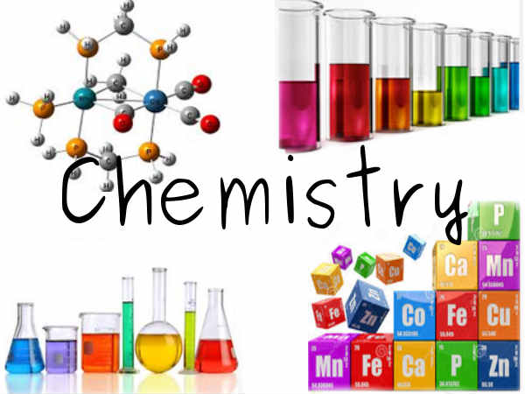

**Introduction**

Before you start the A-Level Chemistry course in September you should have completed this transition pack to lay the foundations to your studies here at St Benedict’s Sixth Form. It is the important information from GCSE plus some more to make you think like an A-level Chemist. Over the summer holidays you should find time to go through this booklet and become confident with the concepts covered. In your first ½ term of Chemistry in September you will be tested on this work to see that you are committed to doing as well as you can in this subject. If you are not prepared to work and give this course your best shot it is probably better that you discontinue your study of A-level Chemistry right now! However, for those who continue on the course you will find that Chemistry is a prestigious subject to have passed at A-level and you will find that you acquire useful knowledge and great transferable skills.

Good luck and see you all in September.

Ms Elspeth Coogan

Curriculum Leader for Chemistry

**Naming compounds and writing their formulae.**

This is a really important section and you need to know it well.

For two element compounds all you need is the periodic table

|  |  |  |  |  |  |  |  |
| --- | --- | --- | --- | --- | --- | --- | --- |
|  |  |  |  |  |  |  |  |
| +1 | +2 | +3 | +or-4 | -3 | -2 | -1 | 0 |
|  |  |  |  |  |  |  |  |
| H |  |  |  |  |  |  | He |
| Li | Be | B | C | N | O | F | Ne |
| Na | Mg | Al | Si | P | S | Cl | Ar |

You need to look at the number above the groups. Groups go down. (Periods go across). The total +’s and –‘s for a compound need to be zero.

So the compound of lithium and fluorine is Li (+1) and F (-1). One lithium cancels out the fluorine and so the formula is LiF. This is called lithium fluoride. Notice the metal name stays the same but the non-metal part gets an –ide.

Next Beryllium and Oxygen. Be (+2) and O (-2). One beryllium cancels out the oxygen and so the formula is BeO. Beryllium oxide. Oxygen produces oxides when combined with other elements. Sodium and Oxygen Na (+1) and O (-2). In this case we need two lots of Na and so the formula is Na2O. Sodium oxide.

*Try these. Give the formulae and the names of the compounds they form.*

|  |  |  |
| --- | --- | --- |
| *Elements* | *Formula* | *Name* |
| *Hydrogen and chlorine* | *H (+1)*  *Cl (-1)*  *= HCl* | *Hydrogen chloride* |
| *Lithium and oxygen* |  |  |
| *Magnesium and chlorine* |  |  |
| *Hydrogen and carbon* |  |  |
| *Aluminium and chlorine* |  |  |
| *Aluminium and oxygen* |  |  |

Often there are groups of elements that go together to form an ion. Here are the more common groups of elements ions. You will be expected to know these for your course.

**OH- hydroxide**

**SO42-  sulphate**

**NO3- nitrate**

**CO32- carbonate**

**MnO42- manganate**

(Notice ion names – when an element is combined with oxygen to form an ion it ends with –ate)

And one positive ion – **NH4+ ammonium.**

These groups should be treated exactly the same as a single element when combining them with other elements to form a compound.

Magnesium hydroxide is made up of Mg2+ and OH- . One Mg2+ needs two hydroxides to balance the charges and so the compound’s formula is

**Mg(OH)2**

Note the use of the brackets to ensure that there are two lots of OH- required. MgOH2 would be wrong as it would look like there are two hydrogens and one oxygen. Make sure that brackets are used to indicate numbers of the groups that are being used.

Sodium nitrate is made up of Na+ and NO3- . One Na+ needs one nitrate to balance the charges and so the compound’s formula is

**NaNO3**

Notice that brackets are not needed here.

**Chemical formulae – further guide**

A chemical formula is a useful shorthand method for describing the atoms in a chemical: sometimes you will see the formula used instead of the name, but you should not do this if you are asked for a name.

The chemical formula of an element or compound tells you:

• Which elements it contains: eg FeSO4 contains iron, sulphur and oxygen

• How many atoms of each kind are in each molecule: eg H2SO4 contains two atoms of hydrogen, one atom of sulphur and four atoms of oxygen in each molecule

• How the atoms are arranged: eg C2H5OH contains a group of atoms known as the ethyl group, -C2H5, and a hydroxyl group, -OH

• The masses of the various elements in a compound: eg 18 g of water, H2O, contains 2 g of hydrogen atoms and 16 g of oxygen since the relative atomic mass of hydrogen is 1 (x 2 because there two hydrogen atoms) and that of oxygen is 16.

You should not learn large numbers of chemical formulae by heart. However, it is useful to know a few of them and when you do you should be able to work out the rest. The table below shows the names, formulae and valency of the more common elements and some groups of atoms, called radicals, that you will study and you should refer to it when necessary.

Although it is best to learn formulae by using the valency of the common parts, it is sometimes useful to be able to work out the formula of a compound. This set of rules helps you to do this using information in the table.

You can think of valency as the combining power and use it to show the simplest ratio in which the atoms of the elements and radicals combine together in the formula. The following rules can now be applied:

• Write down the symbols of the elements and radicals given in the chemical name of the compound

• Now write down the valency of each element or radical under the corresponding symbols for the element or radical

• Now cross them over as shown below

• The valency shows the simplest combining ratio and may be cancelled down but only the valency can be simplified in this way

• If an element has more than one valency, the name of the compound will indicate which valency is to be used.

Here are a few examples:

• Sodium Sulphate

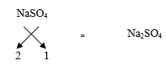

• Calcium hydrogen carbonate

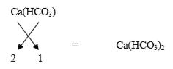

Note: A bracket must be placed around the radical if it is multiplied by 2 or more and composed of more than one element.

Eg: MgBr2 no bracket required whereas Ca(OH)2 bracket essential as CaOH2 is incorrect.

• Often you can cancel the numbers on the two formulae:

Ca2(CO3)2 =CaCO3

However, you should not do this for organic compounds: C2H4 has two atoms of carbon and four of hydrogen so it cannot be cancelled down to CH2.

• Copper(I) oxide means use copper valency 1, ie Cu2O: lead(II) nitrate means use lead valency 2, ie Pb(NO3)2

The periodic table can help you to find the valency of an element and hence the formula of its compounds, it is important to realise that all formulae were originally found by experiment.

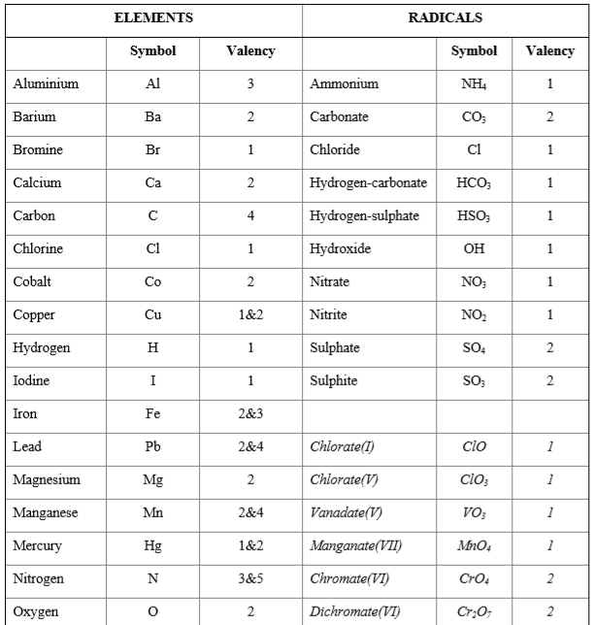

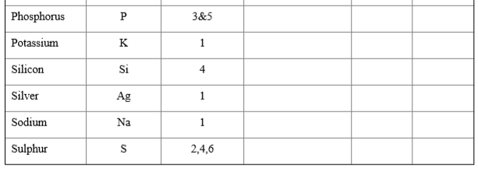

*Try the following*

|  |  |  |
| --- | --- | --- |
| *Elements /groups* | *name* | *formula* |
| *Sodium and hydroxide* |  |  |
| *Lithium and sulphate* |  |  |
| *Magnesium and carbonate* |  |  |
| *Potassium and manganate* |  |  |
| *Calcium and nitrate* |  |  |
| *Ammonium and nitrate* |  |  |
| *Aluminium and nitrate* |  |  |
| *Aluminium and sulphate* |  |  |

**Repetition is important part of learning… complete these….**

Write the formula of the following ionic compounds.

* potassium iodide
* sodium oxide
* aluminium bromide
* magnesium chloride
* silver oxide
* iron (II) oxide
* iron (III) oxide
* calcium sulfide
* copper (II) chloride
* lithium fluoride
* barium chloride
* lead sulfide

**And now a little bit more practice….**

Iron(III) Hydroxide

Iron(II) Hydroxide

Ammonium Chloride

Ammonium Carbonate

Ammonium Hydroxide

Ammonium Nitrate

Ammonium Sulphate

Ammonium Phosphate

Phosphorus Trichloride

Phosphorus Pentachloride

Phosphorus Trioxide

Phosphorus Pentoxide

Hydrogen Phosphate (Phosphoric Acid)

Hydrogen Sulphate (Sulphuric Acid)

Hydrogen Nitrate (Nitric Acid)

Hydrogen Chloride (Hydrochloric Acid)

Carbon Tetrachloride

Silicon Tetrachloride

Sodium Carbonate

4 Sodium Sulphate

5 Sodium Phosphate

6 Potassium Chloride

7 Potassium Bromide

8 Potassium Iodide

9 Potassium Hydrogen Carbonate

10 Potassium Nitrite

**Empirical and molecular formulae**

Empirical formula is the simplest whole number ratio of elements. Divide the percentage or mass by the Mr of each element in the compound, divide by the smallest number and simplify to give a whole number ratio.

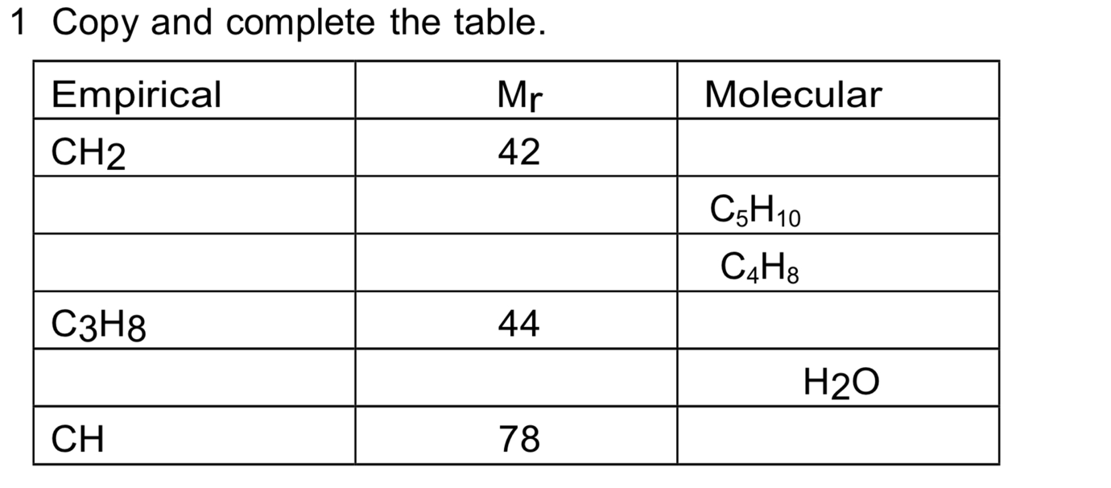

2. Find the empirical formula of each of the following substances using the data about composition by mass.

* H 5% F 95%
* Na 3.71g O 1.29g
* Pb 90.7% O 9.3%
* C 60.0% H 13.3% O 26.7%

3. 3.53 g of iron reacts with chlorine to form 10.24 g of iron chloride. Find the empirical formula for the iron chloride.

4. Analysis of a compound consisting of carbon, hydrogen and oxygen showed it to contain 0.273 g C, 0.046 g H, and 0.182 g O. It has a relative formula mass (Mr) of 88.

a Calculate the empirical formula of the compound.

b Calculate the molecular formula of the compound.

**Moles and chemical calculations**

This is a very important section. You need to become competent with these calculations as soon as possible.

**The mole**

A mole is 6.02 x 1023 of atoms, ions, molecules, electrons etc.

Although the number is important in chemistry it is really only used to work out masses and concentrations at A-level.

You need to follow this section very carefully and complete all the questions.

**Relative atomic mass Ar**

The mass number for any atom is the large number that you will find next to every element in the periodic table. The small number as we have already seen is the proton number or atomic number. Write down the mass numbers for the following elements. You will need a periodic table

|  |  |  |  |
| --- | --- | --- | --- |
| element | Atomic mass | element | Atomic mass |
| Ca |  | U |  |
| P |  | Be |  |
| N |  | B |  |
| O |  | I |  |
| K |  | Ra |  |

**Relative molecular mass Mr**

Relative molecular mass is simply all the relative atomic masses in a molecule added together. However, there are a few things that may catch you out.

Brackets- anything inside a bracket is multiplied by the little number outside the bracket

Water of crystallisation- Some compounds have **.xH2O** such as **CuSO4.5H2O**. When you work out the relative molecular mass of the compound you must remember to add on the correct number of water molecules, in the example above 5 lots of 18 which is 90.

Complete the following

|  |  |  |  |
| --- | --- | --- | --- |
| compound | Mr | compound | Mr |
| NaCl |  | NH4NO3 |  |
| CuCO3 |  | (NH4)2SO4 |  |
| Cu(Cl)2 |  | CuSO4.5H2O |  |
| Ca(NO3)2 |  | Al2(SO4)3 |  |

**Remember practice… practice… practice… complete these:**

Mr: Mg(OH)2

Mr: Ca(HCO3)2

Mr: Fe(NH4)2(SO4)2.6H2O

Mr: Na2CO3.10H2O

**Moles of compounds**

Now you have worked out the relative atomic and molecular masses it is very easy to state the mass of a mole of a specific substance.

A mole of a substance is simply the atomic or molecular mass expressed in grams.

A mole of calcium carbonate has a mass of 100g. A mole of carbon atoms has a mass of 12g. Half a mole of calcium carbonate has a mass of 50g and a tenth of a mole of carbon has a mass of 1.2g

The mass therefore is the *number of moles x the atomic or molecular mass*

Work out the gaps in the following table

|  |  |  |  |
| --- | --- | --- | --- |
| Element, molecule or compound | Atomic or molecular mass | Number of moles | Mass in grams |
| C |  | 2 |  |
| Ca |  | 0.1 |  |
| H2 |  | 0.125 |  |
| N2 |  |  | 2.8 |
| H2O |  |  | 9 |
| CaCO3 |  |  | 2 |
| C2H6 |  |  | 0.6 |
| C2H4O2 |  | 2.5 |  |
| NaCl |  | 0.16 |  |
| CuSO4 |  | 1.4 x 10-3 |  |

**Remember practice… practice… practice… complete these:**

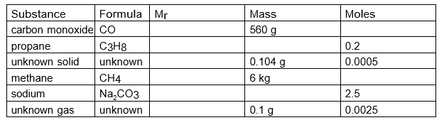

**Now a little bit more practice….**

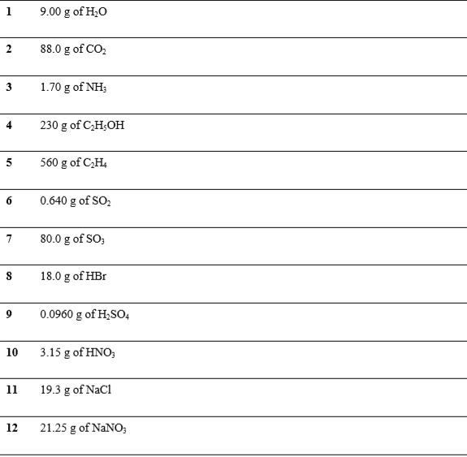

**And a little bit more…..**

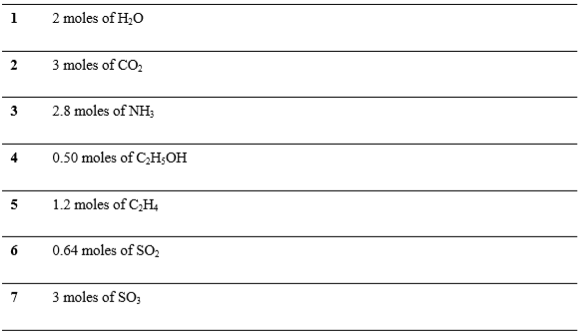

**Solutions and their concentrations**

Concentrations are expressed as so many moles in a dm3 of solution and the correct unit is mol dm-3 (moles per cubic decimetre). A dm3 is the same as a litre.

1 mole of a substance dissolved in 1dm3 of solution gives a concentration of 1 mol dm-3.

0.5 mol of a substance dissolved in 0.5dm3 of solution gives a concentration of 1 mol dm-3.

2 mol of a substance dissolved in 0.5dm3 of solution gives a concentration of 4 mol dm-3.

Fill in the spaces in the table below. Mol = conc x vol

|  |  |  |
| --- | --- | --- |
| No. of mols | Vol. of solution  dm3 | Concentration  mol dm-3 |
| 1 | 1 |  |
|  | 1 | 0.5 |
| 1 |  | 2 |
| 0.5 | 1 |  |
| 0.1 | 1 |  |
| 0.2 | 0.5 |  |
| 0.25 |  | 1 |
| 0.15 | 0.2 |  |
|  | 2 | 0.56 |
| 0.125 |  | 2.5 |

**Bring in this completed workbook in September for your first A Level Chem lesson.**