Welcome to A level Physical Education Preparation Work. You have a unique opportunity to prepare for your A Level course and we hope that the following resources and research tasks will enable you to start the course with a foundation of knowledge and confidence to achieve your potential.
The course is split into 4 components:
01: Physiological factors affecting performance (30%)-SWR teaches this unit
02: Psychological factors affecting performance (20%)
TLR teaches these units
03: Socio-cultural issues in physical activity and sport (20%)
04: Performance in Physical Education (30%)-TLR and SWR facilitate completion of practical elements out of school and both teach the Non-Examined Assessment: EAPI (Evaluation and Analysis of Performance for Improvement).

Please read through the booklet carefully and complete all tasks to ensure that you are fully prepared for September. Ensure that you develop your knowledge in all three components. Possibly divide your time so you cover all three components during a week.
Ensure you keep a record of your learning in your reflection log book!

01 Physiological factors affecting performance

This component focuses on developing the learner’s knowledge of the science behind physical activity. This includes the structure and function of key systems in the human body, the forces that act upon us and the adaptations we make to our bodies through diet and training regimes.
Through the study of this component, learners will gain a deeper understanding of key systems in the body and how they react to changes in diet and exercise. They will also study the effects of force and motion on the body and how these effects can be used in physical activities to our advantage.
This component is worth 30% of your overall grade and is assessed in year 13 by a 1 hour 45 minute exam.
The first unit you will study in September for this component is Applied Anatomy and Physiology- Skeletal and Muscular Systems. Within this unit you will re-cap some knowledge learnt in GCSE PE, but there will be a lot of additional information that you will learn on these two body systems. It is important that you start to learn some of this information before September so that you can make a confident start to the year.

Research and Tasks
You will need to complete a variety of tasks on the next few pages based on the Skeletal and Muscular Systems. These will help you to complete the main research task for this component (more information on this later in the booklet).
I highly recommend that you purchase the textbook ‘OCR A Level PE book 1’ or ‘OCR A Level PE book year 1 & 2’ as this will help you to complete these tasks (please find a link on the reading list to these text books). If not, all information can be found on a variety of websites (I have added some options to the reading list but you may have to find others yourself for some of the tasks) and Youtube is a great platform to learn information on these topics (some links on the reading list).

Task 1-Skeletal System- The skeleton

- Label ‘The Skeleton’ diagram below and learn the names of the bones.
- In the box below, identify which bones are flat and long bones and state why they are important.

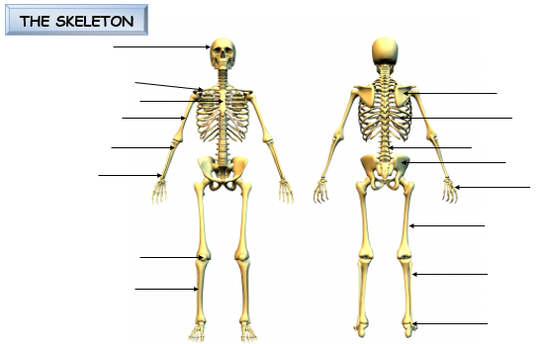
FLAT BONES:

LONG BONES:

IRREGULAR BONES -VERTEBRAE & SACRUM-PROTECT SPINAL CORD.
SHORT BONES-CARPALS AND TARSALS-BEAR WEIGHT WELL
SESAMOID BONES- PATELLA- EASE JOINT MOVEMENT AND RESIST COMPRESSION.

Task 2-Skeletal System- Planes and Axes
- Label the planes and axis correctly on the diagrams below. Please refer to GCSE PE work/textbook/internet to help with this task.
__________ plane
__________ plane
__________ plane
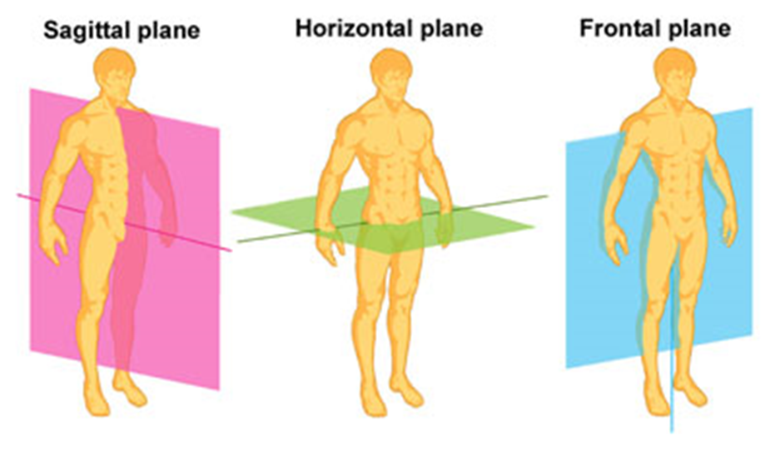
________axis
________axis
________axis
- Choose one of these planes and axis to explain a sporting action. You must state the joint movement occurring, identify the plane and axis, identify the bones involved in the action.

________________________________________________________________________________________________________________________________________________________________________________________________________________________________________________________________________________________________________________________________________________________________________________________________________________________________________________________________________________________________________________________________________________________________________________

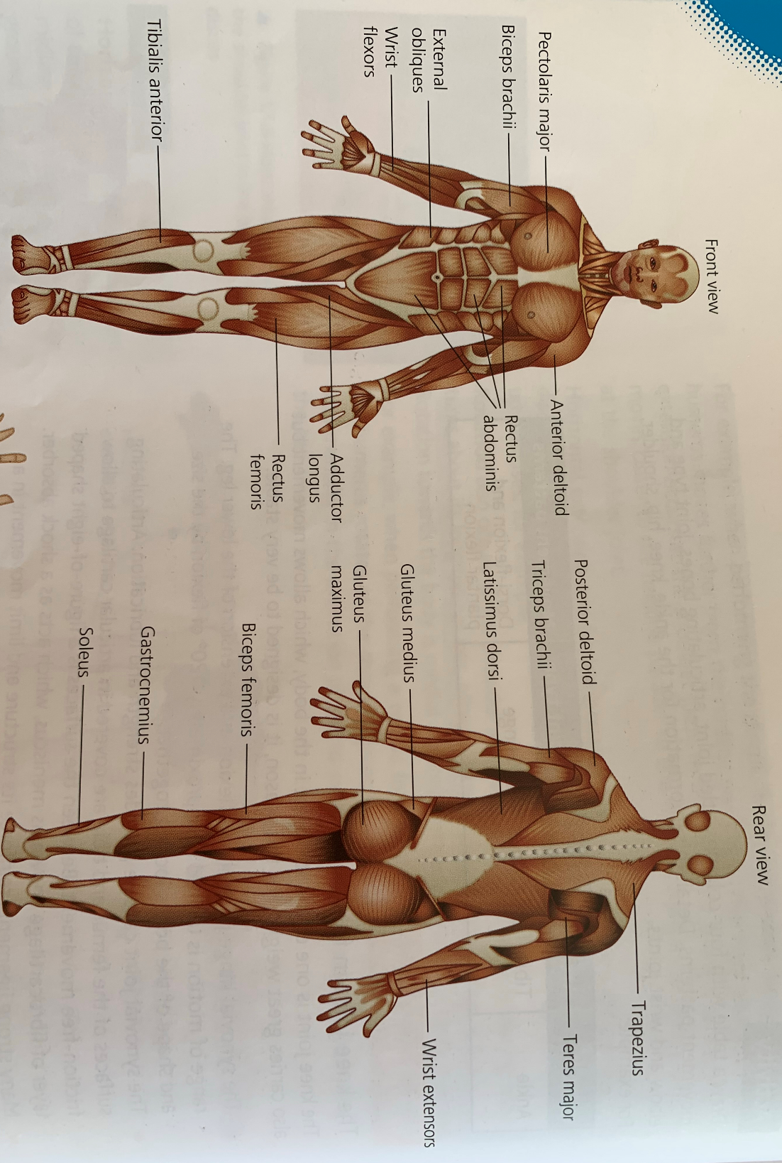
Task 3-Muscular System-major skeletal muscles
- Label the ‘Skeletal muscles’ diagram below and learn the muscle names.

Task 4- Muscular System-Antagonistic pairs
Find the definitions of the following words and complete the table below.
AGONIST:
ANTAGONIST:
FIXATOR:
Movement | Agonist | Antagonist
Flexion (wrist)
Flexion (elbow)
Flexion (shoulder)
Flexion (Hip)
Flexion (knee)
Dorsi-flexion (ankle)
What would happen to the agonists and antagonists that you have named in the table if these movements switched to extension?

Main Research Task- Skeletal and Muscular Systems presentation
You need to choose a sport that you can talk about in depth. Your task is to choose 3 different sporting actions that would occur in your sport. Using the information from the tasks that you have completed and extra research you have found, you need to explain how a performer can create these 3 sporting actions in relation to the skeletal and muscular systems. You must include information on the following for each action you choose:
- Names of bones and muscles involved in the movement.
- Name of joint movement
- Antagonistic muscle pairs
- Planes and axes involved
- Type of joint
- Type of muscle contraction occurring
- The muscle fibres required for each action.
Extension: What is a motor unit and how does this enable the performer to create these actions?
You can choose how you present your findings. You may want to create a power point presentation, poster or Prezi presentation.

Reading List
- OCR A Level PE Book 1: https://www.amazon.co.uk/OCR-Level-PE-Book-1/dp/1471851737-
- OCR A Level PE Book Years 1 & 2https://www.amazon.co.uk/OCR-Level-PE-Year/dp/1510473319/ref=sr_1_1?dchild=1&keywords=ocr+a+level+pe+1+%262&qid=1586435414&s=books&sr=1-1

Websites:
- https://www.gcseperevision.co.uk/topics/applied-anatomy-physiology/movement-analysis/planes-axes-of-movement
- https://www.youtube.com/watch?v=NoHSGRvK3jg- antagonistic pairs
- https://www.youtube.com/watch?v=moP483UxRQ8 – planes and axis

02 Psychological factors affecting performance and 03 Socio-cultural issues in physical activity and sport

This part of the course is taught by Mr Taylor together; 02 Psychological factors affecting performance and 03 Socio-cultural issues in physical activity and sport. Both elements are worth 20% of your total mark and each is assessed by a 1 hour exam worth 60 marks.

Guide to the content below
The reading list is comprehensive but not compulsory. You will gain enough resources through the A level course. However, these books will be beneficial in developing your knowledge and understanding of the key topics. I would suggest only one book per topic! These books will also support your education through university and if kept in good condition you would be able to re sale.
Websites are excellent and provide many accessible resources to support your studies in developing your knowledge and understanding.
Films/documentaries are great ways to learn and build your background knowledge around certain topics.
The tasks are suggestions that will give you solid foundations of which will support your studies when we start the A level course.
Please make a reflection log of all the reading/films/documentaries watched. Keep any tasks that you keep on file or printed.

Once we start back at school, I would like you to create a power point presentation of the topics you research and discover. This is a chance to show what you have learned and found interesting and engaging.
The presentation should cover 02/03 topics. You do not need two presentations for each topic. Your presentation needs to be 10 minutes long. This will then be used as basis for a reflection interview of what you did to prepare for your A level PE course.

02 Psychological factors affecting performance

This component focuses on the psychological factors affecting physical activities and sports. This includes models and theories that affect learning and performance in physical activities, how different methods of training and feedback work and why their effectiveness differs from person to person. It also includes psychological factors affecting group dynamics and the effects of leadership and stress on performers.

Skill Acquisition

This topic will develop learners’ knowledge and understanding of the role of skill acquisition in performance of physical activities and sports. It aims to develop knowledge and understanding of the principles required in order to optimise the learning of new, and the development of existing, skills.

Reading List

Schmidt, R.A. & Wrisberg, C.A. (2004). ‘Motor Learning and Performance’ (3rd Edition). Champaign, IL: Human Kinetics Publishers.

Schmidt, R.A., & Lee, T.D. (2005). ‘Motor Control & Learning – A Behavioural Emphasis’ (4th Edition). Champaign, IL: Human Kinetics Publishers.

Research and Tasks

- Classification of Skills – Find an a sporting image of your sport and an alternative that you are not an expert. Using the skills classification continua identify the key skills in the sporting actions.
- Research and explain why understanding how to serve in tennis enables you to quickly learn a new skill such as a volleyball serve or table tennis serve?
- There are many types of practice. Pick two skills from your chosen sport and research types of practice and select a different practice for each skill.
- What are the differences between Bandura’s theory of social/observational learning and the cognitive learning theory? Use practical examples to explain your answer.

Sports psychology

In this topic, learners will develop their knowledge and understanding of the psychological factors that can affect performers in physical activity and sport. Learners knowledge and understanding will be developed on the individual differences affecting performers in physical activity and sport; group and team dynamics in sport; the importance of goal setting in sports performance; the role of attribution in motivating performers; confidence and self-efficacy in sport; leadership in sport and stress management in physical activities and sports to optimise performance.

Research and Tasks

- Can you explain why home teams often produce better performances compared to playing away?
- Research two performances where a performer in a winning position performance can capitulate. Linking to psychology can you explain why this may have occurred?
- Many performers use stress management techniques to enhance their performance. Outline the different techniques that a specific performer could use and explain how it could benefit performance.
- What is the difference between aggression and assertion in sporting performance? Research and include at least two theories to explain your answer!

Reading List
Cox, R.H. (2007). Sport Psychology: Concepts and Applications. (6th edition). New York: McGraw-Hill.
Cox, R.H. (2007). Sport Psychology: Concepts and Applications. (6th edition). New York: McGraw-Hill.
Berger, B., Pargman, D., & Weinberg, R. (2002). Foundations of Exercise Psychology. Morgantown, WV: Fitness Information Technology.
Gill, D.L. (2000/2008). Psychological Dynamics of Sport and Exercise (2nd/3rd edition). Champaign, IL. Human Kinetics.
Moran, A. (2004). Sport and Exercise Psychology: A Critical Introduction. London: Routledge.

03 Socio-cultural issues in physical activity and sport
This component focuses on the sociological and contemporary issues that influence and affect physical activity and sport for both the audience and the performer and how sport affects society. It includes the emergence and evolution of modern sport and how social and cultural factors shaped the characteristics of sports and pastimes in pre-industrial and post-industrial Britain. The impact of the modern Olympic Games will be understood as well as the impact on society of hosting global sporting events. The ever-evolving modern technology and its influence on sport performers and spectators will be understood and practical examples will be used by learners to show the effect of modern technology.

Sport and society
In this topic, learners will develop their knowledge and understanding of how physical activity and sport have developed through time and the factors that shape contemporary sport. For the ‘Emergence and evolution of modern sport’ topic area, it will be beneficial to include the use of case studies in particular sports (for example football, tennis, athletics or cricket) which can be charted through the different time periods covered. Learners will also understand the nature of global sporting events and how they reflect and are impacted upon by social issues.

Research and Tasks
- Produce a timeline of the origins of one of football/rugby/tennis/ to present day! Include the development from mob game through amateurism and professional. Include the development of rules and technology in sport?
- Research sport and society in pre-industrial revolution through to post industrial revolution. Right a report of key comparisons of gender, education, and law?
- Create a poster of the Olympic values and aims
- Why was the friendship of Lutz Lang and Jesse Owens during the berlin Olympics reinforce the values of the Olympics in contrast to Hitler’s propaganda of the Nazis during the games? Write a new article!

Reading List

"Sport and the British" (Richard Holt) up to page 202.
“British Sport A Social History” (Dennis Brailsford) Lutterworth Press
“The Evolution of British Sport” (Neil Wigglesworth)

Contemporary issues in physical activity and sport

The ethics involved in sport and deviance that affects sport and sporting behaviour will be understood and applied using practical examples. Learners will develop their knowledge and understanding of the positive and negative impacts of commercialisation and the media on physical activity and sport. The routes to sporting excellence in the UK will be known and the roles of key organisations to develop excellence will also be understood. The important and developing influences of modern technology in physical activities and sport will be understood as well as its impact on participation, fair outcomes and entertainment.

Research and Tasks

- Pick two sports and research the rules and regulations regarding performance enhancing drugs. How the international/national governing bodies regulate participants through testing.
- Write two personal profiles of sports stars who have cheated using performance enhancing drugs. Include the impact to the performer, the sport and society as a whole.
- Pick two sports and research the how the sport has developed since 1980’s including media coverage and technology and gender? Write a timeline or report on the key changes and impact to the sports.
- In the 21st century sport is a commodity, research the golden triangle to explain the links be advertising and sponsorship?

Reading List
Jay Coakley (1998) - Sport and Society Issues and Controversies
McGraw Hill
Simon Barnes (2006) - The Meaning of Sport
Short Books
Ellis Cashmore (2005) - Making Sense of Sport
Routledge

Websites

http://www.bbc.co.uk/sport/30326825
http://www.bbc.co.uk/history/british/victorians/sport_01.shtml
http://www.academia.edu/203052/A_brief_overview_of_the_history_of_sport_in_the_UK
http://www.uksport.gov.uk/
http://www.sportengland.org/

Films/Documentaries

These films, documentaries and series will give you some excellent background knowledge and understanding to topics and units while being really interesting and a great viewing.
Try and watch those in bold that will definitely support the course content.
The English Game (Netflix) Amatuerism and professionalism the FA Cup – Sport and Society
Tom Browns School Days - Athleticism and the rationalization of sport
Chariots of Fire - Olympism and Harold Abrahams
All or Nothing (Amazon Prime)
- Manchester City
- Arizona Cardinals
- New Zealand All Blacks

Make Us Dream (Amazon Prime)

The Program (Amazon Prime) – Lance Armstrong film
Stop at nothing; Lance Armstrong Story - Netflix

The Race to Dope (Amazon Prime) – Atheltes and Doping

Invictus (Amazon Prime) Sport and politics, South Africa Rugby World Cup

Blindside (Amazon Prime) Awesome true story American football

