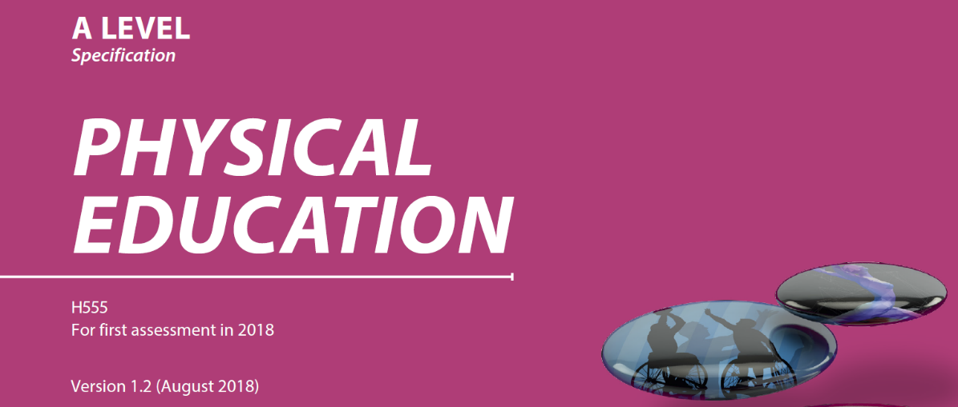
P

Please fill out your reflection log of how you spent your time and what you researched, read and viewed. This could be books, internet resources, films documentaries and you tube clips.
This will be very beneficial for your first discussion with your teacher on what you did to prepare for this course. Please edit and save your own copy!
Date | Time spent | Topic | Resource | Reflection
15/4/20 | 1 hour | 03 Sport and Society | English Game Series on Netflix. Episode 1 | Was very interesting to see the attitudes of Amateurs (Upper Class) to the possibility of professionals being paid to play football! Also the rules looked more like rugby in places.
17/4/20 | 40 mins | 02 Skill Acquisition (Transfer of Skills task) | Teachpe.com | Made not on the different types of transfer. Will use to write an answer to on eof the tasks next time.

