Geography Sixth Form Transition
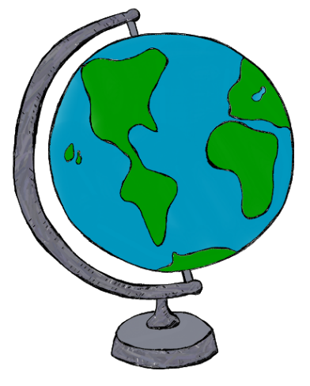
One of the skills you will need to develop for
A-Level is to be able to take your learning into
your own hands
The break you now have is an opportunity not
only to have a rest, but also take an interest in
the world surrounding you.
We have put together a list of ideas of things that you could do to help you become an independent learner in Geography. They will increase your subject knowledge, enable you to make complex links between different geographical ideas and give you valuable case studies.
In addition, you would be able to show any university your commitment to Geography and an academic approach to your studies, thereby increasing your chances of getting into the top institutions.
Be aware that it is not an exhaustive list and you should look for opportunities yourself.
The onus is on you. Universities will want to feel you are committed but they will also be looking for initiative. They will be impressed if you organise and arrange these things rather than them being done for you.

“Geography students hold the key to the world's problems”- Michael Palin

- Read Bill Bryson’s books about travelling around the World or books by authors such as David Attenborough.
- Read ‘Rulers of the new world’ a controversial book about globalisation by John Pilger or ‘The world is Flat’ and ‘The world is flat, hot and crowded’ by Thomas L. Friedman which take a more positive look at this issue. Joseph Stiglitz ‘Making Globalisation Work’ is a must for the globalisation topic.
- Regularly read the news. Take notes of stories relevant to Geography. Storms, earthquakes, volcanoes, poverty, development, industry, tourism, global warming, use of the earth’s resources and managing ecosystems are all examples.
- Join ‘live lessons’ online at https://encounteredu.com/live-lessons. Topics include fieldwork techniques (useful for your Independent Investigation) the Arctic and Coral Reefs. Live lessons start from 20th April.
- Join a local environmental group or look for online schemes you can help with such as data input for meteorologists.
- Join the Royal Geographic Society and view some of their lectures or read their journals
- Listen to Radio 4 ‘Today’ programme and look for other programmes with a geographical theme.
- Enter a Geography writing competition.
- Subscribe to a Geography magazine e.g. Geography Review, Geography or National Geographic.
- Visit places of geographical interest and record your impressions/what you gained from the visits. Local places include Bradfield Woods
- Watch Documentaries on geographical issues such as ‘The age of stupid’ a film about global warming or “water wars”.
- Mentor/support lower school lessons when we return.
- Help at events such as open evenings next year and try to plan some things we can do in the geography department for these.
- Visit the natural history or science museums or try to find their exhibits online
- Create resources to be used in lessons to showcase your knowledge, such as songs or presentations
- Look for geographical references in popular culture, e.g. songs about places and the opinions portrayed in them such as empire state of mind by Jay-Z
- Take online quizzes on sites such as “Sporcle” or create your own to use in class
- Do some research of your own, e,g. study the biodiversity of your garden, or research how your local town/village has changed throughout history using resources such as census or aerial photographs
- Practice using free online cartography sites to see what maps you can create and what you can show using them
- Find geography themed podcasts listen to (History Extra have a podcast in which David Attenborough talks about Charles Darwin which is fascinating)
- Listen or view online lectures from universities or see if there are any open lectures at local colleges or lectures (oxford university have a lecture about Madagascar)
The most important thing to do, is open your mind to the world around you, remember everything is geography in some way and there are lots of views to take in.

