**Extra reading, watching, listening and places to visit:**

All of the books, videos, podcasts and historical sites below will give fantastic background knowledge and experiences which will help you with your study of the Ancient Greek and Roman worlds you’ll be studying. You don’t have to take notes while reading, listening or watching: just enjoy them. When we study the two ancient worlds you’ll be able to match up what you’ve read, heard, seen, and experienced to what you will learn about in lessons.

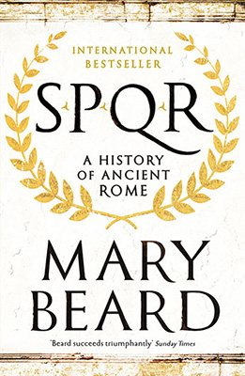**Extra reading**

*SPQR: A History of Ancient Rome* by Professor Mary Beard.

Throughout *SPQR,* Mary Beard charts how over a thousand years, Rome went from an insignificant village in Italy to having a territory covering almost all of Europe, north Africa and into the Middle East. She makes it very clear and relevant how Ancient Rome still matters and how their stories still resonate so neatly with our world today. This book, whilst being incredibly well written, will give you excellent insight into Ancient Rome from one of our greatest historians.

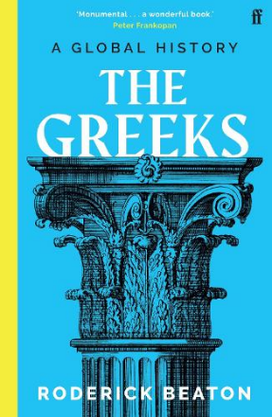

*The Greeks: A Global History* by Professor Roderick Beaton.

This book chronicles the Ancient Greek world, how they came to dominate so much of the Mediterranean, how their culture spread, but more importantly, how their ideas and beliefs have shaped the modern world. This book will give you a great understanding for the Homer poem, *Odyssey*, and the unit on Greek Religion we’ll be studying.

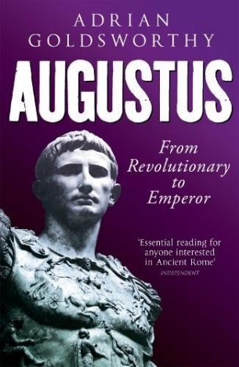*Augustus: From Revolutionary to Emperor* by Dr. Adrian Goldsworthy.

Adrian Goldsworthy is a noted historian of Ancient Rome who’s historical fiction I highly recommend as he manages to convey a feeling of what that time in history truly was. He takes that same ability into his various non-fiction historical works, with the main highlight being this one. The Imperial Image unit and Virgil’s *Aeneid* are all based around Augustus, how he became Emperor and how Rome saw themselves in the wider world. This book would prove crucial in understanding that dynamic.

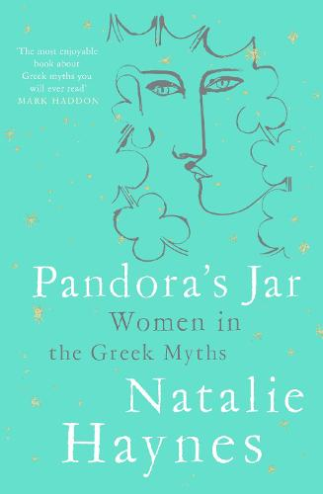*Pandora’s Jar: Women in the Greek Myths* by Natalie Haynes.

This book will offer you great insight into world of Greek mythology and their importance, but from a much misunderstood perspective: the women. As opposed to focusing on Zeus or Agamemnon amidst other Greek mythological men, Haynes draws your focus to the women of their stories and give them voice. Haynes has re-written many Greek myths into a female centred position, but this is an excellent starting point.

**Historical fiction**Historical fiction is a great way to understand and envision the time period, so here are some novelists I highly recommend: Ben Kane (a personal favourite), Simon Scarrow, Natalie Haynes, Conn Iggulden, Lindsey Davis and many more.

**Extra watching and listening**

*The Complete History of the Roman Empire* by Professor Mary Beard on History Hit.

This series of documentaries by Mary Beard chronicle the rise and consolidation of the Roman Empire and how it functioned. She does an excellent job of not just focusing on the rulers, but spends equal time showing what life was like for most, rather than the few. The QR code will take you to the documentary on YouTube.

*Troy* (2004)

This film follows the Trojan siege and war, which is a key founding story for both Ancient Greece and Ancient Rome. You will read about it in the literature module, but this is a reasonably accurate depiction of the war and siege. It’s action scenes are incredible and truly shows the warfare of the time period, which is a key element we’ll study, alongside the role Gods play in deciding human fate. The QR code takes you to the Amazon prime store.

*The History of Rome* by Mike Duncan, podcast.

This podcast was a weekly series where Mike Duncan chronicled the history of the Roman Empire right from it’s first founding to its collapse in extraordinary detail. This will give you a lot of extra contextual knowledge which will aid you greatly.

**Places to visit**

The British Museum in London.

This museum has a wide variety of exhibits and covers a very wide variety of history’s, but has excellent exhibits and items from both Ancient Greece and Rome. The museum, when visited properly, would take a full day or more to properly see everything. The museum does an excellent job of showing the artefacts and items from the time period in context, so would be of great benefit to visit.

London Mithraeum.

During recent building work for Bloomberg’s new headquarters in London, they found an Ancient Roman temple which has been incredibly well preserved for centuries. They’ve restored the majority of it, but have created a museum to show the temple at large and what would have happened in Roman London nearly 2,000 years ago! Best of all, it’s free!

**Things to do**

1: Any of the above isn’t a requirement, but the books or podcasts would be the most recommended to set you up with knowledge before the course starts in September.

2: Requirement: do a mind-map of everything you know about Ancient Rome and Ancient Greece (one each) so we know what knowledge you have for these areas.