ST BENEDICT’S SCHOOL
MATHS DEPARTMENT
GCSE to ALEVEL TRANSITION BOOKLET
Introduction
The ALevel Maths course consists of 3 elements, Pure Maths and two applied ones in Mechanics and Statistics. If you are choosing to do Further Maths you will be taking each of these elements to the next level with some interesting and challenging material, which willl enhance your Mathematical ability and prepare you for courses in Maths after your ALevels.
As a department we are keen to support your Mathematical development and ensure that you are making good progress towards fulfilling your potential. This booklet will help you to make a good start to the course and will give you a firm foundation and essential techniques needed for the work you will be doing throughout the two year course. It is important that you work through each chapter carefully following the examples and procedures needed and then answer the questions that follow. You do not need to go through every question but do enough of them to ensure you have a firm understanding of the topic. It is essential you have a good knowledge of these topics before the start of the year in September. The material covered should be familiar as these topics are also in the GCSE specification.
We all look forward to you joining a very successful ALevel Maths programme at St Benedict’s after the Summer. Work hard to prepare yourself in the best possible way to help enhance your level of understanding of the topics you will encounter.
CONTENTS
Chapter 1 Removing brackets page 2
Chapter 2 Linear Equations 4
Chapter 3 Simultaneous Equations 8
Chapter 4 Factorising 10
Chapter 5 Changing the subject of a formula 13
Chapter 6 Solving quadratic equations 16
Chapter 7 Indices 18
Practice Test 21
Solutions 22
Extended Reading List 24
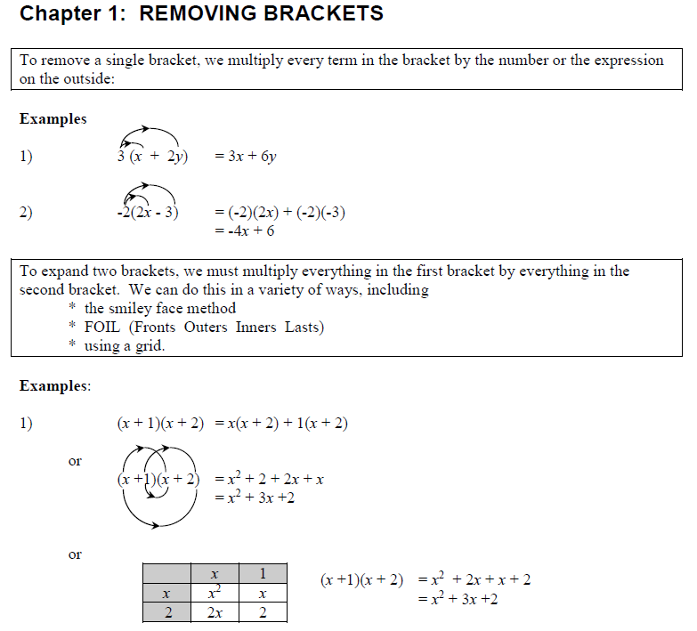
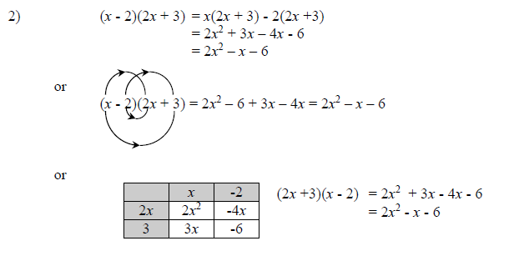
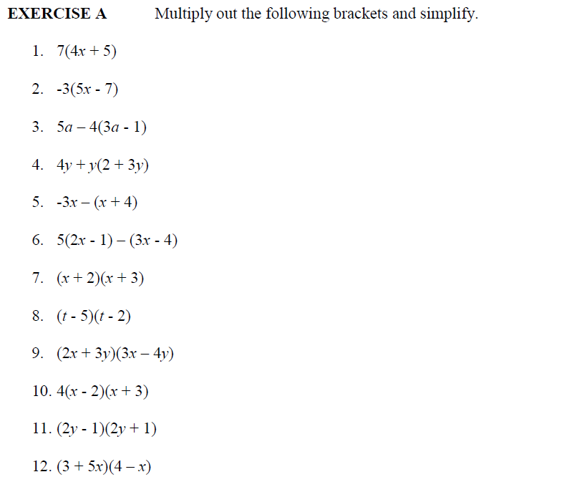
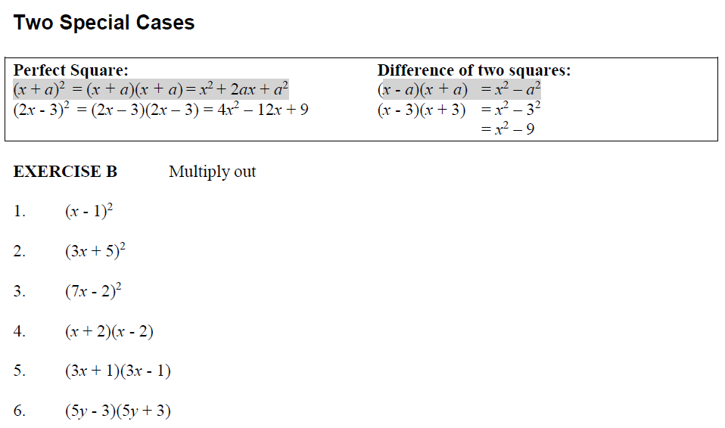
More help: http://www.mymaths.co.uk/tasks/library/loadLesson.asp?title=brackets/bracketsMovie&taskID=1150
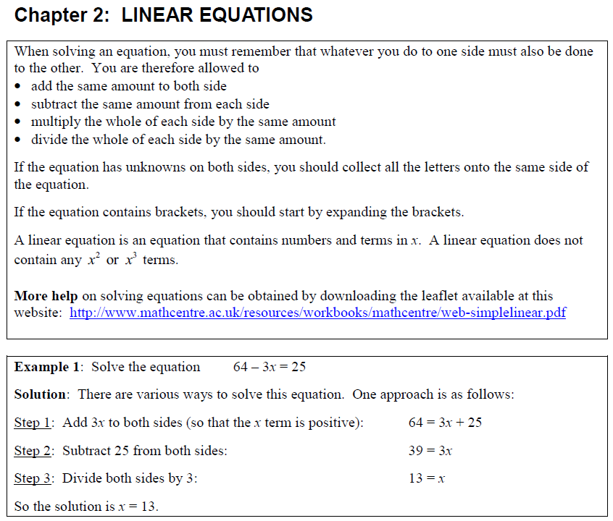
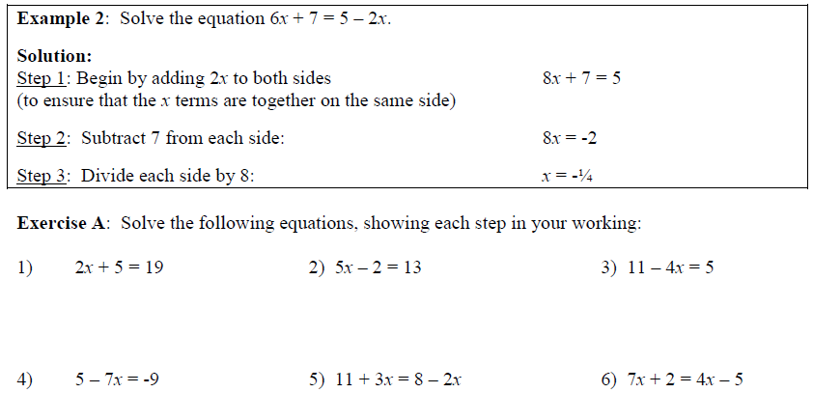
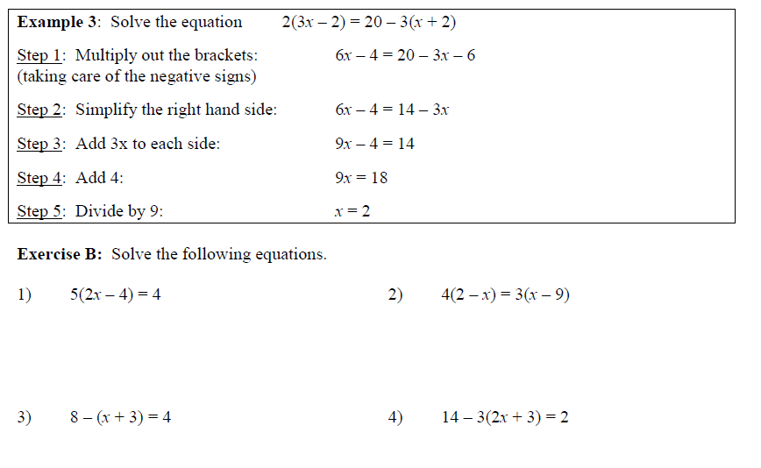
More help: http://www.mymaths.co.uk/tasks/library/loadLesson.asp?title=equations/solvingEquationsM ovie&taskID=1182
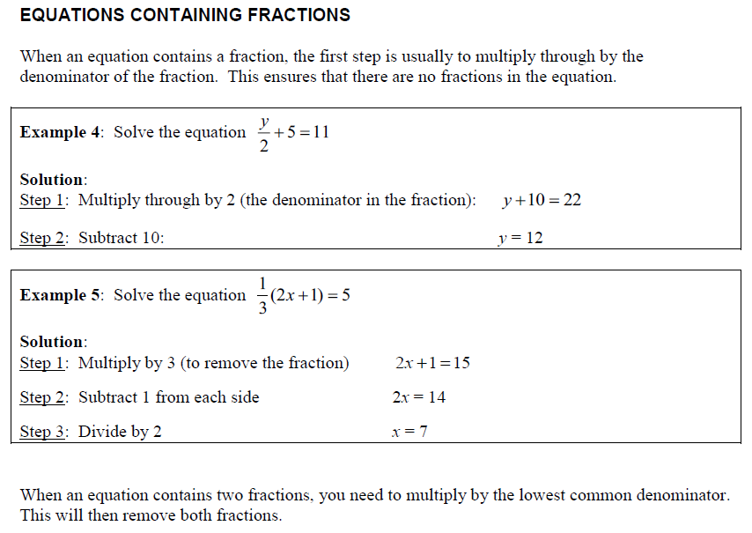
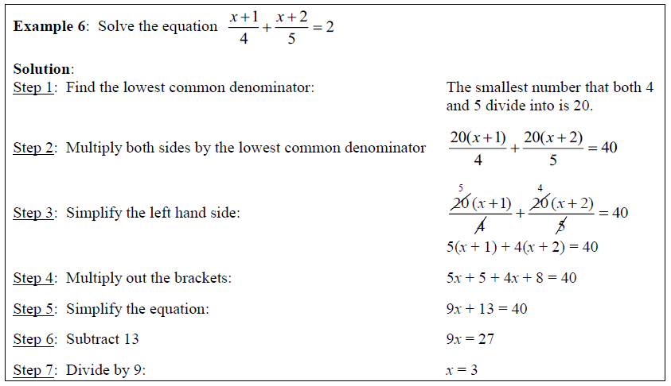
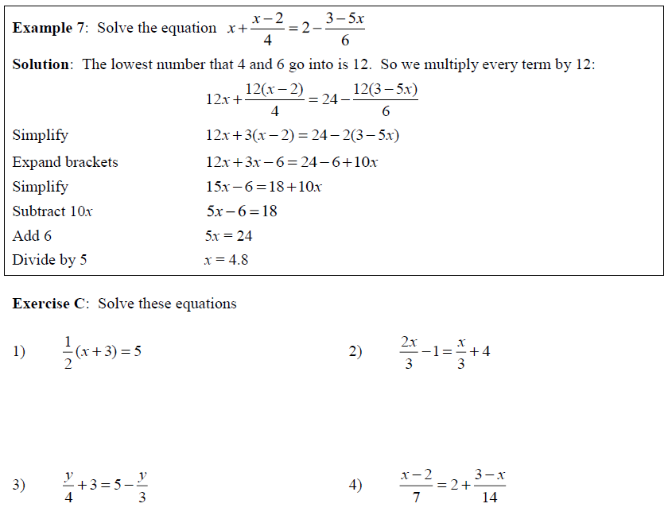
More help: http://www.mymaths.co.uk/tasks/library/loadLesson.asp?title=equations/solvingEquations WithFractions&taskID=1183
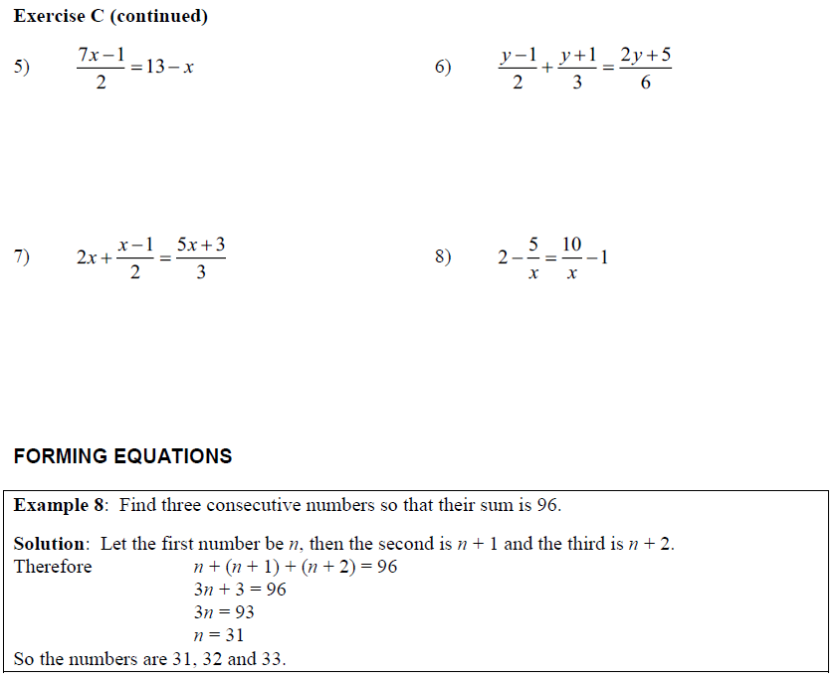
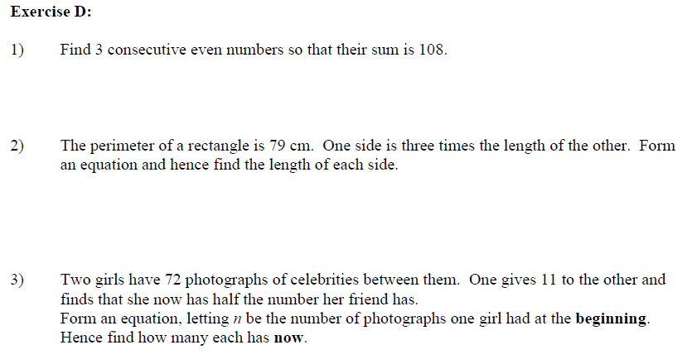
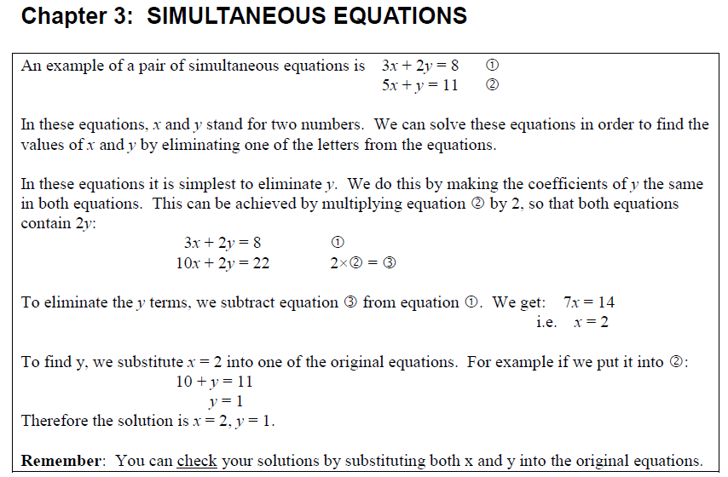
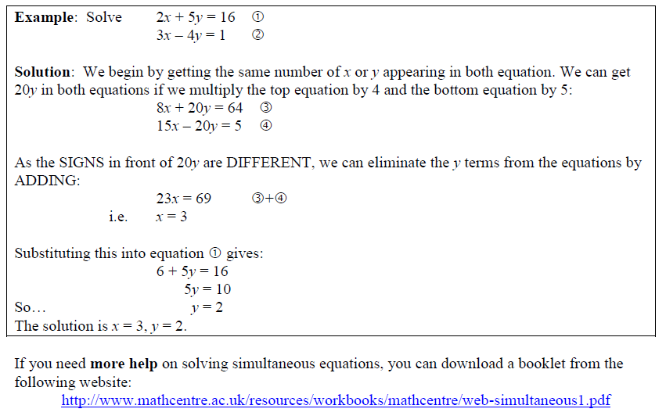
http://www.mymaths.co.uk/tasks/library/loadLesson.asp?title=simultaneous/simEquMovieHard&taskID=1174
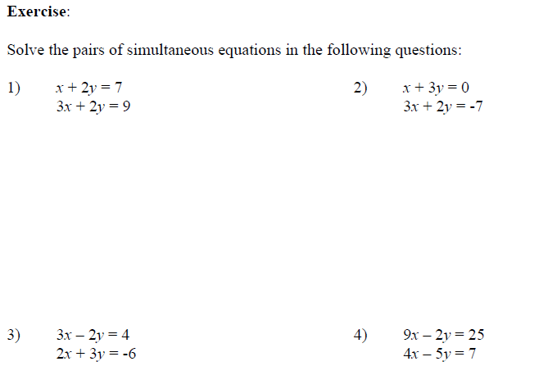
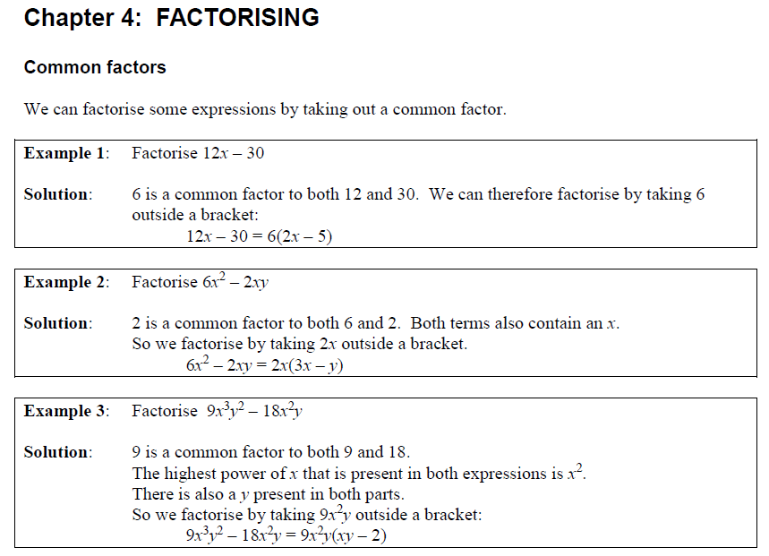
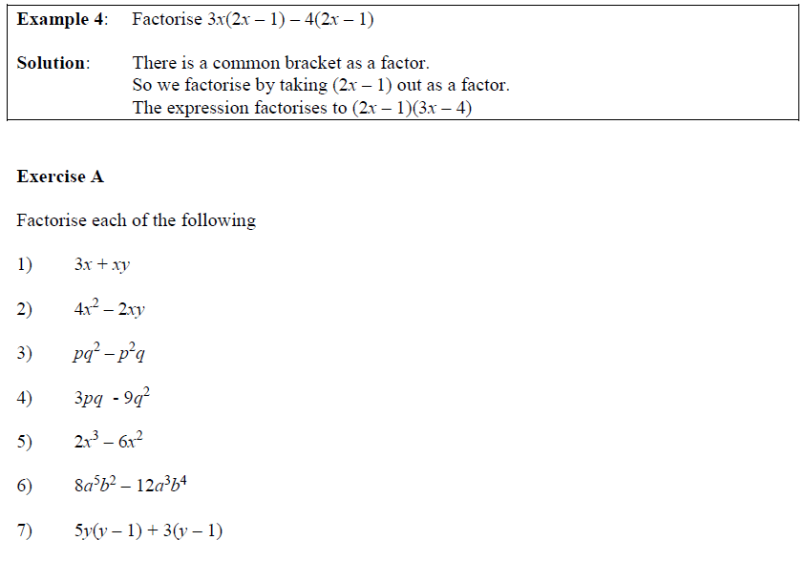
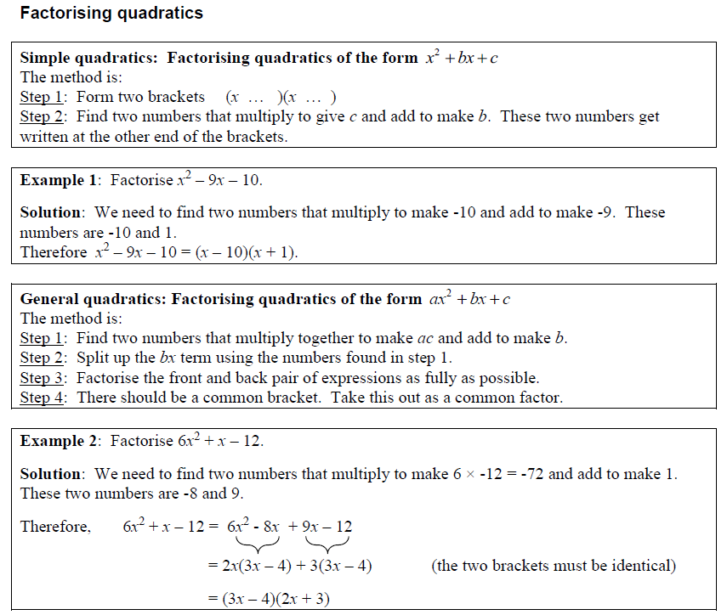
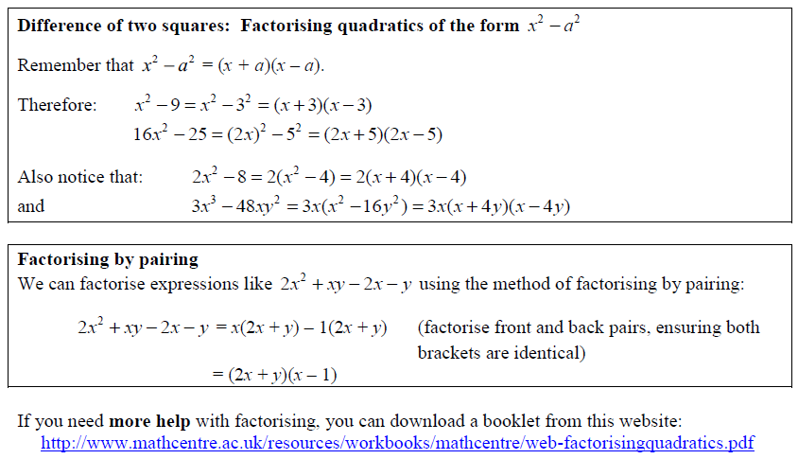
http://www.mymaths.co.uk/tasks/library/loadLesson.asp?title=factorising/factoriseHigher&t askID=1156
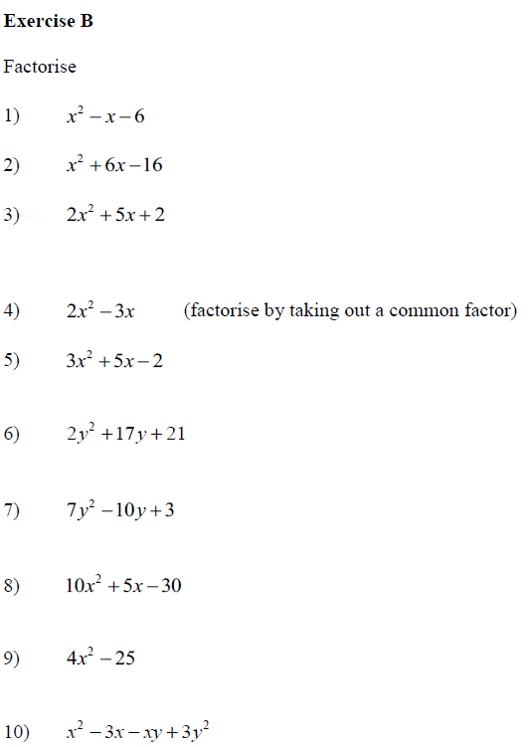
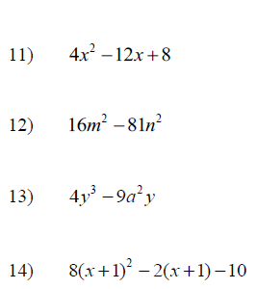
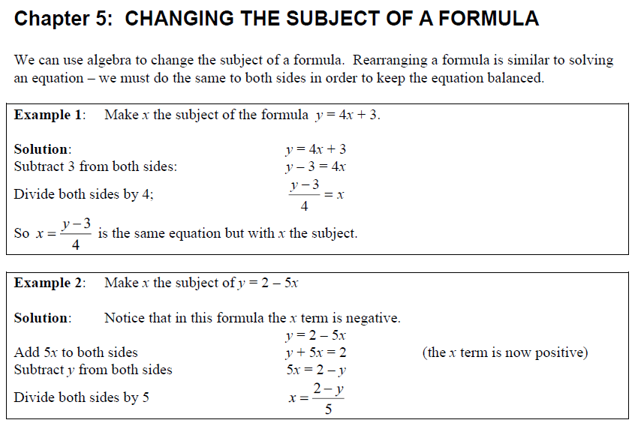
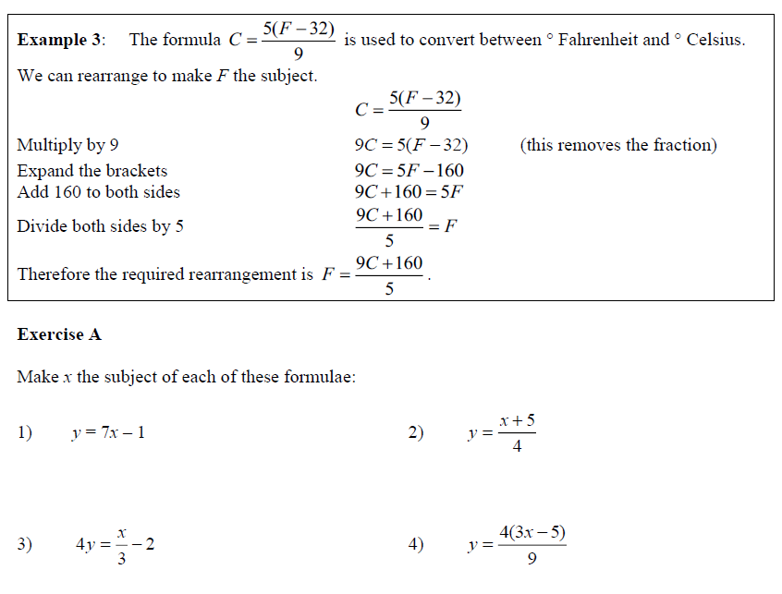
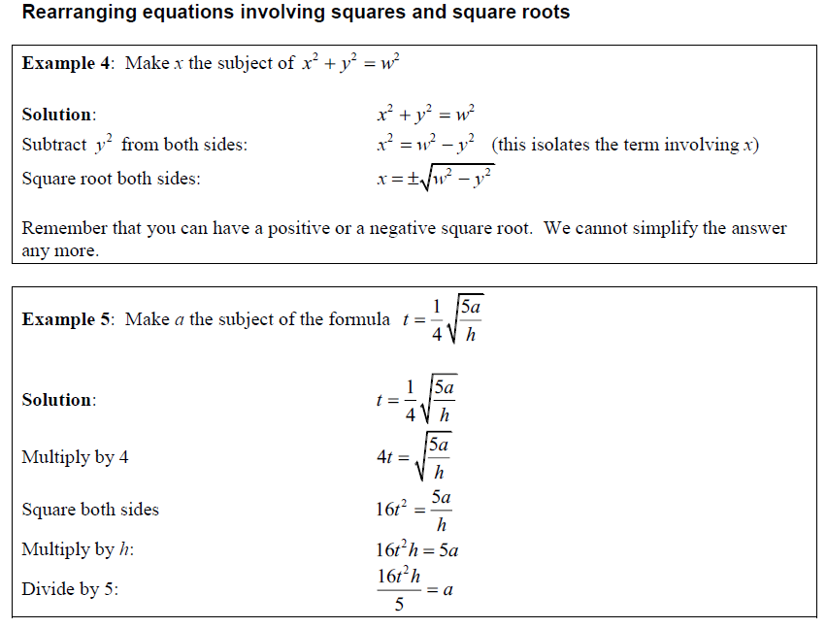
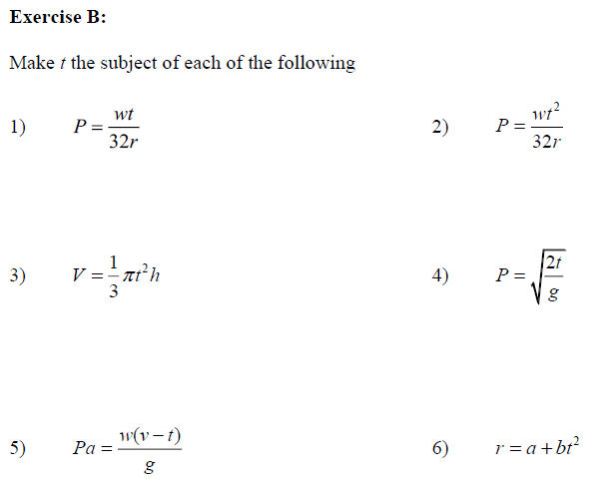
More help: http://www.mymaths.co.uk/tasks/library/loadLesson.asp?title=simplify/rearrangehigher&tas kID=1170
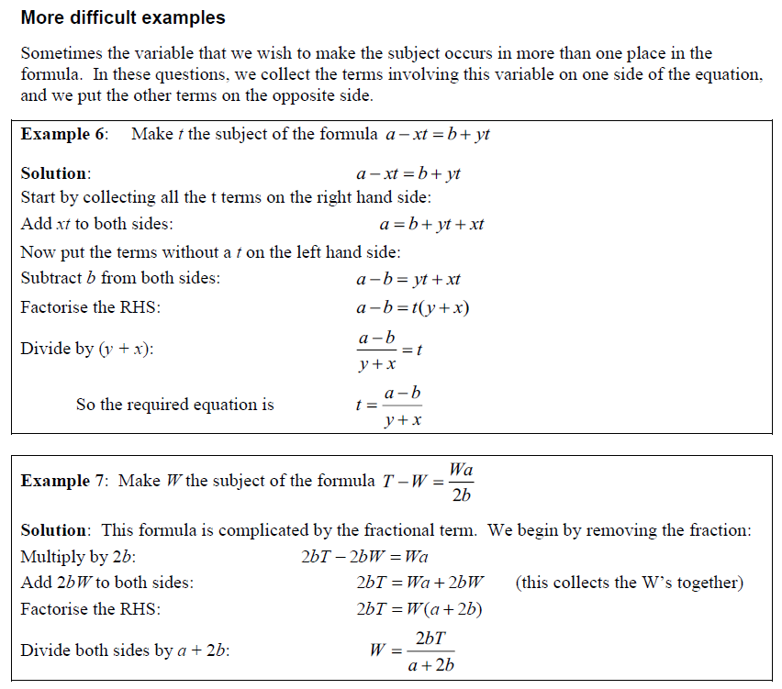
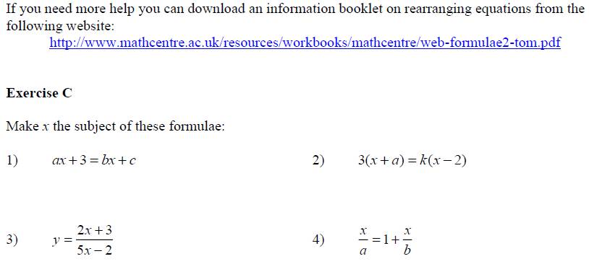
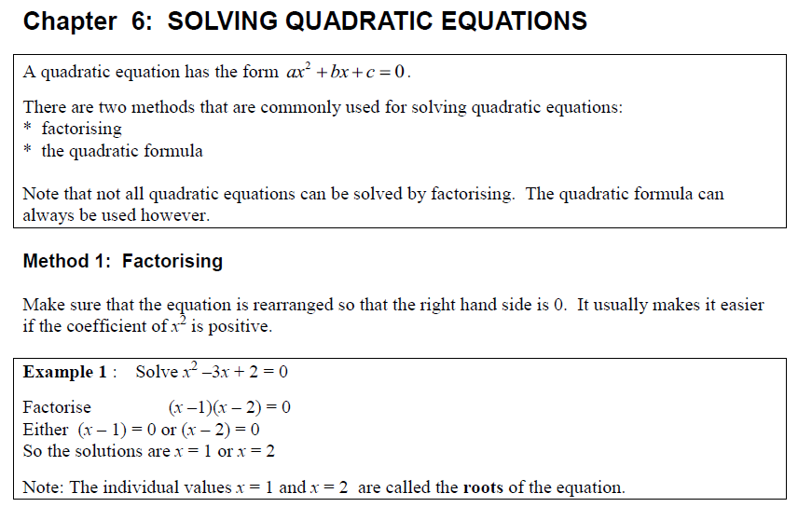
http://www.mymaths.co.uk/tasks/library/loadLesson.asp?title=factorising/solveQuadsByFactoring&t askID=1181
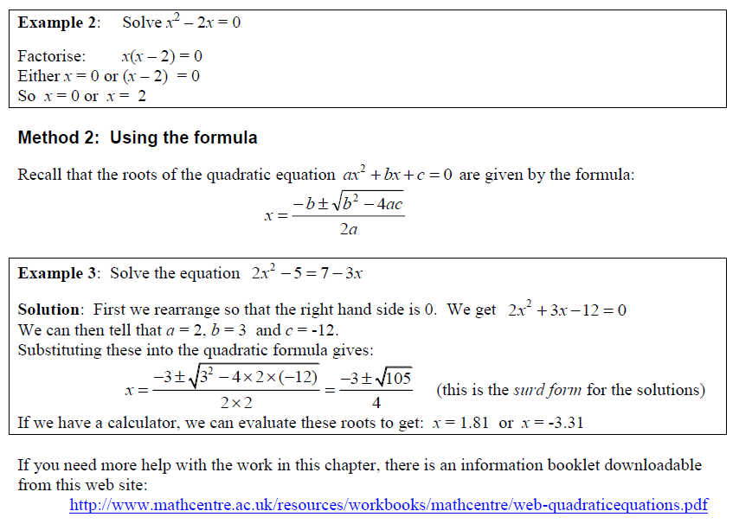
http://www.mymaths.co.uk/tasks/library/loadLesson.asp?title=quadraticformula/formulamovie&taskID=1160
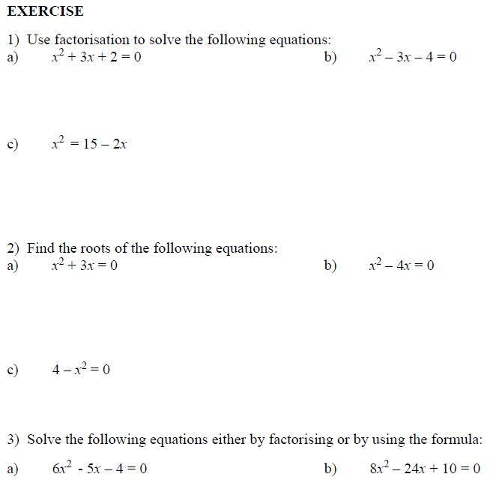
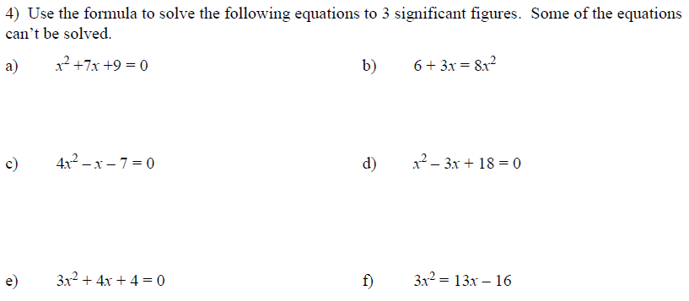
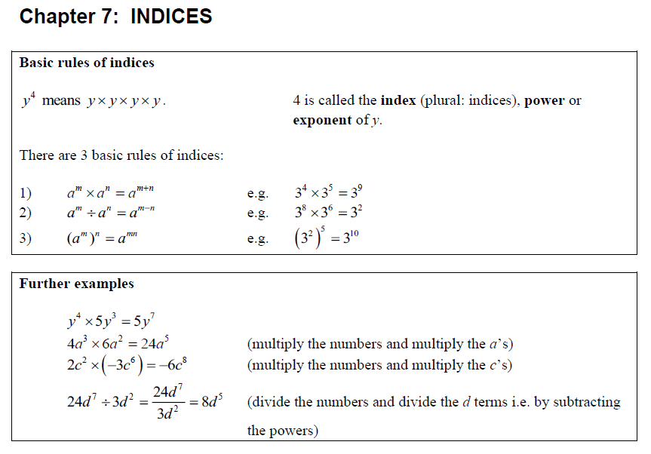
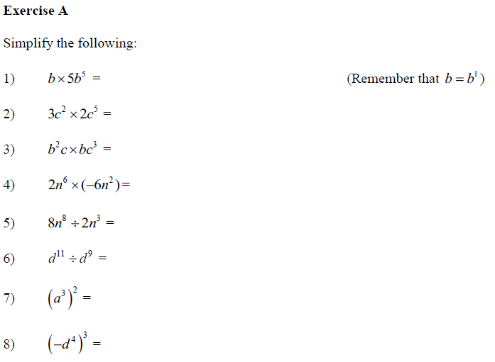
Help: http://www.mymaths.co.uk/tasks/library/loadLesson.asp?title=powers/indicesPart2&taskID= 1045
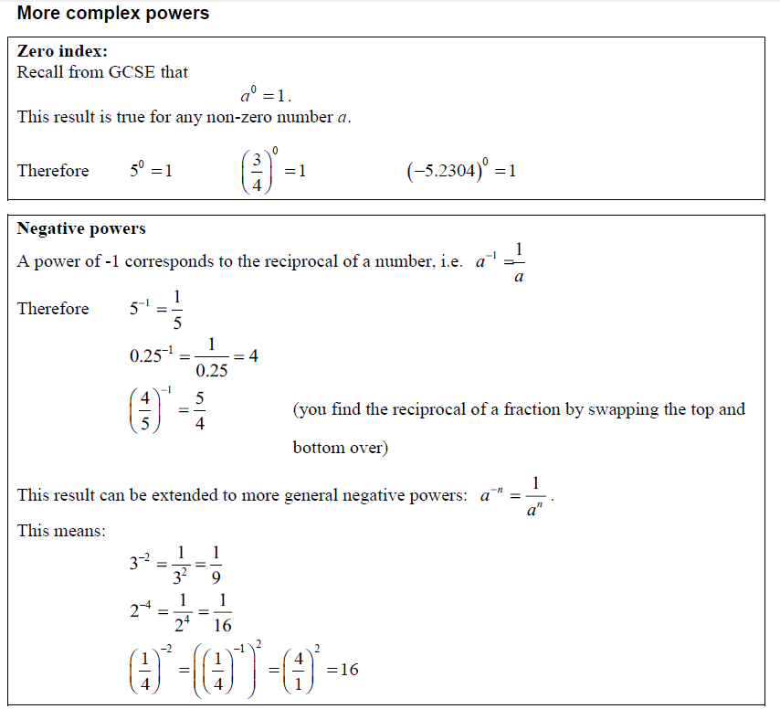
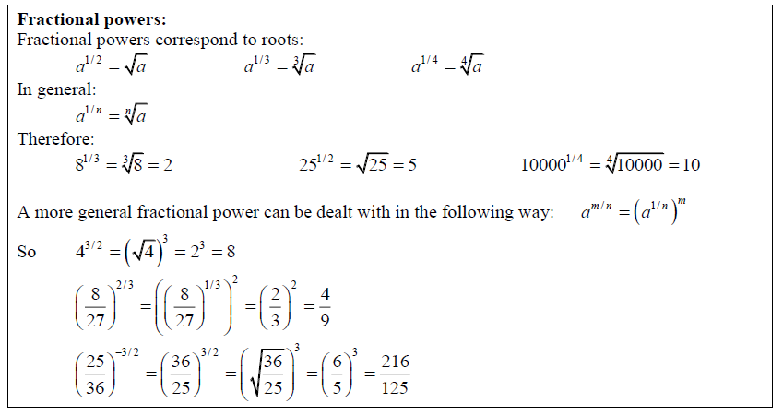
Help: http://www.mymaths.co.uk/tasks/library/loadLesson.asp?title=powers/indicesPart3&taskID=1301
