Year 7 Tutor Time Literacy Booklet

Literacy for Learning: Punctuation
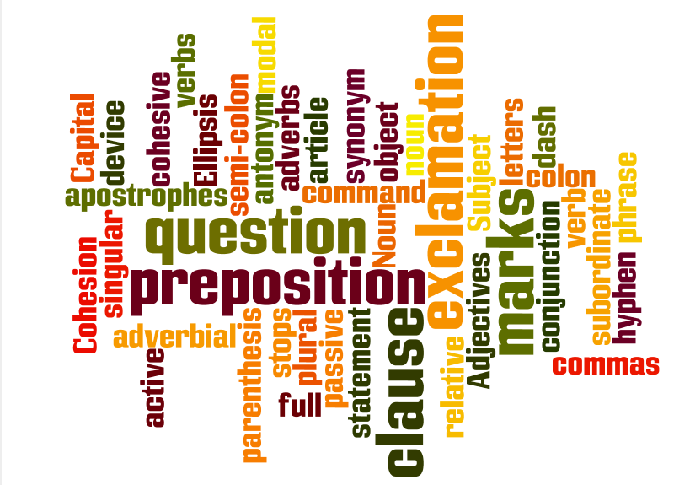
Name:

Tutor group:

Capital letters
Week 1

What is a capital letter and when do I use one?
Rules:
English uses capital letters to point out important words. This is the one element of English grammar that always follows its rules.
Rule 1: All sentences begin with a capital letter, even sentences that only consist of one word.
Rule 2: The proper name, the name of a specific person or thing, begins with a capital letter.
Rule 3: Titles of books, songs, stories, works of art, magazine articles, tests and other written materials must begin with a capital letter. Every other important word of the title must also begin with a capital letter. Words in a title that do not need a capital letter unless they are the first word of the title are a, an, and, of, to, the, etc.
Rule 4: The letter I, when used as a pronoun referring to yourself, must always be written as a capital letter.
Task
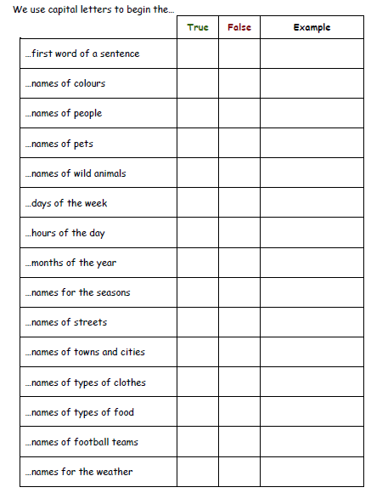
Rule 5: The first word of a direct quotation must begin with a capital letter. For example, "Who's been sleeping in my bed?" Papa Bear cried.
Rule 6: Titles of people when used with their names or in place of their names must begin with a capital letter. For example, My favourite queen is Queen Elizabeth of England.

Capital letters
Week 2

When do we use capital letters?
- At the start of sentences.
- For names of people.
- For names of places.
- Days of the week.
- Months of the year.
- Titles of books, films, songs, plays etc.
- Use of the pronoun ‘I’.
- The first letter inside speech marks: In the distance, I heard someone cry, “Help!”

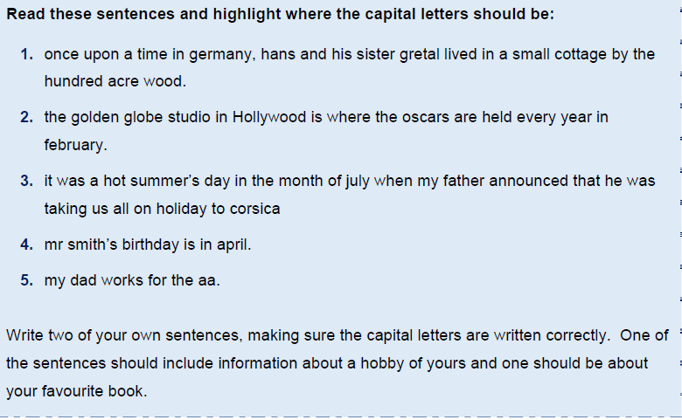
Task

- ___________________________________________________________

- ___________________________________________________________

Capital letters
Week 3
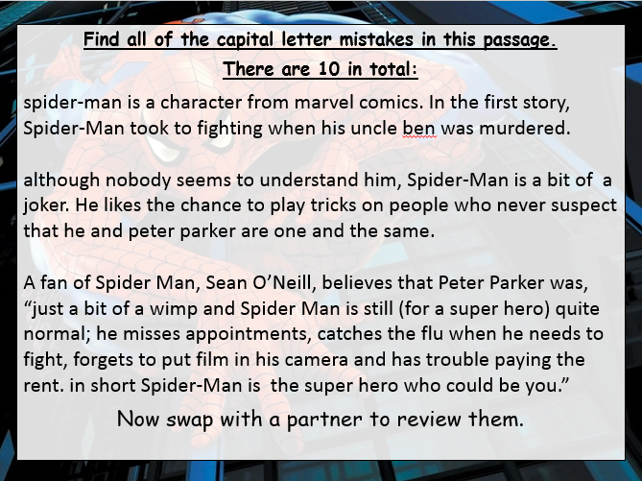
Task

Challenge!
Find an example of each capital letter rule in your reading book or one of your exercise books.

Rule 1: All sentences begin with a capital letter, even sentences that only consist of one word.
Rule 2: The proper name, the name of a specific person or thing, begins with a capital letter.
Rule 3: Titles of books, songs, stories, works of art, magazine articles, tests, and other written materials must begin with a capital letter. Every other important word of the title must also begin with a capital letter. Words that do not need a capital letter unless they are the first word of the title are a, an, and, of, to, the, etc.
Rule 4: The letter I, when used as a pronoun referring to yourself must always be written as a capital letter.
Rule 5: The first word of a direct quotation must begin with a capital letter.
Rule 6: Titles of people when used with their names or in place of their names must begin with a capital letter.

Capital letters
Week 4
Review learning

Record the rules for capital letter use in the box below. You can bullet point them. No cheating!


Progress timeline

How confident are you with capital letters?

Full stops
Week 5
What is a full stop and when do I use one?
Rules:
A full stop is a punctuation mark (.) used at the end of a sentence or an abbreviation.
BEWARE!
Once you have written a sentence, you cannot put a comma and carry on writing. This is called a run-on error. For example:
I love angel cake, it is my favourite.
(run-on error)



Task

Can you add the capital letters and full stops to these sentences? Highlight the words or letters you have changed.

scarlet made her way down the steps to the beach her dog ran behind her wagging its tail when she got to the bottom of the steps scarlet ran to the sea

the waves were breaking on the rocks scarlet decided to make a huge sandcastle her brother came to help her

the tide began to come in the waves came over the sandcastle and washed it away scarlet and her brother went home

jacob stood on the riverbank watching the boats go by he waved to the people as they went past the engines made a quiet chugging noise

mrs hall got the paints out of the store room she put some on each table connor covered the tables with newspaper then karina gave out the aprons
Full stops
Week 6
Task

In each piece of text identify where the full stops and capital letters go. Re-write the sentences correctly underneath.
pandas are members of the bear family they have black and white fur giant pandas are one of the world’s rarest mammals a young panda is called a cub

beavers are rodents that live in North America they can live in water and on land they are powerful swimmers and can stay underwater for up to fifteen minutes a baby beaver is called a kit kits learn to swim when they are about one month old

bottlenose dolphins send messages to each other they do this by squeaking, whistling or slapping their tails on the water dolphins are mammals like us and breathe air like we do they have a poor sense of smell but very good hearing


Challenge!
Full stops
Week 7

Find three examples of a full stop in your reading book or your exercise book. Why have they been used? Are there any times when you have forgotten to use a full stop in your exercise book?
Review learning

Record the rules for a full stop in the box below. No cheating!

Progress timeline

How confident are you with full stops?

Week 8
Question marks

What is a question mark and when do I use one?
Rules:
A question mark comes at the end of a question.
“What are you doing?” asked Mr Baker.
A question mark replaces a full stop at the end of a sentence.
A question mark acts like a full stop - you need a capital letter afterwards.
“Are you going on the school trip? I’m not allowed!”
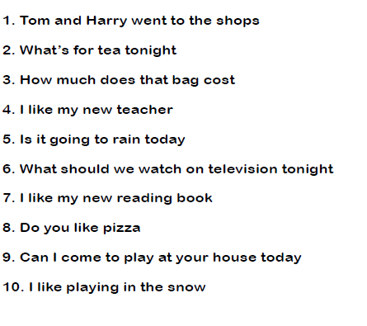
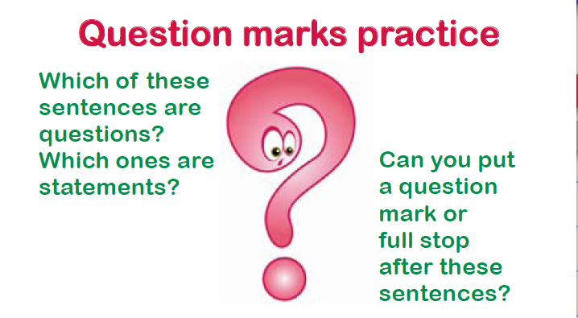
Task

Question marks
Week 9
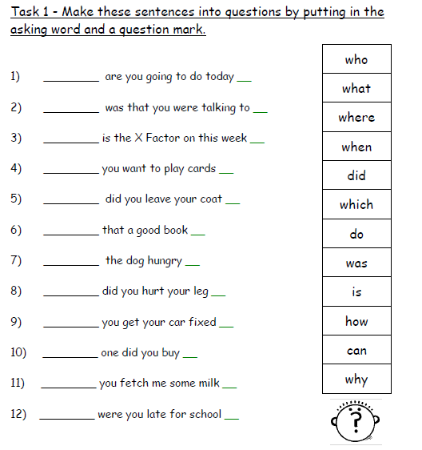
Task

Question marks
Week 10

Task
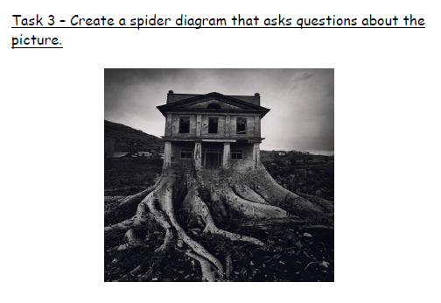

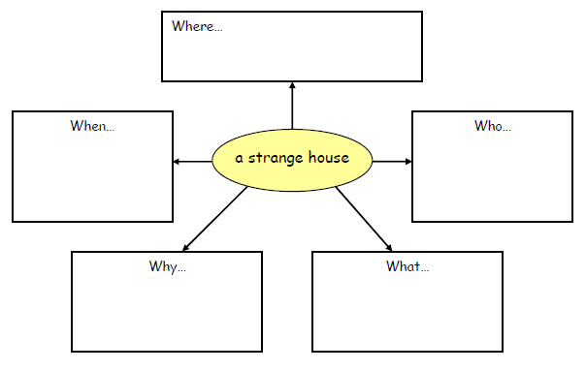

Challenge!
Question marks
Week 11

In your book, find 3 examples of when you have used a question mark and highlight them. Now look for a question mark in your reading book. What rules does it follow?

Review learning

Record the rules for using a question mark in the box below. No cheating!

Progress timeline

How confident are you with question marks?

Week 12
Exclamation marks!

What is an exclamation mark and when should I use one?
Rules:
An exclamation mark is used instead of a full stop when the sentence written needs emphasising, or someone is shouting.

Sometimes, you use an exclamation mark at the end of a sentence.
It shows when you feel strongly about something or when you are surprised.
My birthday party was brilliant!
An exclamation mark can be used when someone is excited or shouting or if they are saying something that's strange or surprising.
“I've just seen a flying pig!” exclaimed Mr Daly.
N.B: Do not use an exclamation mark unless you are certain it is necessary — and never use two or three of them in a row:
Example: This is a sensational result!!!

Task

Re-write the following sentences, adding exclamation marks where necessary.

- “Look out” shouted James to his brother.

- “Ouch” screamed Charlotte.

- What a wonderful surprise that was

- “Tidy your room” shouted mother. “It’s a pig sty”

- Looking out at the golden sunset, Maria exclaimed, “This is the life”

Exclamation marks!
Week 13
Task

Write a dialogue involving an argument. Use exclamation marks when necessary. Your story could begin with the words:

‘You knew I wanted that!’ Tom cried, rising from the chair.

Review learning

Record the rules for using an exclamation mark in the box below. No cheating!

Progress timeline

How confident are you with exclamation marks?

