RSHE
Relationships, Sexual, Health Education



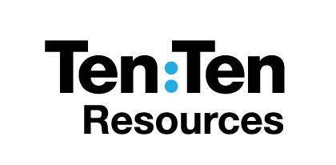
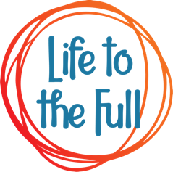
Year 8
Name _______________________________________
Class_________ RE Teacher _____________________
Initial Assessment
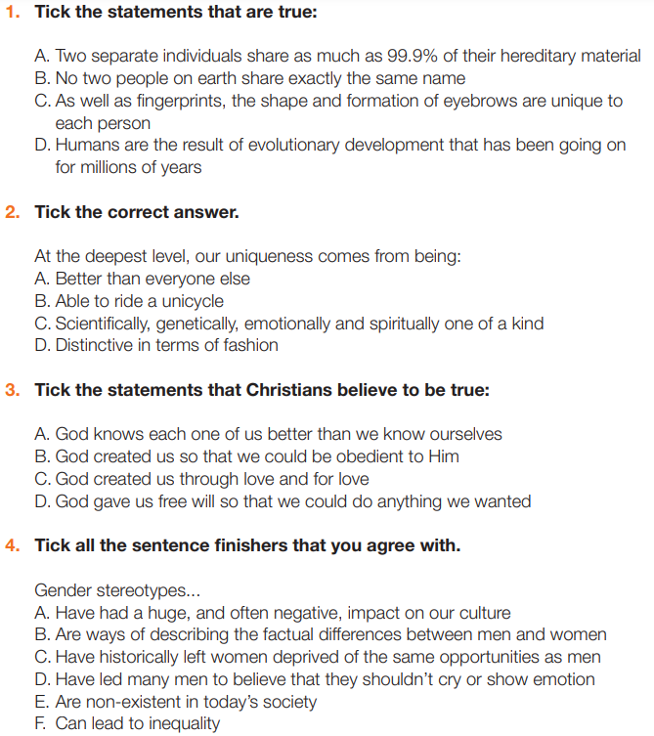
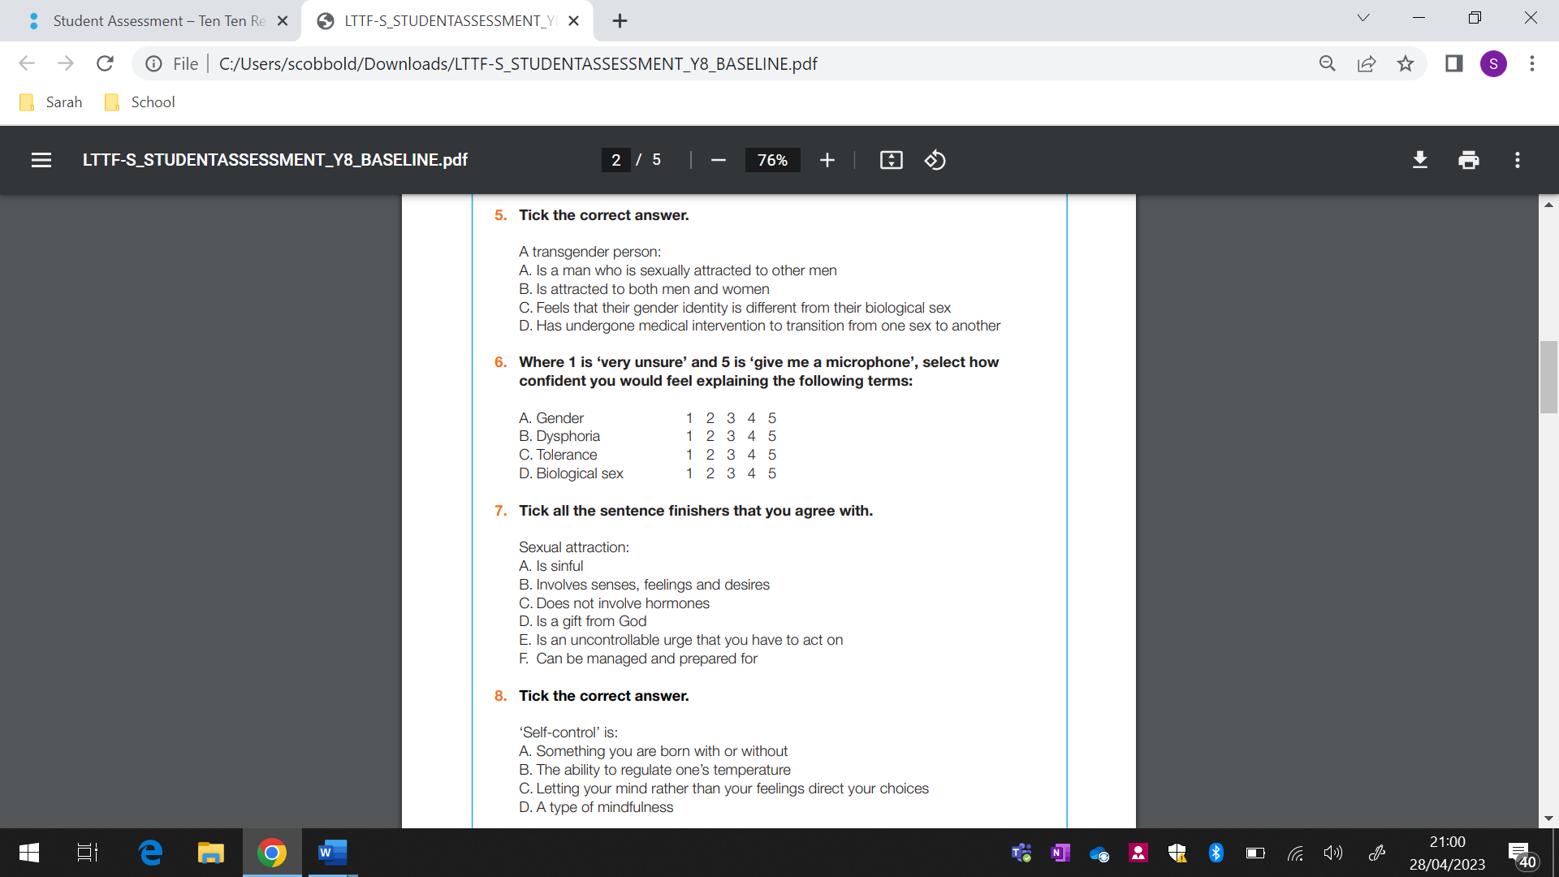

Lesson One – Created and Chosen

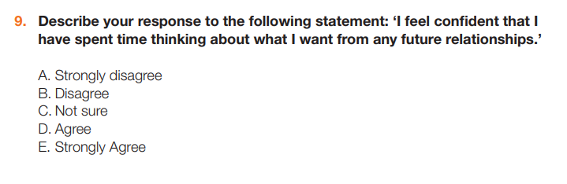

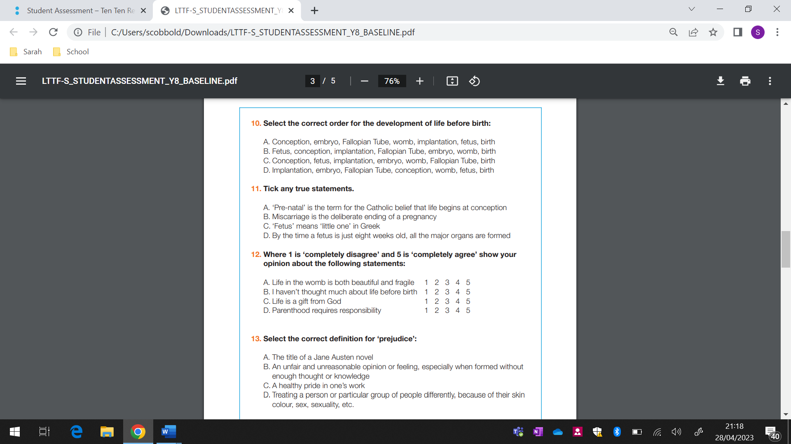

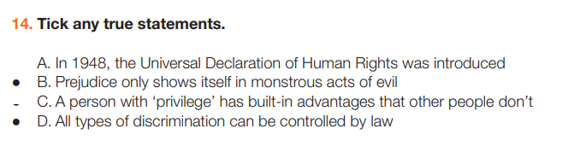

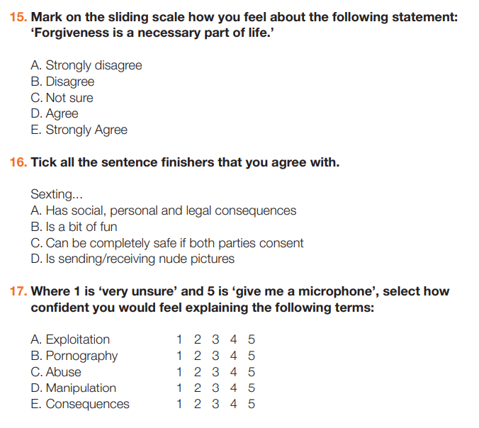

Learning Objective: What makes me unique? Why do I need to be loved?

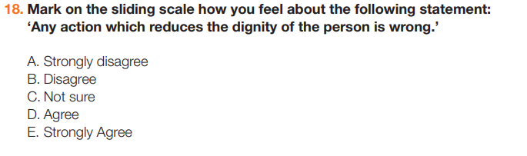

Well done. We will go through the answers at the end of this topic!

Lesson One: Created and chosen
Discussion: What are your 5 guidelines are for talking about difficult topics. Decide as a class.

- _____________________________________________________________________
- _____________________________________________________________________
- _____________________________________________________________________
- _____________________________________________________________________
- _____________________________________________________________________
Discussion:
How can fitting in with the crowd get you in trouble? _____________________________________
__________________________________________________________________________________
__________________________________________________________________________________

How can standing out from the crowd get you in trouble? _________________________________
__________________________________________________________________________________
__________________________________________________________________________________

Extension Discussion:
The above questions refer to people who choose to stand out from the crowd, but how do people who stand out for reasons they don’t choose might feel, e.g. those living with disabilities, or from a different country/region to most of their peers.
Discuss how they might feel and what others can do to be more inclusive.
___________________________________________________________________________
___________________________________________________________________________
___________________________________________________________________________
Look at these scenarios and decide the risks and opportunities of standing out/fitting in.

Scenario | Risks of Standing Out | Opportunities by Standing Out
1

2

3

4

5

6

Lesson Two – Appreciating Difference
Learning Objective: How do people choose to articulate their identity?
Stereotyping of Men v Women
Complete the mind maps below with stereotypes that you have heard about men and women.

Women
Men

Do men and women always live up to their gender stereotypes? Give reasons.
__________________________________________________________________________________
__________________________________________________________________________________
__________________________________________________________________________________

Debate: Prepare your arguments for a debate on the table below.
‘Beyond biology, there is no difference between men and women.’
 | Some would agree with the statement because | Some would disagree with the statement because
Point
Evidence
Explain
Own Opinion
Activity: Define the Following words.
Gender ___________________________________________________________________________
__________________________________________________________________________________
Dysphoria _________________________________________________________________________
__________________________________________________________________________________
Biological Sex ______________________________________________________________________
__________________________________________________________________________________
Tolerance _________________________________________________________________________
__________________________________________________________________________________
Kindness __________________________________________________________________________
__________________________________________________________________________________

Independent Writing:
• Write a list of your own strengths and weaknesses/likes and dislikes.
_________________________________________________________________________________
__________________________________________________________________________________
__________________________________________________________________________________

• What things in your character identity would you like to work on, change and improve?
__________________________________________________________________________________
__________________________________________________________________________________
__________________________________________________________________________________

Lesson Three – Feelings
Learning Objective: How do I manage my changing feelings during puberty?

Do you think the age or gender of the couple changes whether something is right or not? Explain your thoughts below.
__________________________________________________________________________________
__________________________________________________________________________________
__________________________________________________________________________________
Look at this scenario and write a response to it. You need to:
• Reassure the message writer. • Identify if their problem concerns self-control, mutual respect and/or patience. • Identify what senses, feelings and/or desires are at play. • Give advice on how to develop self-control, mutual respect and/or patience.
___________________________________________________________________________
___________________________________________________________________________
___________________________________________________________________________
___________________________________________________________________________
___________________________________________________________________________
___________________________________________________________________________
___________________________________________________________________________
___________________________________________________________________________
___________________________________________________________________________
___________________________________________________________________________

Extension Task:
Why do you think that the Catholic Church teaches that watching porn is not advisable and can be very harmful?
__________________________________________________________________________________
__________________________________________________________________________________
__________________________________________________________________________________
__________________________________________________________________________________
Personal Writing:
Either:
Write a letter to your future self, which involves your hopes for your future relationships.
I hope that you are … I want … for you.
OR
Imagine you are 30 and write a letter to yourself as you are now, offering advice that you wish you had known at 12/13.
I want you to know that… Remember you are…
___________________________________________________________________________
___________________________________________________________________________
___________________________________________________________________________
___________________________________________________________________________
___________________________________________________________________________
___________________________________________________________________________
___________________________________________________________________________
___________________________________________________________________________
___________________________________________________________________________
___________________________________________________________________________
___________________________________________________________________________
___________________________________________________________________________

___________________________________________________________________________
___________________________________________________________________________
___________________________________________________________________________

___________________________________________________________________________
___________________________________________________________________________

___________________________________________________________________________
___________________________________________________________________________
___________________________________________________________________________

___________________________________________________________________________
___________________________________________________________________________

___________________________________________________________________________
___________________________________________________________________________
___________________________________________________________________________
Lesson Four – Before I was born
Learning Objective: What are the different stages of pregnancy? Why is pre-natal care important? What emotional impact does a pregnancy have on all involved?
Answer the questions/tasks below:

Discussion: Pre-Natal care.
What might mums to be do or not do to avoid risking harm to her baby?
___________________________________________________________________________
___________________________________________________________________________
___________________________________________________________________________

Activity:
Read this scenario and answer the following questions:-
• Who acted well/badly? Explain
___________________________________________________________________________
___________________________________________________________________________
___________________________________________________________________________
• What pressures were involved?
___________________________________________________________________________
___________________________________________________________________________
___________________________________________________________________________
• What advice would you give?
___________________________________________________________________________
___________________________________________________________________________
___________________________________________________________________________

Lesson Five – Tough relationships
Learning Objective: What do the ‘Protected characteristics’. Tolerance, forgiveness and kindness look like in real life?

Discussion: Judgement
● When have you felt judged? For what?
___________________________________________________________________________
___________________________________________________________________________
___________________________________________________________________________
● When have you judged others? For what?
___________________________________________________________________________
___________________________________________________________________________
___________________________________________________________________________

Activity: What do you think the 9 Protected Characteristics are?

- ___________________________________________________________________________
- ___________________________________________________________________________
- ___________________________________________________________________________
- ___________________________________________________________________________
- ___________________________________________________________________________
- ___________________________________________________________________________
- ___________________________________________________________________________
- ___________________________________________________________________________
- ___________________________________________________________________________
Extension:
Can you think of a time in history when there has been prejudice and/or discrimination. Write about it below.
___________________________________________________________________________
___________________________________________________________________________
___________________________________________________________________________
___________________________________________________________________________
___________________________________________________________________________
___________________________________________________________________________

Answer:
Why might someone might act with discrimination (e.g. misinformation, prejudice, upbringing, misunderstanding, unconscious privilege etc.)?
___________________________________________________________________________
___________________________________________________________________________
___________________________________________________________________________
How might the person experiencing discrimination feel and how this might affect them.
___________________________________________________________________________
___________________________________________________________________________
___________________________________________________________________________
How can we challenge and stop discrimination from happening?
___________________________________________________________________________
___________________________________________________________________________
___________________________________________________________________________
Extension Task: Define the following words:
Word | Definition
Prejudice

Discrimination

Judgement

Apartheid

Extermination

Human Rights

Protected Characteristics

Privilege

White Privilege

Discussion: ‘It’s not bullying if it’s banter.’ Do you agree?
___________________________________________________________________________
___________________________________________________________________________
___________________________________________________________________________
___________________________________________________________________________
___________________________________________________________________________
___________________________________________________________________________

___________________________________________________________________________

Lesson Six – Think before you share
Learning Objective: What are the consequences of sharing sexual images online and how do I keep myself safe online?

Personal Writing:
What rules can you make to keep yourself safe online?
- ___________________________________________________________________________
- ___________________________________________________________________________
- ___________________________________________________________________________
- ___________________________________________________________________________
- ___________________________________________________________________________
Remember what the video said:
“By making a decision now about what you will and won't share means that you will be stronger and more resilient if you ever think about or are asked to share something in the future.”

True or False Quiz. If you think the answer is false then you need to say why.

Question | True or False | If False, why is it False?
Sexting is illegal in every scenario.

Naked selfies are often shared beyond the desired recipient.

Your digital footprint is wearable tech that goes on your feet.

In the UK the age of consent for sexual intercourse is 17.

It is a criminal offence to make, distribute, possess or show any indecent images of anyone under the age of 18

Once a person has sent a nude picture, there’s nothing they can do to get it back.

If someone is asked to send a nude picture, they must have done something to invite it.

Reflection:
Write three statements starting with the words My Body is……. Think about how important your body is and how you wish to treat yourself and have others treat you.
My body is _________________________________________________________________________
__________________________________________________________________________________
My body is _________________________________________________________________________
__________________________________________________________________________________

My body is _________________________________________________________________________
__________________________________________________________________________________

Lesson Seven – Wider World
Learning Objective: How can I play a part in dismantling prejudice?

What forms of discrimination have you come across in your own life? (This might also include on TV or in the news etc.)
___________________________________________________________________________
___________________________________________________________________________
Activity: Read these scenarios and then pick one and answer the questions below about it:
• What discriminative behaviour is being shown?
___________________________________________________________________________
___________________________________________________________________________
___________________________________________________________________________
• Is it hidden or explicit?
___________________________________________________________________________
• What reasons do you think the perpetrator might have for their discrimination?
___________________________________________________________________________
___________________________________________________________________________
___________________________________________________________________________

• How do you think the person experiencing discrimination might feel? How might this affect them?
___________________________________________________________________________
___________________________________________________________________________
___________________________________________________________________________

• How might this discrimination be challenged? Why might that be difficult?
___________________________________________________________________________
___________________________________________________________________________
___________________________________________________________________________

___________________________________________________________________________
___________________________________________________________________________
Now look back at your initial assessment. Complete it again in a different colour. Your answers may or may not have changed. Your teacher will then go through the answers with you.

