RSHE
Relationships, Sexual, Health Education


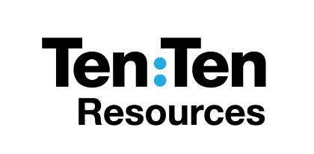
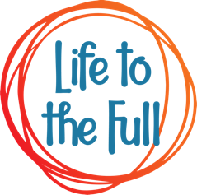
Year 9
Name _______________________________________
Class_________ RE Teacher _____________________
Initial Assessment
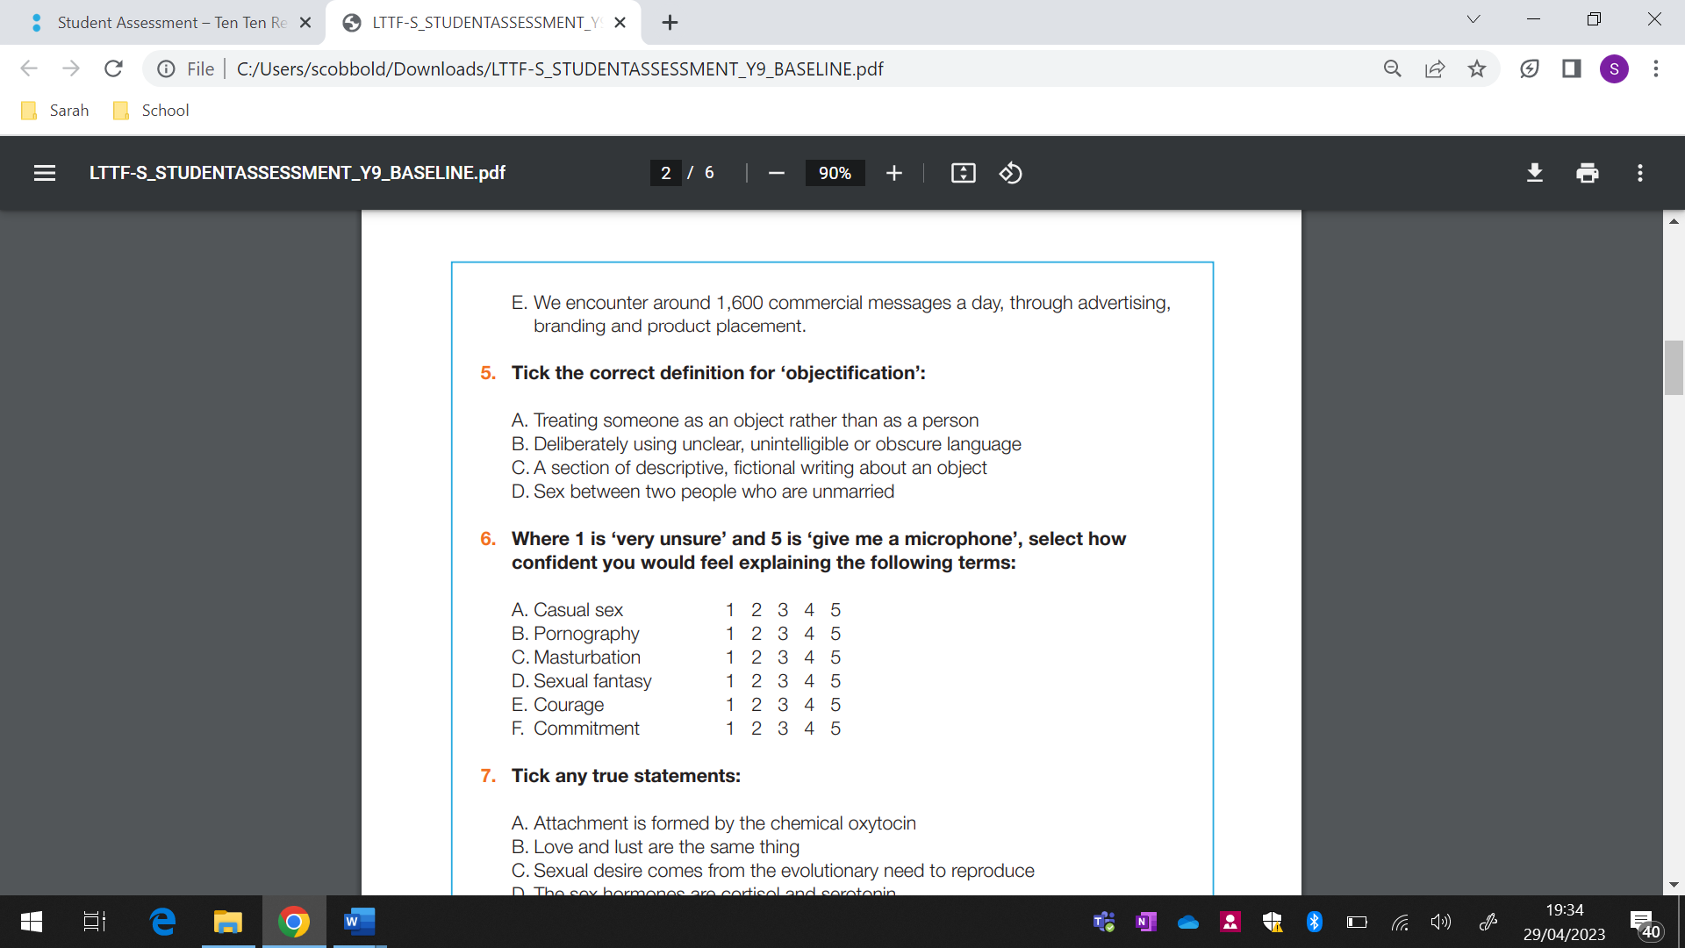
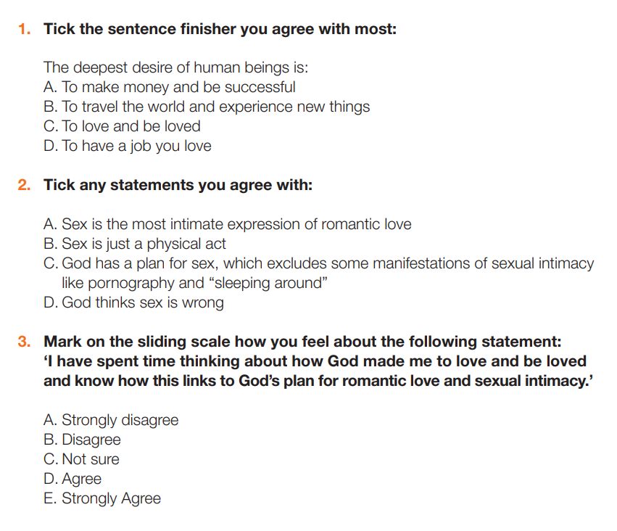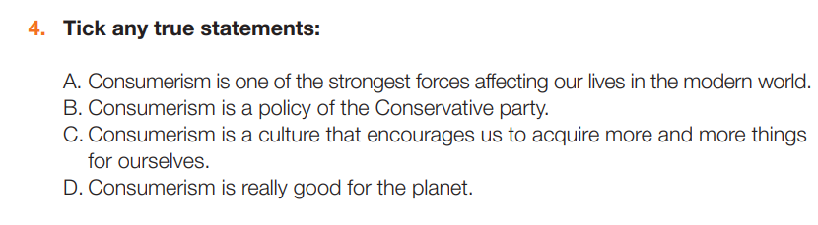

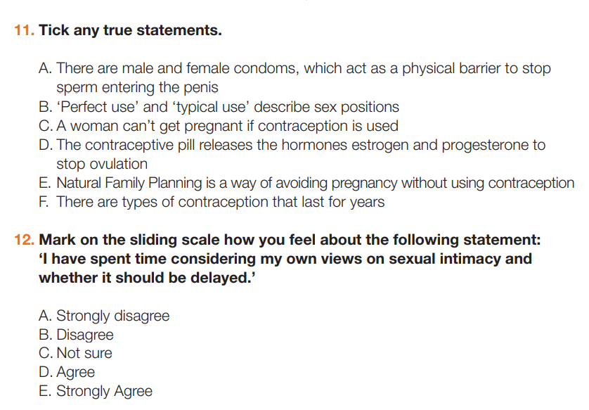
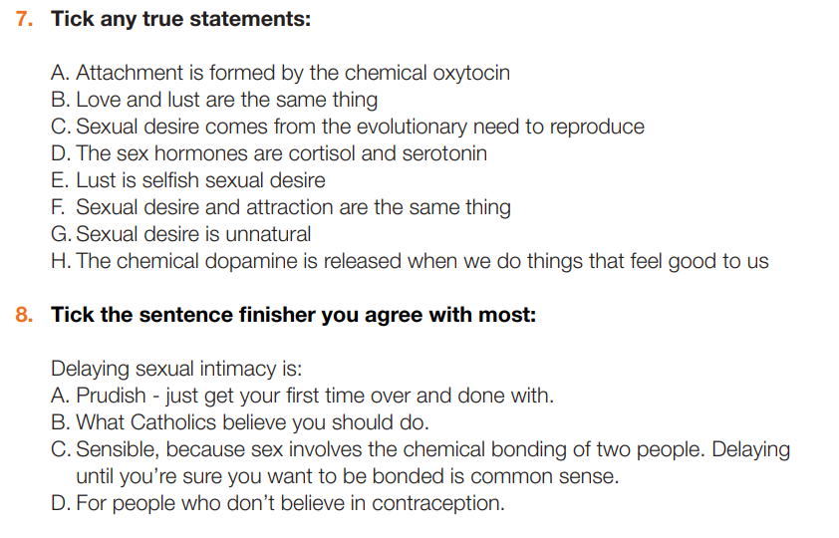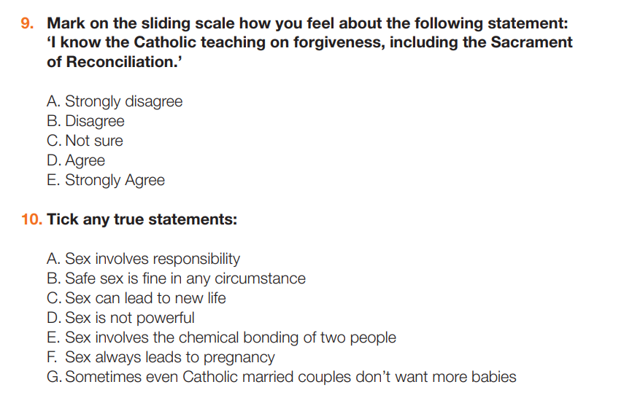

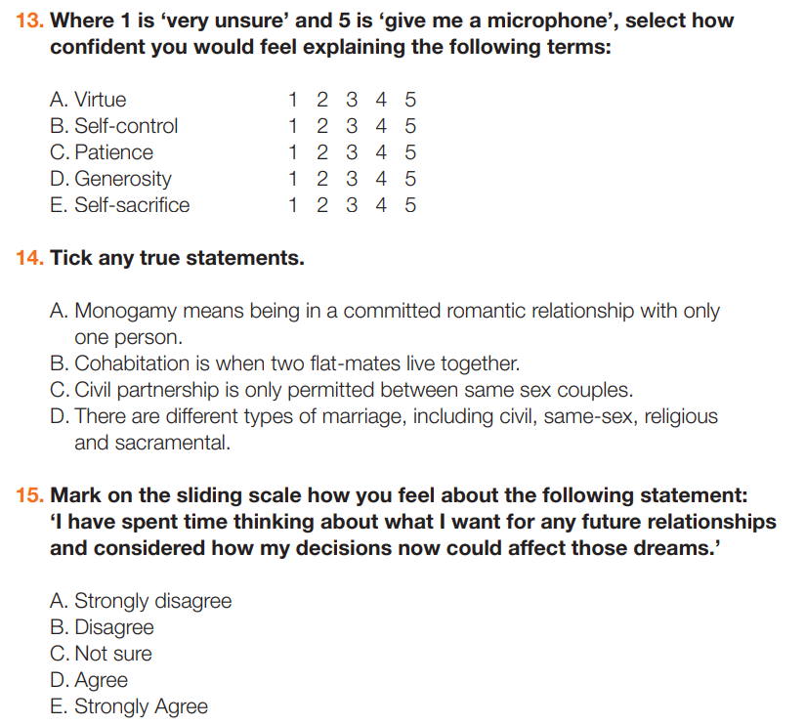
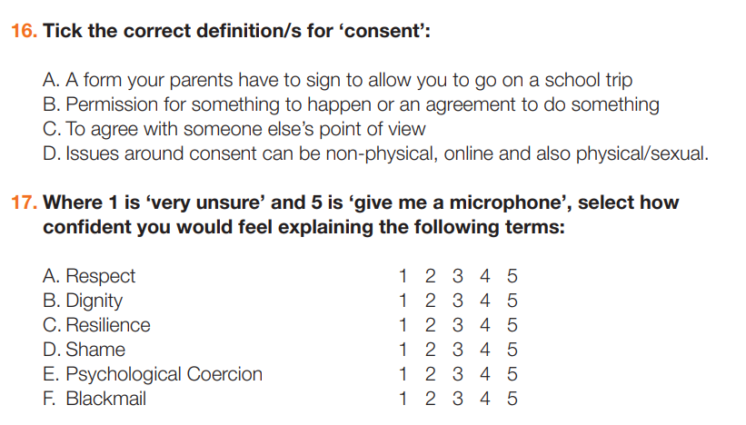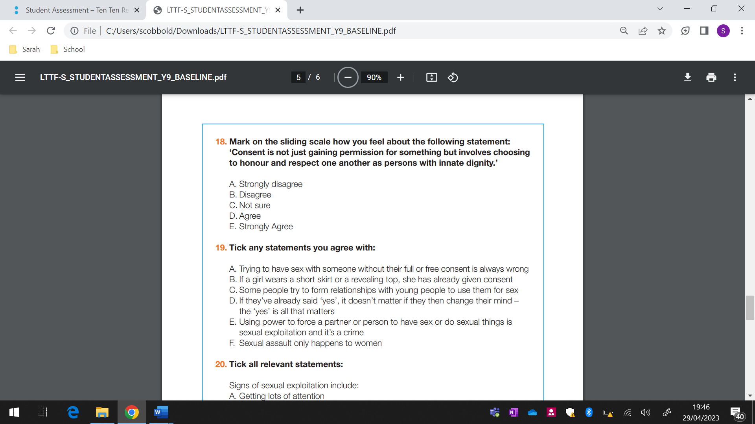
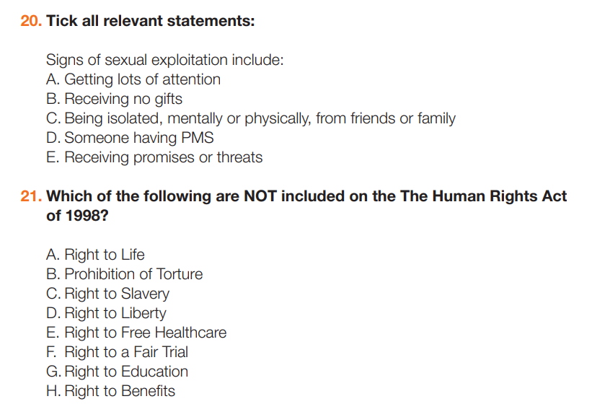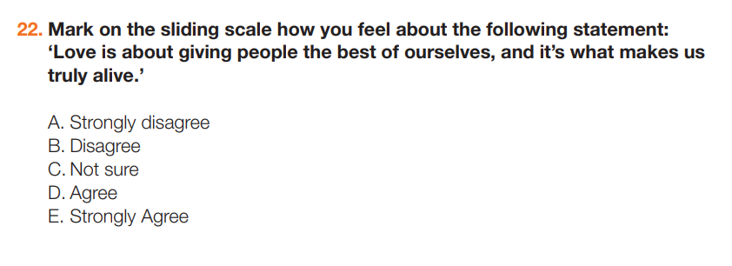
Well done. We will go through the answers at the end of this topic!

Lesson One – The search for love
Learning Objective: What is God’s plan for romantic love, sexual attraction and intimacy?
Prayer:
Dear Lord,
Open my heart and mind to your voice speaking to me throughout this lesson and throughout this day. Teach me your ways and bring me closer to you. Amen

Discussion: Jesus says, “I have come that they may have life, and have it to the full.” (John 10:10)
What do you think it means to have ‘life to the full’?
___________________________________________________________________________
___________________________________________________________________________
___________________________________________________________________________

Discuss as a class and then come up with 5 agreed ground rules for talking about relationships and sex within your class. Write these 5 rules below:
1._________________________________________________________________________
2._________________________________________________________________________
3._________________________________________________________________________
4._________________________________________________________________________
5._________________________________________________________________________
Discussion:
What is sex for?
___________________________________________________________________________
___________________________________________________________________________
Personal Writing:
How can you show love to the people who you come into contact with every day? Think of practical ways.
___________________________________________________________________________
___________________________________________________________________________
___________________________________________________________________________

Discussion: Choose one of the statements below, circle it and then write a response.
● Why do you think romantic comedies are so popular?
● What is romantic love?
● Do you agree that marriage is the ‘ultimate romance’?
● What is meant by the ‘gift of self’?
● ‘Sex is just a physical act’ - agree or disagree?
● ‘You should never ignore feelings of sexual attraction’ - discuss
___________________________________________________________________________
___________________________________________________________________________
___________________________________________________________________________
___________________________________________________________________________
___________________________________________________________________________

How does the idea of God loving you make you feel? ___________________________________________________________________________
___________________________________________________________________________
___________________________________________________________________________
___________________________________________________________________________
___________________________________________________________________________
Lesson Two – Love people, use things
Learning Objective: Why can pornography, masturbation and casual sex be harmful?

Discussion:
What is your favourite possession, think about how you treat it and why it is so special to you.
___________________________________________________________________________
___________________________________________________________________________
___________________________________________________________________________

Is it ever ok to use another person?
___________________________________________________________________________
___________________________________________________________________________
___________________________________________________________________________
Discussion:
Okay, now he was close
Tried to domesticate you
But you're an animal
Baby, it's in your nature (meow)
Just let me liberate you (hey, hey, hey)
You don't need no takers (hey, hey, hey)
That man is not your maker (hey, hey, hey)
And that's why I'm gon' take a good girl (everybody get up)
(Blurred Lines – Robin Thicke ft. TI and Pharrell)

Look at the song lyrics above, then answer the following questions.
● How they make you feel? Why?
___________________________________________________________________________
___________________________________________________________________________
___________________________________________________________________________

● How do you think they are objectifying?
___________________________________________________________________________
___________________________________________________________________________
___________________________________________________________________________

● Do the songs mainly objectify women or men? Why?
___________________________________________________________________________
___________________________________________________________________________
___________________________________________________________________________

Extension:
Write a list of ways that you could uphold your dignity e.g. exercise, hygiene, self-care, bodily acceptance etc.
___________________________________________________________________________
___________________________________________________________________________
___________________________________________________________________________

Read one of these scenarios and write a response to it.
___________________________________________________________________________
___________________________________________________________________________
___________________________________________________________________________
___________________________________________________________________________
___________________________________________________________________________
___________________________________________________________________________
___________________________________________________________________________
___________________________________________________________________________
___________________________________________________________________________

___________________________________________________________________________
___________________________________________________________________________
___________________________________________________________________________

Reflection:
Write a pledge about the way you will change the way you treat others as a result of today’s lesson.
___________________________________________________________________________
___________________________________________________________________________
___________________________________________________________________________

Lesson Three – In control of my choices
Learning Objective: How do I make wise, informed and mindful choices about sexual intimacy?

Discussion:
What is the difference between love and lust?
___________________________________________________________________________
___________________________________________________________________________
Personal Writing:
Choose one of the statements below and write a response to it.
● Write about a situation, big or small, that you regret and how you dealt with that shame/guilt/regret.
● What steps could you take to avoid regretting your actions, sexually or otherwise?
● Write a list of features of future relationships you aspire to.
● Describe how your views on sex and relationships have changed.
● Identify your core values - the lenses through which you see the world (e.g. everyone is worthy of respect). How do these affect your choices?
___________________________________________________________________________
___________________________________________________________________________
___________________________________________________________________________
___________________________________________________________________________
___________________________________________________________________________
___________________________________________________________________________
___________________________________________________________________________
___________________________________________________________________________
___________________________________________________________________________
___________________________________________________________________________
___________________________________________________________________________
___________________________________________________________________________
___________________________________________________________________________
___________________________________________________________________________
___________________________________________________________________________
Lesson Four – Fertility and contraception
Learning Objective: What is a contraceptive and what are God’s views on their use?
Discussion:
Complete the mind map.
Who or what are you responsible for?

Discussion:
Think about pop songs or TV programmes that you are familiar with. Do you think they describe sex well? Give reasons for your answers.
___________________________________________________________________________
___________________________________________________________________________
___________________________________________________________________________

Extension Task:
When do you think life begins? What impact does your answer have on the use of contraception?
___________________________________________________________________________
___________________________________________________________________________
___________________________________________________________________________

___________________________________________________________________________

___________________________________________________________________________
Group Activity:
Answer these questions below.
• What is NFP and how does it work?
___________________________________________________________________________
___________________________________________________________________________
• Is it reliable for postponing pregnancy, even for women with irregular cycles? Why/why not?
___________________________________________________________________________
___________________________________________________________________________
• What’s the difference between artificial contraception and NFP?
___________________________________________________________________________
___________________________________________________________________________
• What are the benefits and drawbacks of NFP?
___________________________________________________________________________
___________________________________________________________________________
• Where can a couple learn about NFP?
___________________________________________________________________________
___________________________________________________________________________

Extension Task:
Evaluate the following statement:
“The use of contraception is wrong”
___________________________________________________________________________
___________________________________________________________________________
___________________________________________________________________________
___________________________________________________________________________
___________________________________________________________________________
Lesson Five – Marriage
Learning Objective: What kind of a relationship would you like in the future?

Discussion:
What are you committed to? How do you show your commitment?
___________________________________________________________________________
___________________________________________________________________________
___________________________________________________________________________

Discussion:
What are the qualities of a committed relationship?

Qualities of a committed relationship

Extension Activity:
How does commitment vary in different relationships?
Does commitment enrich your life or hold it back?
___________________________________________________________________________
___________________________________________________________________________
___________________________________________________________________________

___________________________________________________________________________

Read the definitions of different types of relationships and then summarise each definition and record in your own words in the table.

Word | Definition
Monogamy
Co-habitation
Civil Partnership
Marriage
Same Sex Marriage
Civil Marriage
Religious Marriage
Christian Marriage
Sacramental Marriage
Arranged Marriage
Forced Marriage

Lesson Six – One hundred percent
Learning Objective: What is consent?

Discussion:
Is it ever ok to take something without permission? Give reasons.
___________________________________________________________________________
___________________________________________________________________________
___________________________________________________________________________
In Pairs:
Discuss how can you stay safe online? Mind map your thoughts below.

How can I stay safe Online?

Is true consent gained for each of these scenarios? Explain your answers below each.
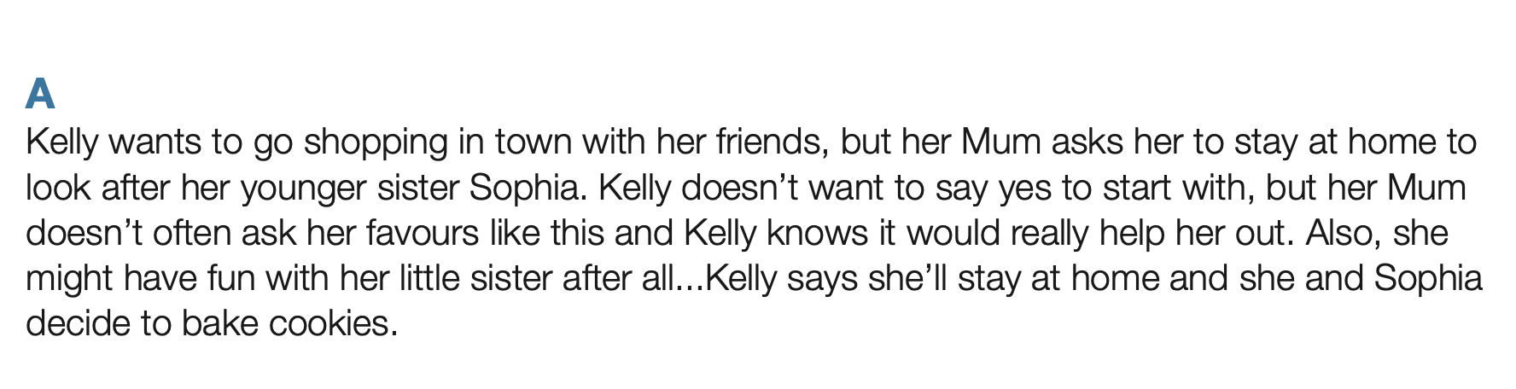
___________________________________________________________________________
___________________________________________________________________________
___________________________________________________________________________

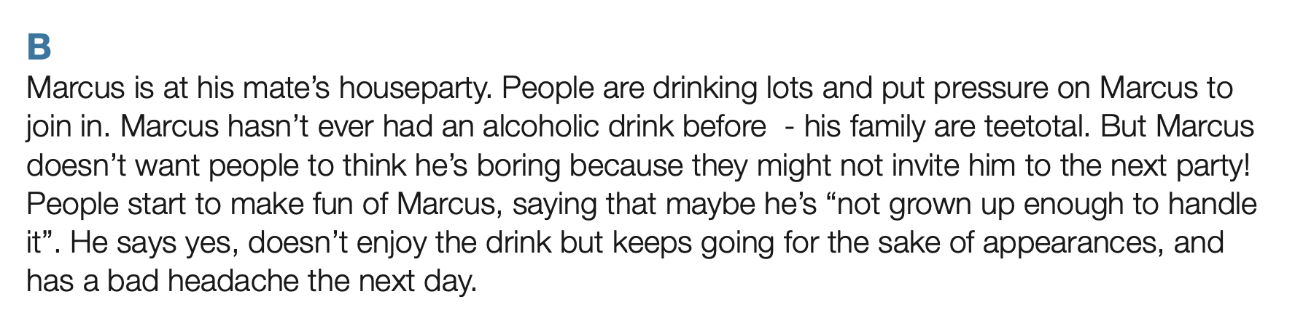
___________________________________________________________________________
___________________________________________________________________________
___________________________________________________________________________
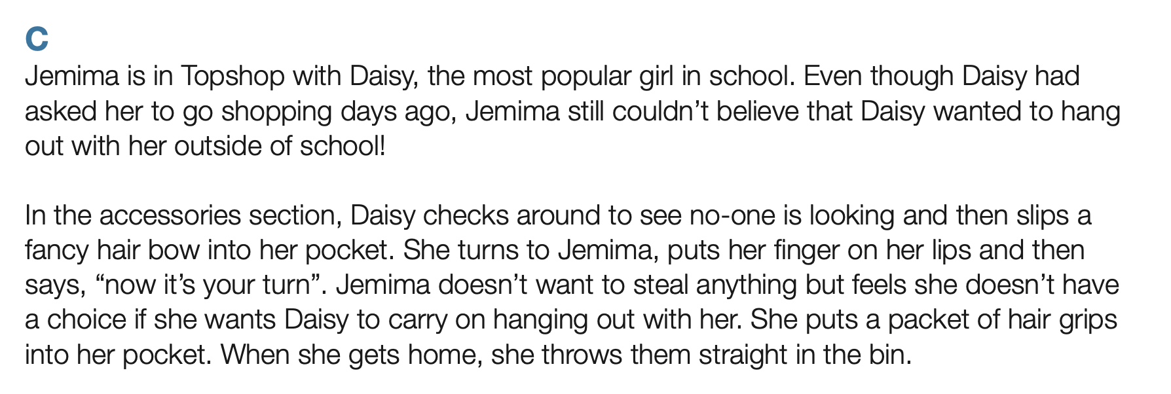
___________________________________________________________________________
___________________________________________________________________________
___________________________________________________________________________
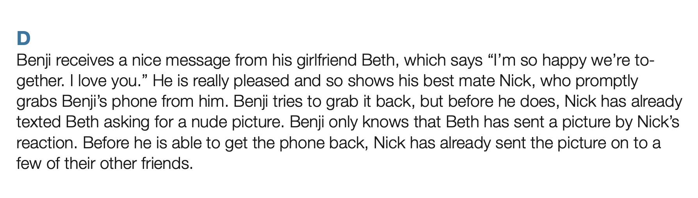
___________________________________________________________________________
___________________________________________________________________________
___________________________________________________________________________
Lesson Seven – Knowing my rights and responsibilities
Learning Objective: What is physical consent, sexual exploitation and human rights?

Discussion:
What do you think about what Nathan and Mairi said in the video?
___________________________________________________________________________
___________________________________________________________________________
___________________________________________________________________________

Group Activity:
Read and discuss these scenarios.

Look at these rights below from the 1998 Human Rights Act. Which ones do you think are the most important and why? Complete the Diamond 9 below and be ready to justify your answers to the class. (Put the ones you think are the most important at the top down to the least at the bottom and the others in the middle).
15 Rights from the Human Rights Acts 1998

- Right to life
- Prohibition of torture
- Prohibition of slavery
- Right to liberty and security
- Right to a fair trial
- No punishment without law
- Right to a private and family life
- Freedom of thought, conscience and religion
- Freedom of Expression
- Right to protest and freedom of association
- Right to Marry
- Right not to be discriminated against
- Right to property
- Right to education
- Right to vote

Extension Activity:
Discuss one of the statements below and record your thoughts.
● Should an illegal immigrant who is also a criminal be allowed to stay in Britain because their sexuality means they would be tortured in their own country?
● Should prisoners be given the right to vote?
● Should mosquito devices (high pitched sounds that only babies and children can hear and are used to prevent young people congregating outside shops) be made illegal?
● Given the rise in knife crime, should teachers have extra powers to search students?
___________________________________________________________________________
___________________________________________________________________________
___________________________________________________________________________
___________________________________________________________________________
___________________________________________________________________________
___________________________________________________________________________
___________________________________________________________________________
___________________________________________________________________________

Personal Writing:
How can you give the best of yourself this week at school, at home, in the community?
___________________________________________________________________________
___________________________________________________________________________
___________________________________________________________________________
___________________________________________________________________________
___________________________________________________________________________
Now look back at your initial assessment. Complete it again in a different colour. Your answers may or may not have changed. Your teacher will then go through the answers with you.

