RSHE
Relationships, Sexual, Health Education

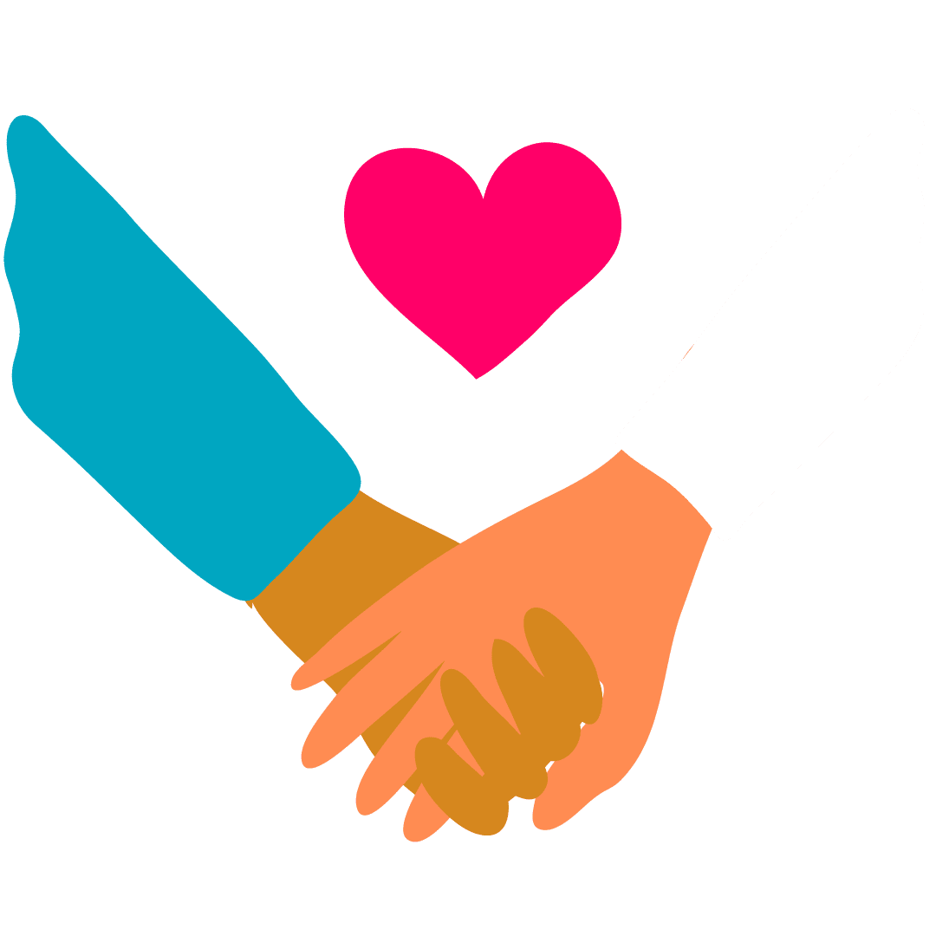
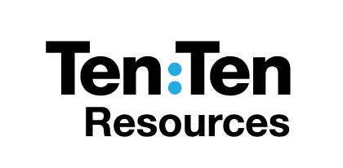
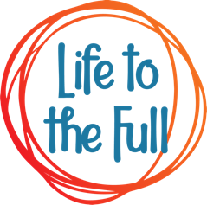
Year 10
Name _______________________________________
Class_________ RE Teacher _____________________
Lesson One – Authentic Freedom
Learning Objective: What do you think about sex and how might this affect your relationship?
Discussion questions
1. Do you think Abi felt pressure to have sex with Cal? Do you think Cal was under any pressure to ask Abi to have sex with him? Explain what pressures they might have felt.
__________________________________________________________________________________
__________________________________________________________________________________
2. Do you think Cal and Abi were emotionally ready to have sex? Explain
__________________________________________________________________________________
__________________________________________________________________________________
3. Do you think Cal and Abi were being responsible? Give reasons
__________________________________________________________________________________
__________________________________________________________________________________
TRUE or FALSE? Tick the relevant box depending on your point of view
Statement | True | False
The pressure to lose your virginity is immense
Sex and regret go together
Sex and responsibility go together
Having sex is a sign of maturity
Expressing true love ought to be the main purpose for sex
Saving sex for marriage is a sign of strength

What are the most common reasons why teenage relationships end.
___________________________________________________________________________
___________________________________________________________________________

Consider the following statement:
‘Sex bonds two people together and it can lead to pregnancy. Bearing this in mind, what are the pros and cons of bringing sex into a relationship?’
Lesson Two – Self-Image
Learning Objective: What do I think about my body image?
Discussion Questions:
1. Was Ayesha right to buy new clothes for her date? Justify your answer ______________________
__________________________________________________________________________________
2. Was Ruby right to say to Ayesha that boys will only think about one thing when girls dress like that? _____________________________________________________________________________
__________________________________________________________________________________
3. Who was the most confident character in the story and why? ______________________________
__________________________________________________________________________________
Look at these statements. Discuss the arguments for and against each.
• Wanting to look good, especially for someone else, is vain and wrong.
• Body shame applies to girls more than boys.
• Modesty is an outdated word to describe 1950s housewives.
• Beauty is only skin deep.
• There is no difference between love and lust.

Look at these statements. Which of them do you think describes a confident person? Number each of them with 1 being the best sign of a confident person and 9 the least sign.
- Has loads of Instagram followers
- Someone skinny/muscly who wears expensive clothes
- Gets good grades
- Knows when to speak and when to listen
- Is respected by others
- Can take a joke at their own expense
- Stands by their opinions but is willing to change their views when presented with new evidence
- Is loud and outgoing
- Is content and secure in themselves

Summarise: A confident person is ______________________________________________________
__________________________________________________________________________________
Lesson Three – Values, attitudes, beliefs
Learning Objective: How are values, attitudes and beliefs crucial in helping me make choices in life?
1. What motivated Lewis to ask Mo to steal the muffin? ____________________________________
__________________________________________________________________________________
2. Why did Mo do what Lewis asked him to do? ___________________________________________
__________________________________________________________________________________
3. What happened to Mo that led to him changing his mind? ________________________________
__________________________________________________________________________________

Discuss these statements:
• How can a person increase their confidence, integrity and understanding in order to stand by what they believe to be true?
• How can a person resist peer pressure?
• How does a person know what they truly believe?
• Why shouldn’t a person just do whatever they want in a given moment?

Personal Writing
1. What are the beliefs that you hold to be true? What values are important to you? _____________
__________________________________________________________________________________
__________________________________________________________________________________
2. How have you tried to live by these beliefs and values? Can you give any examples? ___________
__________________________________________________________________________________
__________________________________________________________________________________

3. Would you stake your life on these beliefs and values as Sophie Scholl did? ___________________
__________________________________________________________________________________
Lesson Four – Parenthood
Learning Objective: How does the 1959 Declaration of the Rights of the Child show me what my legal responsibility would be as a parent?
Discussion
1. Was Milly right to be embarrassed by her Dad? _________________________________________
__________________________________________________________________________________
2. Was Milly’s Dad giving her lifts to ballet out of love, or out of obligation? ____________________
__________________________________________________________________________________
3. How did Milly and her Dad change by the end of the drama? ______________________________
__________________________________________________________________________________
Look at the list below. Plot the letter of each statement on the number line below, with 1 meaning “it is the complete responsibility of the child” and 10 being “it is the complete responsibility of the parent”.
- Committing crime
- Bad behaviour e.g. bullying
- Under-age drinking
- Under-age sex
- Watching films that are classified as too old for them
- Playing games that are classified as too old for them
- Watching too much TV
- Downloading music illegally
- Bad habits e.g. smoking
- Eating too much junk food
- Not exercising enough
Complete child responsibility Complete parental responsibility
1 2 3 4 5 6 7 8 9 10
Look and discuss these questions:
• What do your own parents/carers/parental figures mean to you? Can you think of a time when they have sacrificed something for you?
• What impact might separation or divorce have on children, including their own aspiration and hopes for their own family?
Lesson Five – Pregnancy and abortion
Learning Objective: What happens after conception and is abortion a good idea?
Discussion:
1. Do you think Holly wanted to keep the baby? How do you know? ___________________________
__________________________________________________________________________________
2. Why did Lucy oppose it? ____________________________________________________________
__________________________________________________________________________________
3. What advice would you give to Holly, Lucy and Muzza? ___________________________________
__________________________________________________________________________________
Discussion task:
1. Would you say that your own life is valuable? Give a reason. ______________________________
__________________________________________________________________________________
2. Do you think your life began before you were born? If so, how long before you were born? Explain. ___________________________________________________________________________
__________________________________________________________________________________
3. Do you think abortion takes away life? ________________________________________________
__________________________________________________________________________________
True or False?

Lesson Six – Abuse
Learning Objective: What are the main types of abuse and how to look out for danger signs.
Discussion
1. Did Harrison do anything to deserve the treatment he received? ___________________________
__________________________________________________________________________________
2. In what ways did Keira try to manipulate Harrison?______________________________________
__________________________________________________________________________________
3. Was Jaycee right to say that Keira was trying to control Harrison? __________________________
__________________________________________________________________________________
4. What advice would you give to Harrison/Keira/Jaycee? __________________________________
__________________________________________________________________________________

What do you think some of the reasons might be why abusers abuse others?
1.
2.
3.
What are some of the features of an abusive relationship?

___________________________________________________________________________

What should someone do if they think they are in an abusive relationship?
___________________________________________________________________________

What could someone do if they were concerned that their friend was in an abusive relationship?
___________________________________________________________________________
Lesson Seven – Solidarity
Learning Objective: How does acting on my beliefs affect the world around me?
Discussion:
1. What was Gracie’s motivation to help with the food bank and did it change? _________________
__________________________________________________________________________________
2. Jerome ended up apologising for being ‘a bit harsh’. What do you think was going on under the surface for him?
___________________________________________________________________________
__________________________________________________________________________________
3. What do you think Milly’s Dad (Tony) meant when he said the food bank was a ‘sticking plaster’?
__________________________________________________________________________________
__________________________________________________________________________________

4. What advice would you give to Gracie/Jerome/Tony? ___________________________________
__________________________________________________________________________________
Reflection:
Nathan quoted a Christian writer, who said, ‘Not to enable the poor to share in our goods is to steal from them. The goods we possess are not ours, but theirs.’ Respond personal writing, describing whether you agree or disagree and how this belief might affect a person’s behaviour, career choices, politics etc.
__________________________________________________________________________________
__________________________________________________________________________________
__________________________________________________________________________________
__________________________________________________________________________________
__________________________________________________________________________________

Extension Task 1
Independent Writing
• I’m grateful for my body because _____________________________________________________
__________________________________________________________________________________
• I know that I have dignity because ____________________________________________________
__________________________________________________________________________________
• I choose to see other people not as objects to be lusted after, but as ________________________
__________________________________________________________________________________
• ‘Modesty’ means __________________________________________________________________
__________________________________________________________________________________
• My self-image is ___________________________________________________________________
__________________________________________________________________________________
• To express a deeper respect for myself and others, I can change my behaviour (how I dress, speak, act etc) by _________________________________________________________________________
__________________________________________________________________________________

Extension task
Body insecurities come about by _______________________________________________________
__________________________________________________________________________________

One thing I am going to do to respect myself and others more is _____________________________
__________________________________________________________________________________

Extension Task 2
Write definitions for these words:

• Abuse _____________________________________________________

• Control ____________________________________________________

• Physical abuse _______________________________________________

• Emotional abuse ______________________________________________

• Sexual abuse _____________________________________________________

• Neglect of a child __________________________________________________

• Coercive control ______________________________________________________

• Insecurity ___________________________________________________________

• Selfishness ___________________________________________________________

• Anger ________________________________________________________________

• Entrapment ______________________________________________________________

• Manipulation _____________________________________________________________

• Sexual grooming ____________________________________________________________

Assessment


