Planning Permission Granted for New Sixth Form Building

We are very pleased to announce that planning permission has been granted for the new Sixth Form Building. Planning and works meetings have already taken place and the work is scheduled to start during the summer with completion expected in the Autumn.
Mrs Senior made the following comments, “As a long-standing provider of excellent post-16 education we are always looking for ways to enhance our sixth form provision and as St Benedict’s has continued to grow, we have for some time been planning on developing the resources in school for our sixth form students.”
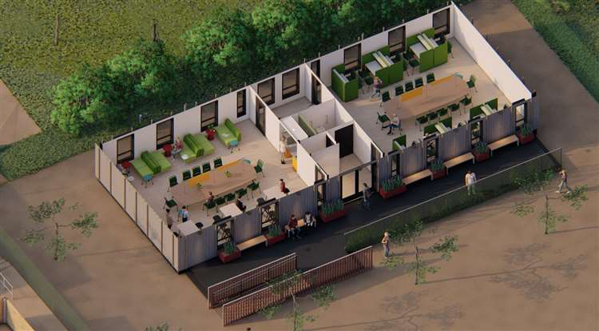
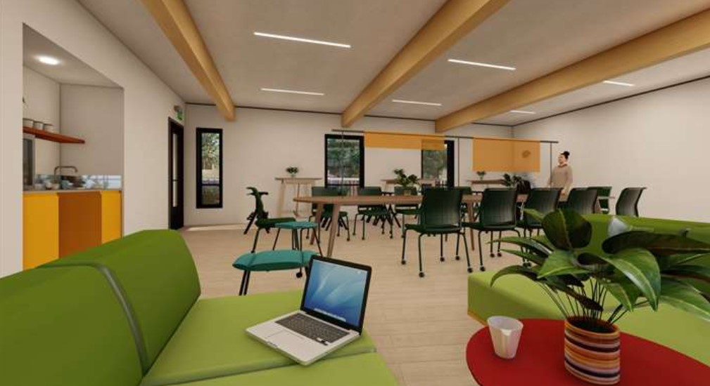
The new building will include a study area, common room, office, toilet, lobby and kitchenette. The current Year 11s have been consulted about their ideas and wishes for the building and it is with great excitement that we look forward to the next steps for the school and the Sixth Form.

