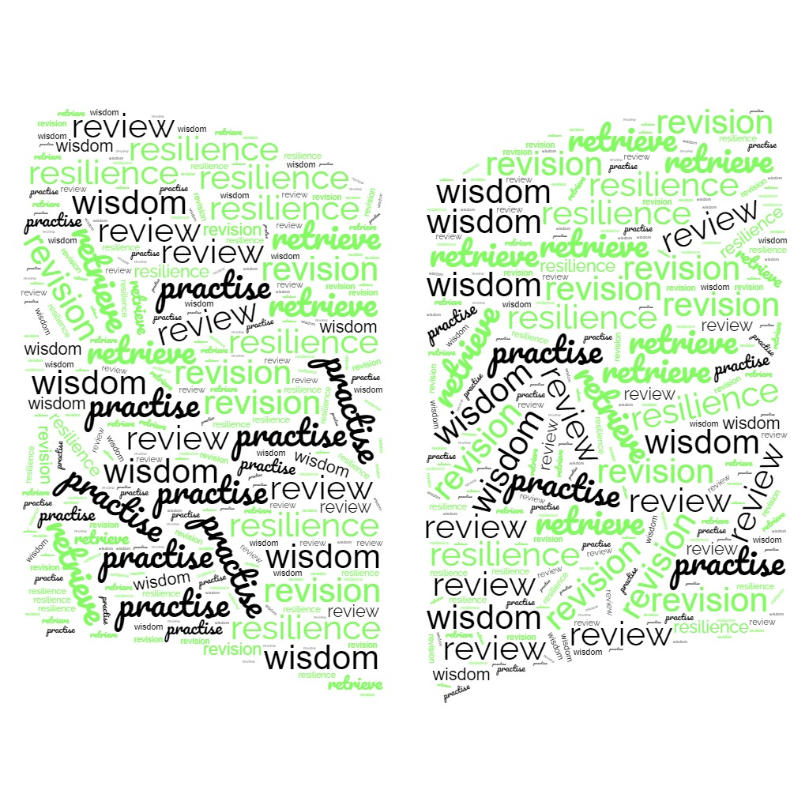
Year 10 Revision Guide

Introduction
Year 10 is the start of the key stage 4 secondary education journey, the public examinations in year 11 are the finale. During year 10, students settle into their GCSE subjects, covering most of the content that is examined in May of year 11. Year 10 is a chance for students to develop their independent study skills, whilst being heavily supported by home and school.
This guide is the beginning of independent study advice for key stage 4 provided by St Benedict’s to develop a life skill of self-preparation. It is important during year 10 for students to trial different methods of self-preparation, understanding that they are individuals and finding methods that work best for them and for each subject will be time well invested in preparing them to be the best they can be.
The purpose of this revision guide is to help direct revision as the year 10 students move towards their first mock examination period at the end of June, to support the review process of curriculum content and the retrieval practice of knowledge; each Year 10 student is being given a copy of this booklet, and a copy will be available electronically on our school website.
All subjects are contained in this booklet, students should only look at the subjects they are currently studying. The subject information outlines the exam board studied, the subject specific content required for year 10 as well as revision tips for each subject. If students have questions relating to any subject, they should speak to their class teacher; this guide has been constructed by the lead subject specialist teachers at St Benedict’s.
We are not expecting year 10’s to have a concrete study method that absolutely works yet, taking the end of year 10 mock examinations is a chance for year 10 students to sit in exam halls, to follow the JCQ guidance on public exams, to test their revision methods (see what works and what doesn’t). We do expect students to be able to improve from the year 10 mocks as they continue with KS4 content and complete year 11 mocks in November of year 11. Each assessment allows students to see what they know and to find the gaps in their knowledge or revision technique that can allow them to continually improve.
Year 10 parents/carers: Revision advice
This is a summary of the revision advice given to year 10 students as they prepare for their mock examinations and embrace independent study.
- Spread out your revision / independent study
Set aside a little bit of time every day. Five hours spread out over two weeks is better than five hours all at once. This is spaced practice and it is regarded as one of the most effective revision strategies. Mass practice or cramming is not effective and can be very stressful. This is when you study for a very intense period just before the exam, the information is only stored in short-term memory, and this is easily forgotten.
Make revision a habit….. use the plan, review, practise and apply strategy.
- Have a study plan – little and often
Divide up your independent study into short manageable chunks of time. When revising aim for 20 - 30 minutes per session. This will include reviewing material and practising the retrieval of material (putting knowledge into your head and drawing it back out to answer questions).
Using a checklist to keep track of the parts of your course you know well and the parts you need to spend more time on is a superb study skill. The more organised you are with your time, the more you can get done!
Use your class notes and textbooks (and this revision guide) to make a list of the important information and content that you need to know across different subjects.
- Review the content of your course
When you are reviewing content, using your class materials and textbooks, find or create visuals that link with the information. Compare and combine the visuals with the words. There are many ways to visually represent materials, such as with infographics, timelines, cartoon/comic strips, diagrams, and graphic organisers.
YouTube has lots of channels dedicated to reviewing GCSE content. Find a channel you like for each subject. Take additional notes as you review.
Active reading of information is a good starting point for reviewing content. Using checklists, keyword glossaries, flashcards, mind maps, condensing and expanding notes are all active information review techniques.

- Retrieval practice
Retrieval practice is taking the information from your memory to generate an answer to a question. It has been proven to be one of the most effective revision strategies. Through the act of retrieval, or calling information to mind, our memory for that information is strengthened and forgetting is less likely to occur. Retrieve as much information as you can then check your answers. It’s important to know what you know and what you don’t know yet!
Strategies to use can include planning and completing past paper exam questions, answering questions aloud with a revision buddy, production and use of question flashcards. Ensuring students have added the challenge of retrieval under a time pressure is crucial to them learning to think promptly and will develop their confidence for examinations.
Use active revision (just reading some text will not work), make summary notes, revision cards, answer past paper and practise questions again and again and again.
- Interleaving
Interleaving is a process where students mix and combine topics within a given subject. Blocked practice on the other hand, involves studying one topic very thoroughly before moving to another. Interleaving has been shown to be more effective than blocked practice leading to better long-term retention, more than three times better when compared to blocked learning if the test was more than a day later. Interleaving helps students to make links between different topics as well as discriminate between different types of problems, this promotes students’ ability to compare, contrast and evaluate, all are higher level cognitive skills.
- DO NOT passively read a copy the information.
Often students will say they have revised when they have re-read notes or textbook pages, they try to memorise the information by skim reading the text. The information is not considered or processed, it has not been transferred into the long-term memory, and will be quickly lost from the short-term memory when the student attention moves onto another task.
This has been proven to be the least effective way of revising and whilst it makes the student feel like they have been busy, the information is not embedded ready to apply to exam questions. There is a false sense of security provided and the results are likely to be a student performing under their actual ability.
Year 10 parents/carers: How to help your year 10 student
As parents/carers we want to help our young person to be the best that they can be. As a school, we are often asked by parents/carers how they can support their young person with independent study.
Honing the skill of revision is a challenge on its own, it takes time and requires resilience. Revising can be frustrating as it doesn’t always lead to an instant improvement in test results, it also requires stamina of concentration and this can be very tiring for a young person. Independent study tests students’ resilience and as the adults in the relationship we can support this journey by:
- Minimise distractions
Consider where your year 10 student will be revising, is it a quiet area? Have they got space to store notes and textbooks? Do they have access to a computer or tablet? (the internet is an awesome resource, but working on a small phone screen is not ideal). Encourage them to revise in a quiet, music free environment (studies show that exam performance is up to 60% better when revising without music with lyrics).
Do not allow all independent study to be done on a computer, the majority of students have to physically write their answers using pen and paper, independent study must have an element of this (unless your year 10 student has the exams concession of using a computer).
- Guide their study plans
Talk to your year 10 student about their study plan, listen to them when they are frustrated and encourage them back on track – giving up is not an option. Agree with your year 10 student a strategy to hold them accountable to sticking to the study plan. Periodically discuss their plan; is it working? Do they need to adapt it? Ask them to show you their revision; are they using strategies we have outlined in this guide?
Encourage them to have breaks and to be gentle on themselves if they have very high expectations of themselves. Keep independent study to a reasonable length of time – we do not want a year 10 experiencing burn-out, this is a slow and steady approach.
- Positively support
One of the biggest and most impactful things a parent/carer can do is to be positive, having high expectations will promote a student to have higher academic achievement, the balance comes in keeping those expectations realistic so the young person doesn’t become stressed and feel a huge pressure to excel. A parent’s reaction to a young person’s mistakes, however frustrating can be an opportunity for learning rather than judgment, promoting the wisdom that a young person can continually improve and that they can do better next time develops a growth mind-set.
Part of the key stage 4 journey is learning key life skills of information management, anxiety management, time management, independent learning techniques, healthy lifestyle choices (eating sensibly and sleeping), resilience in overcoming set-backs, young people can be all or nothing and do have a tendency towards catastrophising, guiding them to see they are doing ok and that no problem is insurmountable promotes healthy key life skills.
- Have clear structure and rules
Having clear expectations and reasonable rules will promote the young person to feel secure, they will then be able to divide up time between leisure and study. You will in turn be able mitigate procrastination and promote better independent decision making.
Young people should revise away from their phones as the huge distraction caused by social media and smart phone gaming is often too much for young people to overcome without clear guidelines. Showing that you care by having clear structure, reasonable rules, gentle reminders, will promote your year 10 student to care and see the importance of this stage in their education journey.

Recommended revision resources from previous key stage 4 students:
www.physicsandmathstutor.co.uk amazing English notes and all round good for exam practise papers.
YouTube channels for English GCSE:
‘Mr Salles teachers English’
‘Mr Bruff’
www.justmaths.co.uk
www.corbettmaths.com this company sell flash cards that previous students have found useful.
www.drfrostmaths.com this site has full coverage worksheets and revision videos.
GCSE POD – free access via our school website
www.senecalearning.co.uk superb for all subjects, short review of material, followed by structured retrieval practise.
CGP revision guides – especially for science. These can accompany students in class and have subject workbooks. Readily purchased through second-hand book shops.
The school student shared area has awesome revision material on it and is overlooked by students….. use it, it’s free and written by the subject specialists that teach you!

Year 10 students: Revision advice
Good revision practice:
- Make a subject specific list; what do you need to know? What are you secure on? What do you need to work on? – this revision guide is a superb place to start.

- Timetable a spaced schedule; study each topic little and often, leave yourself enough time for studying and leisure. This is like marathon preparation, do not try to leave it all to a sprint!

- Re-create notes and information; this does not mean copy out your notes – read, cover, write out as mind maps, brain dumps, condensed notes (that you then expand and elaborate on another day).

- Practise, practise, practise; retrieval practise takes information from your memory to answer questions, then mark that work – challenge your answers to be the best that they can be. Get to know each subjects mark schemes. Don’t be afraid to look up answers – it’s not cheating when you do this during independent study.

- Interleave; mix up your subjects and topics. Block learning is only effective in the short term. Keep your learning little and often. You will lose concentration if you try to stick to one particular topic or subject for long periods of time.

- Collaborate; work with a hardworking, trustworthy classmate (a study buddy). Do not allow the person to distract you and waste your time.

- Use revision material from the internet; YouTube videos are often short concise information blasts that can help you with step 3. Revision websites will have exam style questions and interactive retrieval practise to help you with step 4. Make sure these are recommended from your subject specific exam board.

- Reflect on your revision methods; are you methods working? Have your teachers noticed? Ask them! You know yourself and you know how much you can push yourself (remember revision is a marathon and not a sprint).

- Take regular break and be kind to yourself; part of the life-skills learnt during key stage 4 is that of wellbeing. Eat healthily, sleep properly, control your screen time and exercise (get out of your room, run/walk/bike). Spend time socilaising, just be mindful of procrastination and time management. Do not give-up, ask for help and support if you need it.

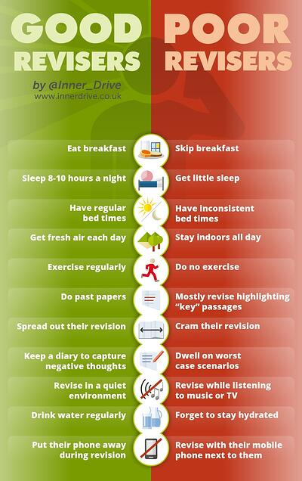

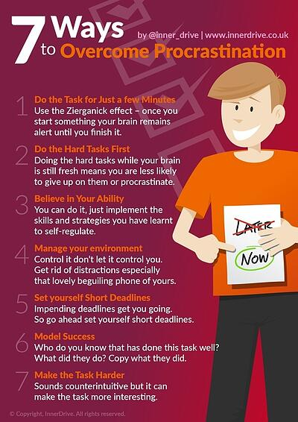

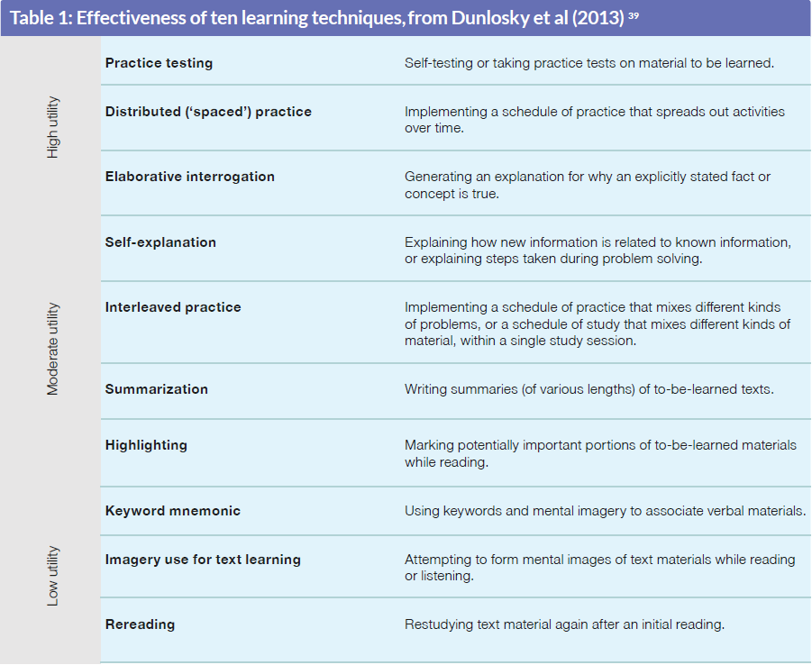

Revision timetable
 | Monday | Tuesday | Wednesday | Thursday | Friday | Weekend 1 | Weekend 2 | Weekend 3
Subject 1 (40 mins)
Break
Subject 2 (40 mins)
Break
Subject 3 (40 mins)
Students should aim for 2 x 30min revision sessions each evening covering 2 subjects.
Students should aim for 4 x 30min revision sessions each weekend day covering 4 subjects.
This must be manageable for students and not mandatory, studying is not at the expense of mental health or physical exercise. A balance needs to be struck.
This table is a guide only. There are some very good digital apps like ADAPT to help young people organise their time and their subjects into bitesize sessions to optimise revision time.
Art: AQA
Coursework assessment advice
Art is 100% coursework; it is a practical subject with no revision required for this subject. Students are supplied with knowledge organisers and individual mock exam support. Although there is a lot of work for Art students earlier on; Art is one of the first courses to finish.
Spread out your portfolio work, use the open art room time to get your artwork done.
Assessment
Students will be assessed both for the portfolio of coursework that they produce throughout the course (60%) and for the final examination project (40%). Every piece of work produced in class or at home contributes to the student’s final grade. Written feedback is given on a regular basis at the back of students’ sketchbooks to help support their learning as well as verbal feedback and direction in class. Student’s final portfolios of work in year 11 are marked out of a total of 96 marks evenly distributed between the four assessment objectives below:
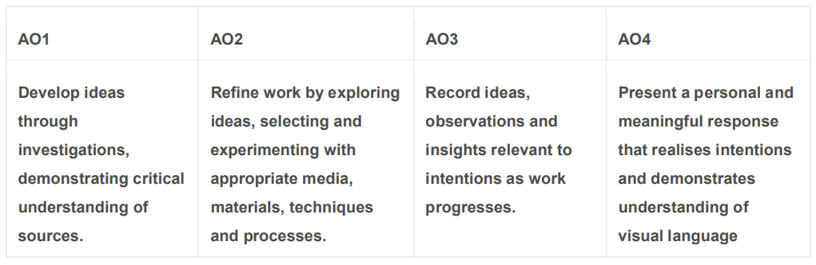

Business
Exam board: Edexcel
Yr10 mock exam paper layout:
Paper 1: 1.5 hour written exam
How to revise for the Business examination:
Revision Websites
Recommended:
BBC Bitesize, Tutor2U, TakingtheBiz Youtube channel, BizConEsh Youtube channel.
Revision Apps
Recommended: Seneca
OneNote Resources
all lesson powerpoints, worksheets, videos and links
Multiple choice question tasks
CGP Revision Guides
blue information book, white exam question book, flashcards
What you will need to revise for the year 10 Business mock exam:
Paper 1
1.1 Enterprise and Entrepreneurship
  - Spotting a Business Opportunity
1.3 Putting a Business Opportunity into practice
1.4 Making a Business Effective
1.5 Understanding External Influences on business

Practicing past paper questions and reviewing mark schemes is the most effective revision method.

Computer Science
Examination information (including exam board)
OCR J277
Paper layout
Paper 1: Computer Systems
Paper 2: Computational Thinking, Algorithms and Programming
Both Papers: 1.5 hour written exams
How to revise for the Computer Science examination:
Revision Websites
Recommended: Teach-ICT, BBC Bitesize
Revision Apps
Recommended: SoloLearn, GCSEPod
OneNote Resources
all lesson powerpoints, worksheets, videos and links
CGP Revision Guides
blue information book, white exam question book, flashcards
Programming Tutorials (Python)
Recommended: Data Camp, LearnPython, Code Academy

What you will need to revise for the Computer Science examination
Paper 1 | Paper 2
1.1.1: Architecture of the CPU | 2.1.1: Computational Thinking
1.1.2: CPU Performance | 2.1.2: Designing, Creating and Refining Algorithms
1.1.3: Embedded Systems | 2.1.3: Searching and Sorting Algorithms
1.2.1: Primary Storage (Memory) | 2.2.1/2.2.3: Programming Fundamentals/Additional Techniques
1.2.2: Secondary Storage | 2.2.2: Data Types
1.2.3: Units of Measurement | 2.3.1: Defensive Design
1.2.4: Data Storage | 2.3.2: Testing
1.2.5: Compression | 2.4.1: Boolean Logic
1.3.1: Networks and Topologies | 2.5.1: Languages
1.3.2: Wired and Wireless Networks, Protocols and Layers | 2.5.2: The IDE
1.4.1: Threats to Computer Systems and Networks
1.4.2: Identifying and Preventing Vulnerabilities
1.5.1: Operating Systems
1.5.2: Utility Software
1.6.1: Ethical, Legal, Cultural and Environmental Impacts

Product Design
Examination information (including exam board)
WJEC Eduqas
Paper layout
For the Year 10 mock exams the paper will last for 1.5 hours, in Year 11 the real exam is 2 hours in length.
The paper is divided into 6 sections as follows:
- 21st Century Living
- Smart Materials
- Electronics and Mechanism’s
- Materials
- Product Analysis
- Choice of 2 in depth knowledge areas e.g Timber/Manufactured boards or Paper and Boards
How to revise for the GCSE Product Design examination
- Use your ‘Pocket Sized’ revision Guide to help you revise key topics
- Re-cap topics covered already in your exercise books.
- Use BBC Bitesize to help with revision of each topic
- FocusElearning has helpful videos and revision content to test yourself.
What you will need to revise for the GCSE Product Design examination
60% of the paper in based on your knowledge of materials and 15% of this is maths based, so revising and practicing applying maths formula is an important aspect of revision for this subject.
For the forthcoming mock paper in June please focus on the following areas:
- Environment and Sustainability
- New and Emerging technologies
- Developments in New materials - such as smart and composite materials
- Timbers, Metals and Polymers
- Mechanical Devices such as mechanisms, Gears, Cams and followers, Pulleys and Belts, Levers and Linkages

Food Preparation and Nutrition
Examination Board - Eduqas
Paper layout
For the Year 10 mock exams the paper will last for 1 hour, in Year 11 the real exam is 1 hour 45 mins in length. The paper is worth 50% of your final GCSE mark. The exam paper is divided into two sections:
Section A: questions based on stimulus material.
Section B: structured, short and extended response questions to assess content related to food preparation and nutrition.
How to revise for the GCSE Food Preparation and Nutrition examination
- Use your notes taken from the textbook in class to help you revise key topics
- Use the PowerPoint on One Note
- Use BBC Bitesize to help with revision of each topic
- FocusElearning has helpful videos and revision content to test yourself.
- GCSE WJEC Eduqas Food Preparation and nutrition exam practise workbook
- GCSE WJEC Eduqas Food Preparation and nutrition revision guide

What you will need to revise for the GCSE Food technology examination
Focus on ensuring you have recapped key points on the following topics of study from the six areas of content which you have studied so far.

1. Food commodities
2. Principles of nutrition
3. Diet and good health
4. The science of food
5. Where food comes from
6. Cooking and food preparation
In year 10, focus on the following topics:
- Cereals (primary and secondary processes; different flours, rice other cereal crops)
- Obesity
- Meat
- Two types of cholesterol
- The function of protein in the body/diet
- Being a vegan
- Vitamins and Minerals

English Language
Exam Board - AQA
Paper layout
Paper 2: Writers’ viewpoints and perspectives (1 hour 45 minutes)
Section A: Reading
- Read two non-fiction extracts (one 19th century, one 20th or 21st century).
- Answer four questions: Q1 = retrieval of information; Q2 = comparing ideas; Q3 = analysis of language; Q4 = comparison of writers’ perspectives.
Section B: Writing
- Produce a piece of writing that presents a viewpoint on a statement.
How to revise for the English Language examination
- Use a knowledge organiser to quiz yourself on subject terminology and language and structure devices.
- Practise annotating an extract from a newspaper or magazine article or a non-fiction book such as a biography or travel book.
- Learn the conventions for an article, letter and speech.
- Practise planning an article, letter or speech in response to a statement.
- Complete exam questions.
What you will need to revise for the English Language examination
- How to respond to each question type
- Recognising and analysing language techniques
- How to compare ideas and perspectives
- Subject terminology
- How to write PETAL paragraphs
- How to plan a piece of writing that presents a point of view
- PAF (Purpose, Audience, Form)
- Rhetorical devices (including DAFOREST)

English Literature
Exam Board - AQA
Paper layout:
Paper 2: Modern Texts and Poetry (1 hour 45 minutes)
Section A ‘An Inspector Calls’
- Answer one question (from a choice of two) about how a character and/or theme is presented throughout the play.
Section B ‘Worlds and Lives’ Poetry
- Answer one question comparing how a theme is presented in one named poem and another poem of your choice.

How to revise for the English Literature examination
Make sure you know the texts really well
- Re-read the play and poems.
- Create a timeline for the play, with key events/moments highlighted.
Testing and applying your knowledge
- Use a knowledge organiser to quiz yourself on plot, character, themes, context, quotations.
- Create theme mind-maps which include key events, characters, context and quotations for the important ideas in the play or poem.
- Use flash cards to learn quotations (put an image on one side and the quotation on the other, or half the quotation on one side and the rest on the other).
- Practise annotating an extract from the play or a copy of the poem.
- Complete exam questions.
What you will need to revise for the English Literature examination
You must have a good knowledge of these aspects of the play and poems:
- Plot, key events and characters
- Key themes and ideas
- Writer’s message/intent
- Context
- Important quotations
- Literary techniques and subject terminology
French
Examination information - AQA
There are two tiers- Foundation and Higher. We will decide the tier for each candidate in the Spring term of year 11.
Paper layout:
Paper 1 – Listening
Paper 2 - Reading including translation into English
Paper 3 - Speaking
Paper 4 - Writing including translation into French
How to revise for the French examination
Start with the vocabulary covered in the course
Look at the grammar covered in your lessons
Get your family or other members of your class to test you, especially for the speaking exam.
Use your books to revise the above.
Use BBC Bitesize to help with grammar points/ revision of topic
Use the Elephant speaking book to help you with the speaking mock.
What you will need to revise for the French examination:
Year 10 topics

- Relationships with family and friends
- Marriage/partnership
- My studies
- Life at school/college
- Education post-16
- Jobs, career choices and ambitions
- Healthy/unhealthy living
- Travel and tourism

Geography
Exam Board - Edexcel Specification A
Paper layout:
Paper 1 – The Physical Environment
Paper 2 – The Human Environment
How to revise for the Geography examination:
There is a folder full of revision aids in the student shared area. In this folder you will find knowledge organisers, revision guides, exam practice and technique, case study summaries and more: W:\Revision\Year 10 revision materials 2023-2024\Geography
You should also use GCSE Pod, make sure you pick the Edexcel Specification A pods.
What you will need to revise for the Geography examination:
Paper 1 - The Physical Environment:
- Changing Landscapes (Rivers and Coasts)
- Weather Hazards and Change
- Biodiversity and Ecosystems Management
Paper 2 – The Human Environment:
- Changing Cities
- Global Development
- Resource Management

History
Exam Board - Edexcel History
Paper layout:
Medicine in Britain, c1250-present and The British sector of the Western Front, 1914-18: Injuries, treatment and the trenches (55 minutes) 32 marks
Anglo-Saxon and Norman England c1060-88 (1hr 15 minutes) 52 marks

How to revise for the History examination:
Please use the following resources to revise:
Your exercise book
Pearson REVISE Edexcel GCSE (9-1) History Medicine in Britain Revision Guide and Workbook: For 2024 and 2025 assessments and exams
GCSE History Edexcel Topic Guide – Medicine in Britain, c1250-Present: for the 2024-2025 exams (CGP Edexcel GCSE History)
Pearson REVISE Edexcel GCSE (9-1) History Anglo-Saxon and Norman England Revision Guide and Workbook: For 2024 and 2025 assessments and exams
GCSE History Edexcel Topic Guide – Anglo-Saxon and Norman England, c,1060-1088 for the 2024-2025 exams (CGP Edexcel GCSE History)
Try to make your revision as active a possible – make revision cards/spider diagrams, ask your parents/siblings to test you, complete past papers
What you will need to revise for the History examination:
Option 11: Medicine in Britain, c1250-present and the British sector of the Western Front, 1914-18: injuries, treatment and the trenches
Key Topics | Content Learners should have studied the following:
C1250-c1500: Medicine in medieval England
- Ideas about the cause of disease and illness | - Supernatural and religious explanations of the cause of disease.  - Rational explanations: the Theory of the Four Humours and the miasma theory; the continuing influence in England of Galen.
- Approaches to prevention and treatment | - Approaches to prevention and treatment, and their connection with ideas about disease and illness: religious actions, bloodletting and purging, purifying the air.  - Medical training and traditional approaches to treatment and care for the sick: the role of the physician, apothecary and barber surgeon; the role of hospitals, care within the community and at home, including the use of herbal remedies
- Case study | - Dealing with the Black Death, 1348–49; approaches to treatment and attempts to prevent its spread.
C1500-c1700: The Medical Renaissance in England
- Ideas about the cause of disease and illness | - Continuity and change in explanations of the cause of disease and illness. A scientific approach, including the work of Thomas Sydenham in improving diagnosis. The influence of the printing press and the work of the Royal Society on the transmission of ideas.
- Approaches to prevention and treatment | - Continuity and change in approaches to prevention, treatment and care in the community and in hospitals.  - Improvements in medical training and the influence in England of the work of Vesalius.
- Case study | - Key individual: William Harvey and the discovery of the circulation of the blood. Dealing with the Great Plague in London (1665): approaches to treatment and attempts to prevent its spread.
C1700c1900: Medicine in the eighteenth- and nineteenth-century Britain
- Ideas about the cause of disease and illness | - Continuity and change in explanations of the cause of disease and illness. The influence in Britain of Pasteur’s Germ Theory and Koch’s work on microbes.
- Approaches to prevention and treatment | - The extent of change in care and treatment: improvements in hospital care and the influence of Nightingale on nursing and hospitals in Britain. The impact of anaesthetics and antiseptics on surgery.  - New approaches to prevention: the development and use of vaccinations and the Public Health Act (1875).
- Case study | - Key individual: Jenner and the development of vaccination.  - Fighting Cholera in London (1854); attempts to prevent its spread; the significance of Snow and the Broad Street pump.
C1900-present: Medicine in modern Britain
- Ideas about the cause of disease and illness | - Advances in understanding the causes of illness and disease: the influence of genetic and lifestyle factors on health.  - Improvements in diagnosis: the impact of the availability of blood tests, scans and monitors.
- Approaches to prevention and treatment | - The extent of change in care and treatment. The impact of the NHS and science and technology: improved access to care; advances in medicines, including magic bullets and antibiotics; high-tech medical and surgical treatment in hospitals.  - New approaches to prevention: mass vaccinations and government lifestyle campaigns.
- Case study | - Key individuals: Fleming, Florey and Chain’s development of penicillin.  - The fight against lung cancer in the twenty-first century: the use of science and technology in diagnosis and treatment; government action
The British sector of the Western Front, 1914-18: injuries, treatment and the trenches
- The British sector of the Western Front, 1914–18: injuries, treatment and the trenches | - The context of the British sector of Western Front and the theatre of war in Flanders and northern France: the Ypres salient, the Somme, Arras and Cambrai. The trench system - its organisation, including frontline and support trenches. Significance for medical treatment of the nature of the terrain and problems of the transport and communications infrastructure.  - Conditions requiring medical treatment on the Western Front, including the problems of ill health arising from the trench environment. The nature of wounds from rifles and explosives. The problem of shrapnel, wound infection and increased numbers of head injuries. The effects of gas attacks.  - Medical treatment on the Western Front. The work of the RAMC and nurses. Transport in the chain of evacuation: stretcher bearers, horse and motor ambulances. Stages of treatment in the chain of evacuation: aid post and field ambulance, dressing station, casualty clearing station, base hospital. The underground hospital at Arras.  - The significance of the Western Front for experiments in surgery and medicine: new techniques in the treatment of wounds and infection, the Thomas splint, the use of mobile x-ray units, the creation of a blood bank for the Battle of Cambrai.  - The historical context of medicine in the early twentieth century: the understanding of infection and moves towards aseptic surgery; the development of x-rays; blood transfusions and developments in the storage of blood.

Option B1: Anglo-Saxon and Norman England c1060-88
Key Topics | Content Learners should have studied the following:
Key topic 1: Anglo-Saxon England and the Norman Conquest, 1060-66
- Anglo-Saxon Society | - Monarchy and government. The power of the English monarchy. Earldoms, local government and the legal system.  - The economy and social system. Towns and villages. The influence of the Church.
- The last years of Edward the Confessor and the succession crisis | - The House of Godwin. Harlod Godwinson’s succession as Earl of Wessex. The power of the Godwins.  - Harold Godwinson’s embassy to Normandy. The rising against Tostig and his exile. The death of Edward the Confessor.
- The rival claimants for the throne | - The motives and claims of William of Normandy, Harald Hardrada and Edgar.  - The Witan and coronation and reign of Harold Godwinson.  - Reasons for, and significance of, the outcome of the battles of Gate Fulford and Stamford Bridge.
- The Norman invasion | - The Battle of Hastings.  - Reasons for William’s victory, including the leadership skills of Harold and William, Norman and English troops and tactics.
Key topic 2: William I in power: securing the kingdom, 1066-87
- Establishing control | - The submission of the earls, 1066  - Rewarding followers and establishing control on the borderlands through the use of earls. The Marcher earldoms.  - Reasons for the building of castles; their key features and importance.
- The causes and outcomes of Anglo-Saxon resistance, 1068-71 | - The revolt of Earls Edwin and Morcar in 1068.  - Edgar the Aethling and the rebellions in the north (1069).  - Hereward the Wake and rebellion at Ely (1070-71).
- The causes and outcomes of Anglo-Saxon resistance 1068-71 | - The reasons for and features of Harrying of the North (1069-70). Its immediate and long-term impact, 1069-1087.  - Changes in landownership from Anglo-Saxon to Norman, 1066-87.  - How William I maintained royal power.
- Revolt of the Earls, 1075 | - Reasons for and features of the revolt.  - The defeat of the revolt and its effects.
Key topic 3: Norman England, 1066-88
- The feudal system and the Church | - The feudal hierarchy. The role and importance of tenants-in-chief and knights. The nature of feudalism (landholding, homage, knight service, labour service); forfeiture.  - The Church in England: its role in society and relationship to government, including the roles of Stigand and Lanfranc. The Normanisation and reform of the Church in the reign of William I.  - The extent of change to Anglo-Saxon society and economy.
- Norman government | - Changes to government after the Conquest. Centralised power and the limited use of earls under William I. The role of regents.  - The office of sheriff and the demesne. Introduction and significance of the ‘forest’.  - Domesday Book and its significance for Norman government and finance.
- The Norman aristocracy | - The culture and language of the Norman aristocracy.  - The career and significance of Bishop Odo.
- William I and his sons | - Character and personality of William I and his relations with Robert. Robert and revolt in Normandy (1077-80).  - William’s death and the disputed succession. William Rufus and the defeat of Robert and Odo.

Mathematics (1MA1)
Examination information - Edexcel
GCSE Maths – Edexcel exam board 3 papers (for 1MA1) at Higher (grades 4-9) or Foundation (grades 1-5) tiers.
Paper layout:
Paper | Content | Length | Weighting
1 | All 6 areas are tested (Number, Algebra, Ratio, proportion and rates of change, Geometry and measures, Probability, Statistics. No calculator allowed (80 marks) | 1 hour 30 | $$33\frac{1}{3}\%$$
2 | All 6 areas are tested (Number, Algebra, Ratio, proportion and rates of change, Geometry and measures, Probability, Statistics.  Calculator allowed (80 marks) | 1 hour 30 | $$33\frac{1}{3}\%$$
3 | All 6 areas are tested (Number, Algebra, Ratio, proportion and rates of change, Geometry and measures, Probability, Statistics.  Calculator allowed (80 marks) | 1 hour 30 | $$33\frac{1}{3}\%$$

How to revise for the Maths examination:
Maths Revision is best done by doing questions from past papers. There are three key elements to follow when doing revision. They are:
- understanding what the question is asking you
- knowing formula, key terms and mathematical notation
- PRACTICE, PRACTICE, PRACTICE
Revision guides are useful for referring to when stuck with a question and also offer some good examples. Practice books are even better so a complete revision and practice book is probably better to invest in than a revision guide alone.
The Maths department also issue out a complete revision checklist that is good for identifying areas to work on during your revision.

What you will need to revise for the Maths examination:
NUMBER:
Structure and Calculations
- Properties of number such as factors, multiples, prime numbers, square numbers.
- Numeracy. Using the four operations, indices working with brackets (BIDMAS).
- Standard form.

Fractions, Decimals and percentages
- Converting between fractions, decimals and percentages.
- Percentage increase and decrease.

Measures and accuracy
- Rounding answers to a given degree of accuracy and estimating answers to check accuracy of calculations.
- Using units of measure for length, mass, time, money and other measures.
- Upper and Lower bounds for limits of accuracy.

ALGEBRA:
Notation, Vocabulary and Manipulation
- Working with expressions (collect like terms, expanding brackets, factorising.
- Substitution into algebraic expressions and formulae.
- Solving equations and inequalities (linear and quadratic).
Graphs
- Working with co-ordinates
- Straight line graphs (y = mx + c). Working with the gradient to find parallel and perpendicular lines.
- Graphs of quadratic functions (roots and turning point from completing the square).
- Reciprocal graphs and real-life graphs.
- Graphs of trigonometric functions.
- Transformations of graphs.

Sequences
- Generate terms of a sequence and identify the nth term for both linear and quadratic sequences.
- Recognise and work with Arithmetic and simple geometric progressions.

RATIO, PROPORTION AND RATES OF CHANGE
- Using ratio in real life context, simplifying ratios and relating them to fractions.
- Solve problems involving direct and inverse proportion.
- Compound units of measure such as speed, density, pressure and others.
- Compound Interest calculations.
- Exponential growth and decay.

GEOMETRY AND MEASURES
Properties and Constructions
- Use a ruler and compass to perform standard constructions of triangles and loci.
- Angle properties (angles on a line, about a point and for parallel lines).
- Congruent triangles (SSS, SAS, ASA, RHS).
- Properties of polygons including transformations (enlargement, translation, reflection and rotation).
- Plans and elevations of 3D solids.
- Circle theorems.

Mensuration and Calculation
- Use standard units of measure for length, area and volume.
- Use circle formulae (circumference and area).
- Pythagoras’s Theorem (𝑎²+𝑏² =𝑐²)
- Using trigonometry to find missing lengths and angles (SOHCAHTOA)
Vectors
- Addition and subtraction of vectors; multiply vectors by a scalar and represent them diagrammatically.
- Use vectors to construct arguments and proof.

PROBABILITY
- Use appropriate language. Know that the total probability of all possible outcomes is 1 and use a probability scale.
- Use and draw Venn Diagrams (including set notation), Probability trees and two-way tables. Link these to conditional probability.
- Calculate the probability of combined independent and dependent events.
- Risk (probability used in real life contexts).
- Listing outcomes systematically and use a sample space diagram for two combined events.

STATISTICS
- Sampling techniques and types of data (discrete and continuous).
- Interpret and construct statistical tables, charts and diagrams (pie charts, bar charts, pictograms, times series).
- Measures of central tendency (mean, median, mode and modal class) and measures of spread (range, quartiles, inter-quartile range and also consider outliers).
- Use and interpret scatter graphs (causations, interpolation, extrapolation and drawing lines of best fit).

Music
Exam Board - Edexcel
Paper layout:
Unit 1- Performance
Unit 2 - Composition
Unit 3 – 1 ½ hour listening exam
How to revise for the Listening examination:
Go over the musical elements for each extract.
Listen to the extracts.
Create revision cards for each extract.
What you will need to revise for the Listening examination:
(these should be brief statements that allow students a general tick list of content)
Knowledge organisers which are in the student shared area.
Edexcel revision guide.
BBC bitesize.
James Stevenson channel on youtube.

Physical Education
Exam Board - OCR
Paper layout:
You will complete Paper 1 only:
Physical Factors Affecting Performance, 60 marks, 1 hour
Section A: Applied Anatomy and Physiology
Section B: Physical Training

These are how the papers are laid out in year 11:
Paper 1: Physical Factors Affecting Performance, 60 marks, 1 hour
Section A: Applied Anatomy and Physiology
Section B: Physical Training
Paper 2: Socio-cultural issues and Sports Psychology, 60 marks, 1 hour
Section A: Socio-cultural influences
Section B: Sports psychology
Section C: Health, fitness and well-being

How to revise for the PE examination
There are a number of techniques you can use to revise for PE
- Brain Dumps: write a topic down on a piece of A4 paper, brainstorm and write down as much as you can about the topic. Then read deeper into the topic and add to this using a different colour pen to identify areas you need to develop for the exam.

- Exam practice questions: Many of these are available on One Note.

- Transform it: Create graphic information organisers: Use your knowledge organiser to help you do this:
- Concept mapping – Great for summarising topics and reviewing content (whole topic)
- Venn diagrams – good for Benefits of exercise
- Spider diagrams – good for structuring and building answers
- Flow diagrams – good for processing your answers

- Create flash cards: questions on one side and the answer on the other – colour code them for different topics. Quiz yourself or others
You can also use them to remember; definitions of key words, application to sporting examples, evaluations advantages and disadvantages.
What you will need to revise for the PE examination:
PAPER ONE: Physical Factors affecting performance
Applied Anatomy and Physiology:
Structure and function of skeletal system:
- Names and location of bones
- Functions of the skeletal system
- Types of joints
- Joint movements
- Role of ligament, tendon and cartilage
Structure and function of muscular system:
- Names and location of muscles
- Antagonistic muscle pairs
Movement Analysis:
- Lever systems
- Planes and Axis
Cardiovascular and Respiratory Systems:
- Structure and function of CV system-blood vessels, heart, definitions of cardiac output, stroke volume and heart rate
- Structure and function of respiratory system-pathway of air, mechanics of breathing, definitions of tidal volume, minute ventilation and breathing rate.
- Anaerobic and Aerobic exercise
Effect of Exercise on the body:
- Short and long-term effects of exercise on the body systems.
Physical Training:
- Components of fitness
- Principles of training
- FITT principle
- Methods of training
- Warm up and cool down
- Preventing injury

Religious Education

Exam board: AQA Religious Studies B
Paper layout
- In the Year 10 mock you will answer 1 exam paper.
- This will consist of 4 questions on 4 of the topics you have studied this year.
- These are:
  - Judaism Beliefs and Teachings
  - Creation
  - Incarnation
  - Relationship and Families
- Each question should take you about 25 minutes to answer. The whole paper will last 1 hour 45 minutes.
How to revise for the RE mock
- Learn the key quotes for each topic.
- Know the key words for each topic.
- Look through your exercise book/workbook to make sure you know the key content for each topic.
- (For each of these key words, quotes and content you could make mind maps, flash cards, explain them to others or get other people to test you on them).
- Watch the relevant videos on Mr McMilan’s Youtube channel: https://www.youtube.com/@MrMcMillanREvis
- Read and learn the information for each topic from a revision guide. We recommend: Catholic Christianity with Islam and Judaism Revision Guide: Get Revision with Results (GCSE Religious Studies for AQA) by Harriet Power and David Worden
- Your teacher can give you a revision summary page for each of the topics. These include the key words, quotes, space to fill in key content from the topic and exam questions.
- Practice answering exam questions using past papers from the AQA website. Your teacher can show you where these are if you need help finding them.

Science, combined award – Biology
GCSE Combined Science (9-1) – OCR Gateway
Higher (grades 4-9) or Foundation (grades 1-5) tiers
Year 10 mock exam Paper layout:
There will be one paper for Biology worth 60 marks and it will be 1 hour 10 minutes long. Students will either be entered into Foundation or Higher tier papers.
Paper 1 will contain content from B1, B2 and B3, as well as practical skills from PAGS 1-5.
The paper will also test common mathematical skills used in Science; mean, range, %s, graph skills etc.
The paper is split into Section A and B. Section A contains 10 multiple choice questions, with section B containing longer answer questions, including one 6 mark question.
How to revise for the combined award - Biology
Year10 mock examination:
Revision should be split into two key parts; Content Revision and Exam Practice.
Content revision should be started earlier, building knowledge of facts, processes, keywords, diagrams and practical techniques. This can be done by doing 15/20 minute chunks of revision where the knowledge gone over is then used. Key techniques can be flash cards, mind maps, quiz websites or teaching someone else a topic.
Resources such as the CGP OCR 9-1 Gateway revision guide and CGP revision question cards are very useful for this.
Exam technique and practice should follow, helping you to understand how to answer the questions. Learning the meaning of command words (describe, explain, discuss etc.) and use of past paper questions to practice giving full answers. An important part of using past paper questions is reviewing your answers with the mark scheme. This will help you to see what you did well, but also where you can improve your answers next time.
Websites such as Physics and Maths tutor or savemyexams.co.uk are good places to find past paper questions. The CGP OCR Gateway exam practice workbook is also a very good source of questions on every topic.
What you will need to revise for the combined award – Biology year10 mocks examination:
B1 – Cell Level Systems
- Light Microscopes
- Animal, Plant and Bacterial cells
- Electron Microscopes
- DNA
- Enzymes
- Aerobic and Anaerobic respiration
- Biological molecules
- Photosynthesis
B2 – Scaling Up
- Diffusion, Osmosis and Active Transport
- Mitosis
- Cell differentiation and stem cells
- Exchange surfaces (lungs)
- Circulatory system
- Blood and Blood vessels
- Transpiration and Translocation
B3 – Organism Level Systems
- The Nervous system
- Reflex actions
- Hormonal system
- Reproductive hormones
- Contraception and IVF
- Homeostasis
- Blood sugar levels
PAG B1 – Light microscopy
PAG B3 – Rate of enzyme controlled reactions
PAG B4 – Investigating photosynthesis
Science, combined award – Chemistry
GCSE Combined Science (9-1) – OCR Gateway
Higher (grades 4-9) or Foundation (grades 1-5) tiers
Year 10 mock exam paper layout
There will be one paper for Chemistry worth 60 marks and it will be 1 hour 10 minutes long. Students will either be entered into Foundation or Higher tier papers.
The paper will contain content from C1, C2 and C3, as well as practical skills from PAGS 1-4.
The paper will also test common mathematical skills used in Science; mean, range, %s, graph skills etc.
The paper is split into Section A and B. Section A contains 10 multiple choice questions, with section B containing longer answer questions, including one 6 mark question.
How to revise for the combined award - Chemistry
Year 10 mock examination
Revision should be split into two key parts; Content Revision and Exam Practice.
Content revision should be started earlier, building knowledge of facts, processes, keywords, diagrams and practical techniques. This can be done by doing 15/20 minute chunks of revision where the knowledge gone over is then used. Key techniques can be flash cards, mind maps, quiz websites or teaching someone else a topic.
Resources such as the CGP OCR 9-1 Gateway revision guide and CGP revision question cards are very useful for this.
Exam technique and practice should follow, helping you to understand how to answer the questions. Learning the meaning of command words (describe, explain, discuss etc.) and use of past paper questions to practice giving full answers. An important part of using past paper questions is reviewing your answers with the mark scheme. This will help you to see what you did well, but also where you can improve your answers next time.
Websites such as Physics and Maths tutor or savemyexams.co.uk are good places to find past paper questions. The CGP OCR Gateway exam practice workbook is also a very good source of questions on every topic.

What you will need to revise for the combined award – Chemistry Year10 mock examination:
C1 – Particles
- States of Matter
- History of Atomic Models
- The Atom
- Atomic number and mass number
C2 – Elements, Compounds and Mixtures
- The Periodic table
- Electron shells
- Ionic compounds and Bonding
- Covalent compounds and Bonding
- Metals
- Polymers
- Purity
- Separation techniques; distillation, filtration, crystallisation, chromatography
- Empirical formula
C3 – Chemical Reactions
- Chemical formulae and equations
- Conservation of mass
- Endothermic and Exothermic Reactions
- Acids, Bases and Neutralisation
- REDOX reactions
- Electrolysis
PAG C1 – Electrolysis
PAG C2 – Distillation
PAG C3 – Separation Techniques
PAG C4 – Production of Salt

Science, combined award – Physics
GCSE Combined Science (9-1) – OCR Gateway
Higher (grades 4-9) or Foundation (grades 1-5) tiers
Year10 mock exam paper layout
There will be one paper for Physics worth 60 marks and it will be 1 hour 10 minutes long. Students will either be entered into Foundation or Higher tier papers.
The paper will contain content from P1, P2 and P3, as well as practical skills from PAGS 1-5.
The paper will also test common mathematical skills used in Science; mean, range, %s, graph skills etc.
The paper is split into Section A and B. Section A contains 10 multiple choice questions, with section B containing longer answer questions, including one 6 mark question.
How to revise for the combined award - Physics
Year10 mock examination
Revision should be split into two key parts; Content Revision and Exam Practice.
Content revision should be started earlier, building knowledge of facts, processes, keywords, diagrams and practical techniques. This can be done by doing 15/20 minute chunks of revision where the knowledge gone over is then used. Key techniques can be flash cards, mind maps, quiz websites or teaching someone else a topic.
Resources such as the CGP OCR 9-1 Gateway revision guide and CGP revision question cards are very useful for this.
Exam technique and practice should follow, helping you to understand how to answer the questions. Learning the meaning of command words (describe, explain, discuss etc.) and use of past paper questions to practice giving full answers. An important part of using past paper questions is reviewing your answers with the mark scheme. This will help you to see what you did well, but also where you can improve your answers next time.
Websites such as Physics and Maths tutor or savemyexams.co.uk are good places to find past paper questions. The CGP OCR Gateway exam practice workbook is also a very good source of questions on every topic.
What you will need to revise for the combined award – Physics Year 10 mock examination:
P1 – Matter
- History of Atomic models and Structure of the Atom
- Density
- States of Matter
- Specific Heat Capacity
- Specific Latent Heat
- Motion of Gas Particles
P2 – Forces
- Speed and Velocity
- Acceleration
- Distance-Time and Velocity-Time graphs
- Forces and Free Body diagrams
- Newtons Law’s of Motion
- Mass, Weight and Gravity
- Work and Power
- Elasticity, Work and Hooke’s Law
P3 – Electricity and Magnetism
- Static Electricity
- Current, Potential Difference and Circuits
- I-V Characteristics
- Series and Parallel Circuits
- Energy and Power in Circuits
- Magnets and Magnetic Fields
- Electromagnetism
PAG P1 – Materials
PAG P2 – Forces
PAG P3 – Motion
PAG P5 – Energy
PAG P6 – Circuits

Science, separate award – Biology
GCSE Biology (9-1) – OCR Gateway (J247)
Higher (grades 4-9) or Foundation (grades 1-5) tiers
Year 10 mock exam paper layout:
There will be one paper for Biology worth 90 marks and it will be 1 hour 45 minutes long. Learners will either be entered into Foundation or Higher tier papers.
The paper will contain content from B1, B2 and B3, as well as practical skills from PAGS 1-8.
The paper will also test common mathematical skills used in Science; mean, range, %s, graph skills etc.
The paper is each split into Section A and B. Section A contains 15 multiple choice questions, with section B containing longer answer questions.
How to revise for the separate award - Biology
Year10 mock examination:
Revision should be split into two key parts; Content Revision and Exam Practice.
Content revision should be started earlier, building knowledge of facts, processes, keywords, diagrams and practical techniques. This can be done by doing 15/20 minute chunks of revision where the knowledge gone over is then used. Key techniques can be flash cards, mind maps, quiz websites or teaching someone else a topic.
Resources such as the CGP OCR 9-1 Gateway revision guide and CGP revision question cards are very useful for this.
Exam technique and practice should follow, helping you to understand how to answer the questions. Learning the meaning of command words (describe, explain, discuss etc.) and use of past paper questions to practice giving full answers. An important part of using past paper questions is reviewing your answers with the mark scheme. This will help you to see what you did well, but also where you can improve your answers next time.
Websites such as Physics and Maths tutor or savemyexams.co.uk are good places to find past paper questions. The CGP OCR Gateway exam practice workbook is also a very good source of questions on every topic.

What you will need to revise for the separate award - Biology Year 10 mock examination:
B1 – Cell Level Systems
- Light and Electron Microscopes
- Animal, Plant and Bacterial cells
- DNA and Protein synthesis
- Enzymes
- Aerobic and Anaerobic respiration
- Biological molecules
- Photosynthesis
B2 – Scaling Up
- Diffusion, Osmosis and Active Transport
- Mitosis
- Cell differentiation and stem cells
- Exchange surfaces (lungs)
- Circulatory system
- Blood and Blood vessels
- Transpiration and Translocation
B3 – Organism Level Systems
- The Nervous system
- The Eye and Brain
- Reflex actions
- Hormonal system
- Reproductive hormones
- Contraception and IVF
- Plant hormones
- Homeostasis
- Blood sugar levels
PAG 1 – Light microscopy
PAG 2 – Testing for Biological molecules
PAG 4 – Rate of enzyme controlled reactions
PAG 5 – Investigating photosynthesis
PAG 6 – Physiology, Responses and Respiration and PAG 8 – Transport in and out of cells

Science, separate award – Chemistry
GCSE Chemistry (9-1) – OCR Gateway (J248)
Higher (grades 4-9) or Foundation (grades 1-5) tiers
Year10 mock exam paper layout
There will be one paper for Chemistry worth 90 marks and it will be 1 hour 45 minutes long. Learners will either be entered into Foundation or Higher tier papers.
The paper will contain content from C1, C2 and C3, as well as practical skills from PAGS 1-8.
The paper will also test common mathematical skills used in Science; mean, range, %s, graph skills etc.
The paper is each split into Section A and B. Section A contains 15 multiple choice questions, with section B containing longer answer questions.
How to revise for the separate award - Chemistry
Year10 mock examination:
Revision should be split into two key parts; Content Revision and Exam Practice.
Content revision should be started earlier, building knowledge of facts, processes, keywords, diagrams and practical techniques. This can be done by doing 15/20 minute chunks of revision where the knowledge gone over is then used. Key techniques can be flash cards, mind maps, quiz websites or teaching someone else a topic.
Resources such as the CGP OCR 9-1 Gateway revision guide and CGP revision question cards are very useful for this.
Exam technique and practice should follow, helping you to understand how to answer the questions. Learning the meaning of command words (describe, explain, discuss etc.) and use of past paper questions to practice giving full answers. An important part of using past paper questions is reviewing your answers with the mark scheme. This will help you to see what you did well, but also where you can improve your answers next time.
Websites such as Physics and Maths tutor or savemyexams.co.uk are good places to find past paper questions. The CGP OCR Gateway exam practice workbook is also a very good source of questions on every topic.

What you will need to revise for the separate award – Chemistry Year 10 mock examination:
C1 – Particles
- States of Matter
- History of Atomic Models
- The Atom
- Atomic number and mass number
C2 – Elements, Compounds and Mixtures
- The Periodic table
- Electron shells
- Ionic compounds and Bonding
- Covalent compounds and Bonding
- Metals
- Polymers
- Allotropes of Carbon
- Purity
- Separation techniques; distillation, filtration, crystallisation, chromatography
- Empirical formula
C3 – Chemical Reactions
- Chemical formulae and equations
- Conservation of mass
- Mole equation
- Endothermic, Exothermic Reactions and Calculating Energy chanes
- Acids, Bases and Neutralisation
- REDOX reactions
- Electrolysis and Electroplating

PAG C2 – Electrolysis
PAG C3 – Separation Techniques
PAG C4 – Distillation
PAG C6 – Titration
PAG C7 – Production of Salt

Science, separate award – Physics
GCSE Physics (9-1) – OCR Gateway (J249)
Higher (grades 4-9) or Foundation (grades 1-5) tiers
Year 10 mock exam paper layout:
There will be one paper for Physics worth 90 marks and it will be 1 hour 45 minutes long. Learners will either be entered into Foundation or Higher tier papers.
The paper will contain content from P1, P2, P3 and P4 as well as practical skills from PAGS 1-8.
The paper will also test common mathematical skills used in Science; mean, range, %s, graph skills etc.
The paper is each split into Section A and B. Section A contains 15 multiple choice questions, with section B containing longer answer questions.
How to revise for the separate award - Physics
Year 10 mock examination:
Revision should be split into two key parts; Content Revision and Exam Practice.
Content revision should be started earlier, building knowledge of facts, processes, keywords, diagrams and practical techniques. This can be done by doing 15/20 minute chunks of revision where the knowledge gone over is then used. Key techniques can be flash cards, mind maps, quiz websites or teaching someone else a topic.
Resources such as the CGP OCR 9-1 Gateway revision guide and CGP revision question cards are very useful for this.
Exam technique and practice should follow, helping you to understand how to answer the questions. Learning the meaning of command words (describe, explain, discuss etc.) and use of past paper questions to practice giving full answers. An important part of using past paper questions is reviewing your answers with the mark scheme. This will help you to see what you did well, but also where you can improve your answers next time.
Websites such as Physics and Maths tutor or savemyexams.co.uk are good places to find past paper questions. The CGP OCR Gateway exam practice workbook is also a very good source of questions on every topic.

What you will need to revise for the combined award – Physics Year 10 mock examination:
P1 – Matter
- History of Atomic models and Structure of the Atom
- Density
- States of Matter
- Specific Heat Capacity
- Specific Latent Heat
- Pressure of Gases and Liquids
P2 – Forces
- Speed and Velocity
- Acceleration
- Distance-Time and Velocity-Time graphs
- Forces and Free Body diagrams
- Newtons Law’s of Motion
- Mass, Weight and Gravity
- Work and Power
- Elasticity, Work and Hooke’s Law
- Moments, Levers and Gears
P3 – Electricity
- Static Electricity
- Current, Potential Difference and Circuits
- I-V Characteristics
- Resistance
- Series and Parallel Circuits
- Energy and Power in Circuits
P4 - Magnetism
- Magnets and Magnetic Fields
- Electromagnetism
- Motors and Loudspeakers
- Transformers
PAG P1 – Materials, PAG P2 – Forces, PAG P3 – Motion, PAG P5 – Energy, PAG P6 – Circuit Components, and PAG P7 – Series and Parallel Circuits.

Spanish
Exam board - AQA
There are two tiers- Foundation and Higher. We will decide the tier for each candidate in the Spring term of year 11.
Year10 mock exam paper layout:
Paper 1 – Listening including dictation
Paper 2 - Reading including translation into English
Paper 3 - Speaking including reading out loud
Paper 4 - Writing including translation into Spanish
How to revise for the Spanish Year 10 mock examination
Start with the vocabulary covered in the course
Look at the grammar covered in your lessons
Get your family or other members of your class to test you, especially for the speaking exam.
Use your books to revise the above.
Use BBC Bitesize to help with grammar points/ revision of topic
Use the speaking book to help you with the speaking mock.
What you will need to revise for the Spanish year10 mock
Year 10 topics
- Relationships with family and friends
- Technology in everyday life
- My studies
- Life at school/college
- Education post-16
- Jobs, career choices and ambitions
- Healthy/unhealthy living
- Free time activities

