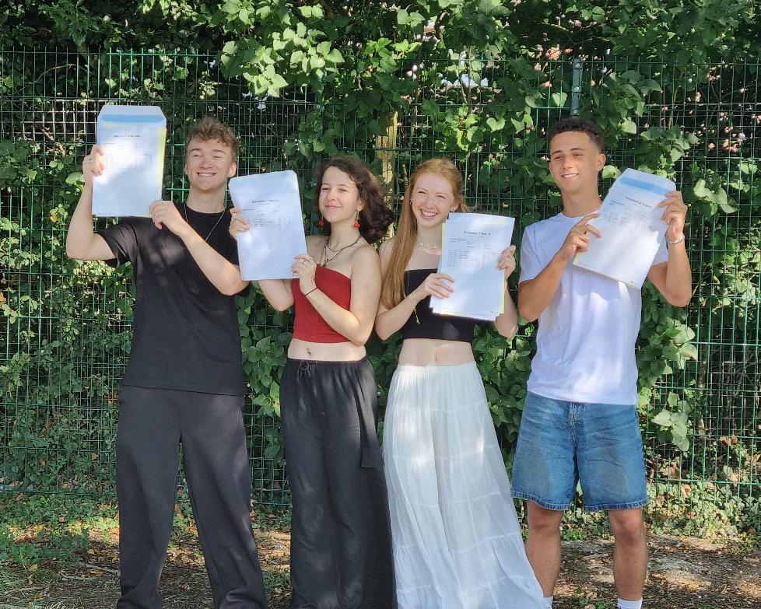

L to R - James Ladbrook, Helena Peachey, Phoebe Harpur-Davies, Isaac Lewis
We are once again delighted with the results that our students have achieved this year, and these reflect their hard work, determination and ability. Our 80 students have made wonderful progress across their courses and as a result they have attained very highly. A quarter of all grades awarded were A*/A grades, 54% of grades achieved were A*/A or B, 79% A*-C and the pass rate overall was 98%. We were particularly pleased to see our first cohorts of A Level Classics and Art History perform well.
We are very proud of all our young people, all their paths, talents, struggles and differences. They are all to be celebrated. In attainment terms - Phoebe Harpur-Davies became the second student in a row to achieve a clean sweep of the highest possible grades in all her exam history when she achieved A*A*A*A* in Maths, Further Maths, Chemistry and Physics, following her 12 GCSE grade 9 results in year 11 and leaves us for her place in Cambridge without ever dropping a grade.
James Ladbrook, also achieved the highest grades in all his subjects with A*s across the board in Computer Science, Maths, Further Maths and Physics, Rose Coldwell achieved A*A*A*A in Maths, History, RE and Psychology respectively, and Helena Peachey achieved A*A*A in English Literature, Sociology and Classics and will go on to read Law at Cambridge. Isaac Lewis secured his place to study Medicine at UEA with AAA in Chemistry, Maths and Economics.
We are also delighted for our soon to be ex-colleague Isaac Pernot. After achieving A*A*A*A grades last year he decided to take a gap year to reconsider his university options and secured a role with us as our IT technician. To his already brilliant A Levels he has now added exceptional performance in the Maths STEP examinations and as a result he leaves us to study Maths at Cambridge.

