International Languages Day
On Wednesday 28th January, St Benedict’s proudly celebrated International Languages Day, recognising and celebrating the rich cultural diversity within our school community. Students marked the occasion by wearing traditional cultural dress and taking part in a variety of activities, including a bake sale, tutor quiz, and a flags quiz.
Year 8 and 9 students also enjoyed language taster sessions, giving them the opportunity to explore new languages and cultures.
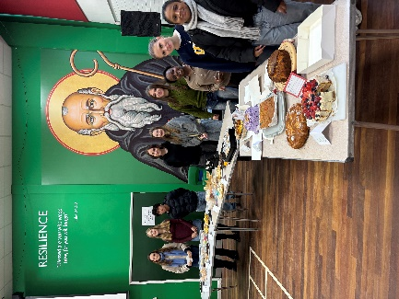
A huge thank you to everyone who contributed to the day, with special thanks to the sixth form cake sale team and all those who baked cakes and helped raise funds for EACH (East Anglian Children’s Hospice). Your generosity and teamwork helped make the event such a success raising £188.
Special recognition goes to the students who delivered foreign language sessions in Hungarian, German, Polish, Russian and Filipino. Their incredible presentations and enthusiasm were an amazing contribution to the day.
Carl Conway Yr13
Adam O’Flynn Yr13
Jessica Dive Yr13
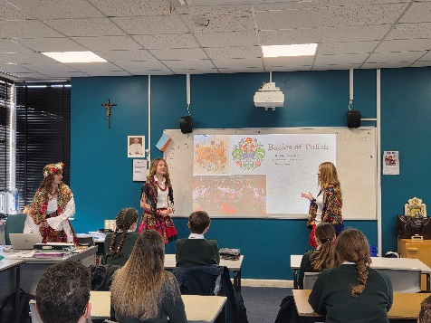
Natasha Dive Yr11
Ara Anacleto Yr12
Raf Calumpiano Yr12
Franek Saladra Yr9
Nadia Kroszkiewicz Yr10
Patrycja Golonka Yr9
Amelia Zabojsz Yr10
The day was a powerful reminder that learning a language is more than words — it builds understanding, respect and connection across cultures. As we celebrated together, we were reminded that “it’s never too late to learn a language,” and every language learned brings us one step closer to understanding the world and each other.
MFL team

