Klondyke Cup Winners
The inaugural U16s Rugby Klondyke Cup between St Benedict's and County High was held on Wednesday 22 April at the Bury St Edmunds Rugby Club. There was an amazing atmosphere in the stand with students, teachers and parents cheering on their respective schools.
Girls Match Report
Final score: 19-17 to St Benedict's
After a few training sessions as a group, our U16s team was well prepped and ready for the game with an expectant baying crowd.
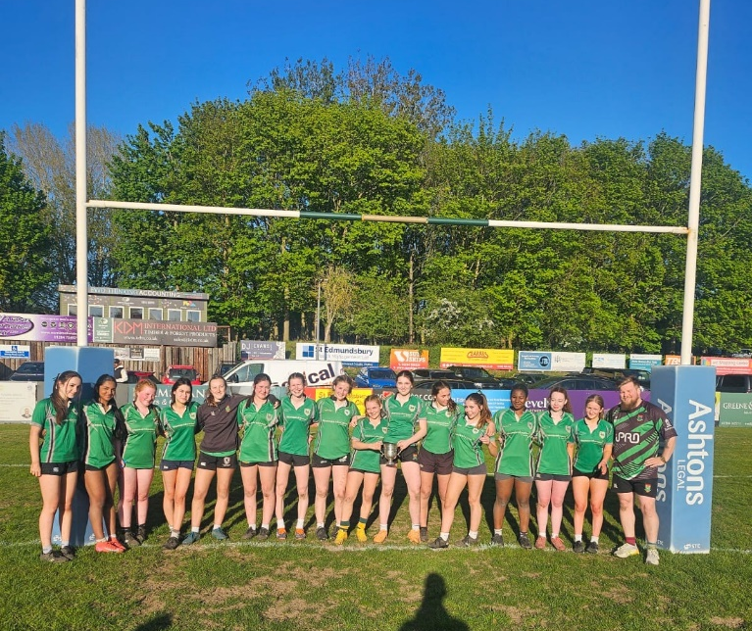
Captain Izzy Wakes kicked off excellently with a strong defensive line chasing up putting County under pressure from the off. This theme remained consistent with some excellent first up tackles before a breakaway try from County to put them 0-7 up. From sustained pressure we unfortunately conceded again to go 0-12 down, but this is where the Bennies girls showed their real resilience. They regained possession after one of Sophie Rankin's many turnovers and managed to score with Audrey Harvey going over, which was converted by Izzy Wakes to make it 7-12. At this point Harriet Tovey went down injured, which motivated our girls to push even harder with Agnes Paul then scoring, which was again converted by Izzy Wakes to make it 14-12. After the second half County managed to score from lots of strong carrying to make it 14-17. Driven on by the crowd though and in the last few moments of the game, Flora Bromley-Martin picked and scored out wide to make it the last score of the game and a win for St Benedict's, 19-17.
However, our win wouldn't have come without real dedication shown by our players, for example Molly Murphy making an 80 metre chase to stop an almost certain try.
For those who weren't there, the crowd were excellent and clearly drove our girls forward, so thank you to all for that support.
Many thanks, Mr. Elmer

Boys Match Report
After the girls had claimed victory, it was time for the boys to continue the show. With the passion of St Benedict in their hearts, they took to the pitch, ready to make a statement. From the first whistle, the lads were all over the County opposition. It didn’t take long until we managed to win a penalty in the opposition 22, at which point the team captain Seamus Gallgher stepped up to kick for 3 points. Unfortunately, it wasn’t meant to be, but it didn’t take long until the bennies boys managed to power their way over the line, taking the score to 5-0. With a wonderful nudge from the now reliable boot of the team captain, the score went to 7-0. It didn’t take long for the next score, which again was converted to take the score to 14-0. A few moments later, a breakaway try saw the lads scoring under the posts again, which after being converted took the score to 21-0. At this point, it looked like our boys in green were going to absolutely demolish the now timid County opposition. With the ever-reliable green army in the crowd spurring on the lads, it was only a matter of time.
At half time, the boys were given an inspirational speech from our very own director of rugby, Sam Tatum, to help them drive home the victory. Then, as the second half kicked off, County immediately scored against us to take the score to 21-5. However, the boys weren’t ready to give up so easily, and it didn’t take long until the small but deadly Noah Wilkinson ran half the pitch to take the score to 26-5, then converted to 28-5. County, now quivering in their boots, knew that they had to do something, and after being held up once, they eventually managed to trip over our line and take the score to 28-10, converted to 28-12. After an awe-inspiring speech from our highly experienced expert sixth form coaches, Adam O’Flynn and Kairo Boyaram, the boys knew that they had to finish the game on a high. Finally, as the clock turned red, our very own (slightly smaller but still as deadly) Jake McConnell dived over the line to seal the victory, which after being converted, topped off the battering at a nice 35-12.
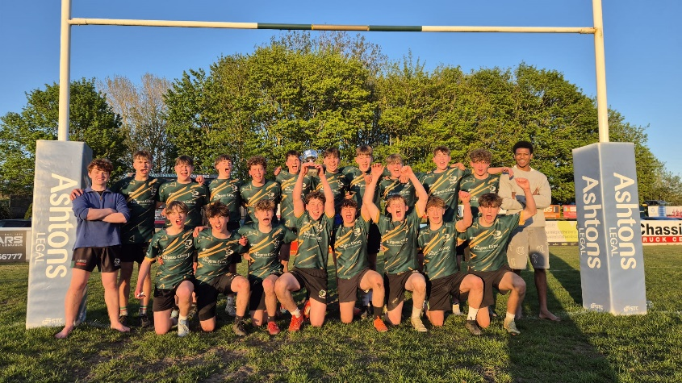
The game saw star performances from many of the lads in the squad and choosing a man of the match was not an easy task. However, Frederick Scott’s work rate in attack and defence as well as a number of impactful carries deserved to be commended, his performance fully encompassed the core values of St Benedict’s. A huge congratulations to all the lads who played on Wednesday, the heart they showed and the ‘jouez rug’ that they played is a true testament to St Benedict, you should all be proud of yourselves, and some of you should consider picking up a proper shaped ball more often. Finally, a huge thank you must be given to Mr Taylor, for organising the event. A huge thank you to the thunderous crowd that helped pushed the lads over the line. Without you, the outcome might have been different. And the biggest thank you must go to the incredible coaches, Adam and Kairo, for the wealth of knowledge, experience and the time that they have sacrificed to help get the lads to where they are today. Without them, such a victory would not have been possible.
Congratulations lads, you’ve earnt a well-deserved break from revision this weekend.
Adam O’Flynn
Year 13 Student and Head Coach

