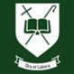
St. Benedict’s School Careers Fair
12th November 2025

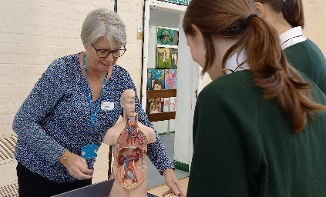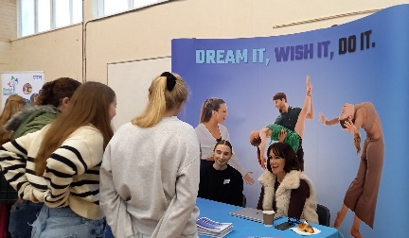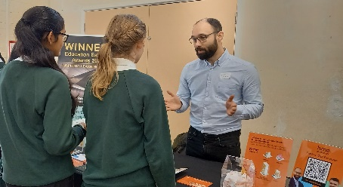
Students making the most of meeting core organisations and new employers
at this year’s Careers Fair
Another year has passed…and the Autumn term Careers Programme moved forward with our annual Careers Fair on Wednesday 12th November. Eleven new organisations joined us for this year’s event, adding to an already varied core group of employers, apprenticeship providers and Further Education Colleges.

The format for our Careers Fair this year was altered slightly to focus on students’ options choices from Y9 onwards. In practice, this meant that it was aimed at our Year 9-Year 13 cohorts only. (Students in Years 7 and 8 will be enjoying their own exclusive STEM event next week!). The new student carousel proved to be a hit with both students and stand holders. It certainly offered more space and time for in-depth chats about different career roles, training opportunities, and an exploration of the work experience programmes on offer.

Huge thanks go out to those employers who gave up their time and energy again, or for the first time, to inspire our students (and staff!): Beckett Financial Services, The British Army, British Racing School, Cambridgeshire Dental Health Improvement Team, Cambridge Regional College, Eastern Education Group, Eden Theatre Arts, Ensors Chartered Accountants, Gainsborough’s House Museum, HALO (software), Marshall Aerospace, MPCT Military Academies, NHS, the RAF, Royal Navy and Marines, Suffolk Constabulary, West Suffolk College (WSC) and WSC Apprenticeships, West Suffolk Council (Economic Development/Growth) and WindsorPatania (property development/architects).

Feedback from students and staff noted that the Fair was: “inclusive, interesting, life changing and fun”. That said, there was a call for “a larger venue/more space and a longer time devoted to the Fair… a true reflection of its popularity and value to our students!
Employers who attended were very positive and impressed by how polite and engaged our students were and said the Fair delivered: “a great selection of companies on the day, was well prepared and organised and had a good vibe, with lots of engaged questions from the students”.

It will be exciting to share a more extensive and varied line-up next time… watch this space!
Miss Hahn

