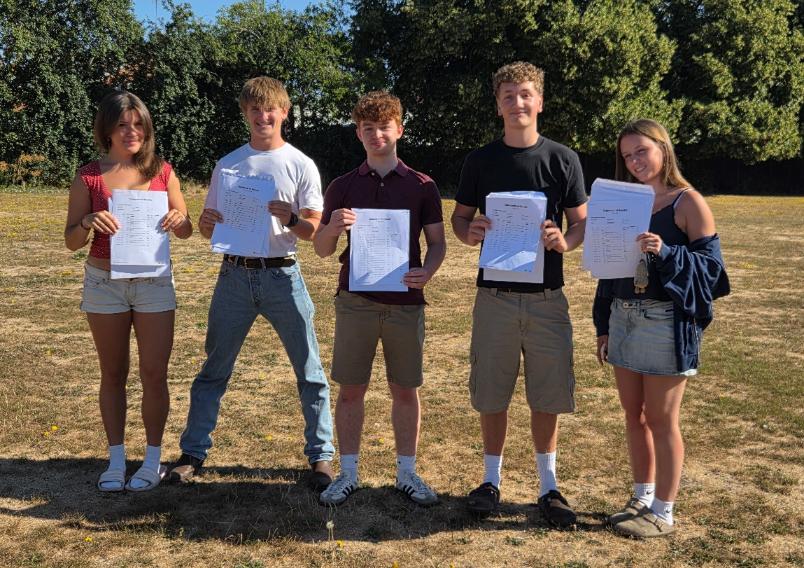

L to R – Mia Turner, Kuba Kluczynski, Adam O’Flynn, Felix Macey and Alice Ellison
We are once again delighted with the results that our students have achieved this year, they represent part of the culmination of a young person’s school education and we are incredibly proud not only of the results this cohort of 61 students has achieved but also of the determined, intelligent and compassionate young people they have turned out to be. We have no doubt that they are well-prepared for the next challenges that they may face and are confident that they will make positive contributions to society in all respects.
Our students made wonderful progress across their courses and as a result they have attained very highly. 31% of all grades awarded were A*/A grades, and 15% of our students received only A*s or As.
We are very proud of all our young people, all their paths, talents, struggles and differences. They are all to be celebrated. Our three Cambridge offer holders have all secured their places at Cambridge, with Mia Turner studying Modern Medieval Languages, Finola Thacker studying History and Amy John taking a gap year before going to study Classics.
Alice Ellison also achieved the highest grades in all her subjects with A*s across the board in Chemistry, Biology and Maths and is going to Edinburgh to study Chemistry. Adam O’Flynn achieved A*A*AA in Maths, Further Maths, Physics and French respectively and goes onto study Maths and Statistics at University College London. Felix Macey is off to study Economics at Leeds having gained AAA in Maths, Economics and Geography. Kuba Kluczynski achieved AAB in Economics, Psychology and Maths respectively and has secured a place at flight school with WhizzAir where he’ll start his training in Budapest in October.

