Year 9 Tutor Time Literacy Booklet

Literacy for Learning: Punctuation
Name:

Tutor group:

Capital letters
Week 1

When do we use capital letters?
- At the start of sentences.
- For names of people.
- For names of places.
- Days of the week.
- Months of the year.
- Titles of books, films, songs, plays etc.
- Use of the pronoun ‘I’.
- The first letter inside speech marks: In the distance, I heard someone cry, “Help!”

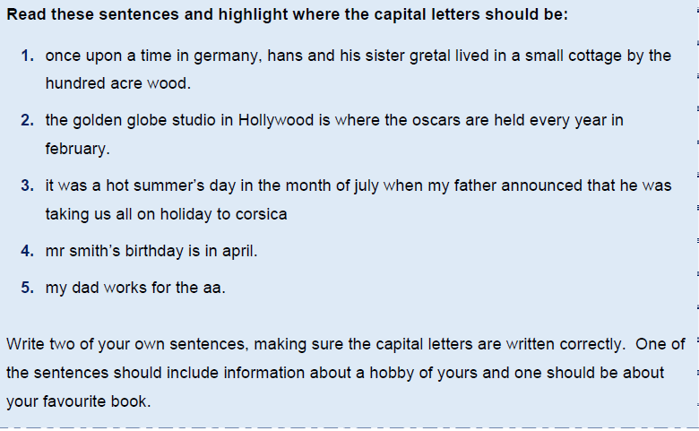
Task

- ___________________________________________________________

- ___________________________________________________________

Full stops
Week 2
What is a full stop and when do I use one?
Rules:
A full stop is a punctuation mark (.) used at the end of a sentence or an abbreviation.
BEWARE!
Once you have written a sentence, you cannot put a comma and carry on writing. This is called a run-on error. For example:
I love angel cake, it is my favourite.
(run-on error)

Task

Can you add the capital letters and full stops to these sentences? Highlight the words or letters you have changed.
scarlet made her way down the steps to the beach her dog ran behind her wagging its tail when she got to the bottom of the steps scarlet ran to the sea

the waves were breaking on the rocks scarlet decided to make a huge sandcastle her brother came to help her

the tide began to come in the waves came over the sandcastle and washed it away scarlet and her brother went home

jacob stood on the riverbank watching the boats go by he waved to the people as they went past the engines made a quiet chugging noise

mrs hall got the paints out of the store room she put some on each table connor covered the tables with newspaper then karina gave out the aprons
Full stops
Week 3
Task

In each piece of text identify where the full stops and capital letters go. Re-write the sentences correctly underneath.
pandas are members of the bear family they have black and white fur giant pandas are one of the world’s rarest mammals a young panda is called a cub

beavers are rodents that live in North America they can live in water and on land they are powerful swimmers and can stay underwater for up to fifteen minutes a baby beaver is called a kit kits learn to swim when they are about one month old

bottlenose dolphins send messages to each other they do this by squeaking, whistling or slapping their tails on the water dolphins are mammals like us and breathe air like we do they have a poor sense of smell but very good hearing

Challenge!
Full stops
Week 3

Find three examples of a full stop in your reading book or your exercise book. Why have they been used? Are there any times when you have forgotten to use a full stop in your exercise book?
Review learning

Record the rules for a full stop in the box below. No cheating!

Progress timeline

How confident are you with full stops?

Week 4
Question marks

What is a question mark and when do I use one?
Rules:
A question mark comes at the end of a question.
“What are you doing?” asked Mr Baker.
A question mark replaces a full stop at the end of a sentence.
A question mark acts like a full stop - you need a capital letter afterwards.
“Are you going on the school trip? I’m not allowed!”
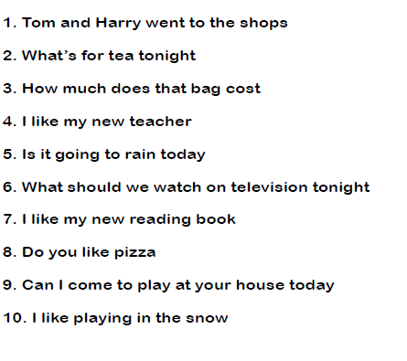
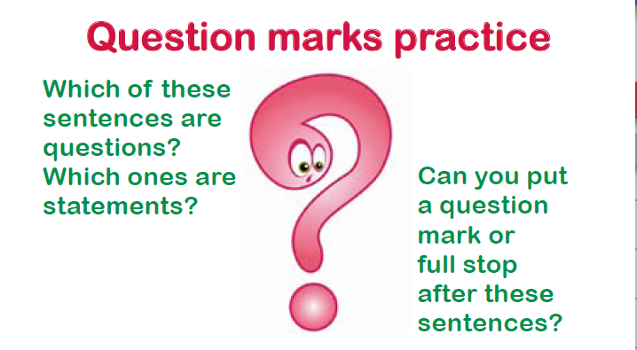
Task

Week 5
Exclamation marks!

What is an exclamation mark and when should I use one?
Rules:
An exclamation mark is used instead of a full stop when the sentence written needs emphasising, or someone is shouting.

Sometimes, you use an exclamation mark at the end of a sentence.
It shows when you feel strongly about something or when you are surprised.
My birthday party was brilliant!
An exclamation mark can be used when someone is excited or shouting or if they are saying something that's strange or surprising.
“I've just seen a flying pig!” exclaimed Mr Daly.
N.B: Do not use an exclamation mark unless you are certain it is necessary — and never use two or three of them in a row:
Example: This is a sensational result!!!

Task

Re-write the following sentences, adding exclamation marks where necessary.

- “Look out” shouted James to his brother.

- “Ouch” screamed Charlotte.

- What a wonderful surprise that was

- “Tidy your room” shouted mother. “It’s a pig sty”

- Looking out at the golden sunset, Maria exclaimed, “This is the life”

Week 6
Commas

What is a comma and when should I use one in my writing?
Rules:
1. Commas separate a list of items:
E.G: I like to play with Jan, Jill, Joe and Brad.

2. Commas allow you to combine 2 ideas into a single sentence. (Subordinate/ Dependent Clause)
E.G: While I finished my homework, my friend played the piano.

3. Use a comma after introductory words or phrases.
E.G: Well, you finally finished your homework.

4. Use a comma to show the relation between a word and a noun phrase that follows. (Apposition)
E.G: My teacher, Mr. Clark, is a great singer!
Task
Why have commas been used in the sentences below?
- When he saw the pirate ship on the horizon, the captain gave the alarm.
- After rush hour, train tickets are cheaper.
- Paul Mann, our star player, broke his leg in the match on Saturday.
- I need to buy eggs, bread, milk, cheese and butter.

Be careful when using commas as they change the meaning of a sentence.

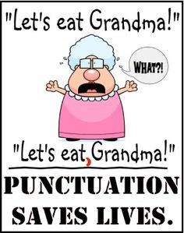

Commas
Week 7
When writing a list, you should put a comma between each item, except for the last item where you use ‘and’.
E.G: To build the shed we will need a hammer, nails and a saw.
Dogs love toys, bones and long walks.
Robbie is a sweet, caring and polite boy.
Add commas to the following sentences to separate the items in a list.
Task
- I have travelled to Spain France Italy and Sweden.
- To make a perfect cup of tea you need a teabag sugar milk and hot water.
- Burglars love open windows dark streets and unlocked cars.
- In London tourists can visit Buckingham Palace London Dungeons and the London Eye.
- The job requires employees to be punctual efficient hardworking and professional.
Task

When writing a sentence, you often provide additional information to make it more interesting to the reader.
When the second part of a sentence provides extra information about the first part, you divide the two parts with a comma. You can then use the words who, which, where or when after the comma.
E.G: Danny is a very talented football player, which is why he plays for Liverpool FC.
Add extra information to the following sentences by using commas and who, which, where or when.
- My granny is a terrible cook

- Harry ran across the road

- My puppy chewed my socks

- I will meet you at the restaurant

- I have a gorgeous fluffy kitten

Commas
Week 8

You can also add information in the middle of a sentence. You need to cushion the extra information with two commas.
E.G: The girl fell off her chair.
becomes
The girl, who was laughing hysterically, fell off her chair.
Task
Rewrite the following sentences by adding extra information and commas.
- The man slid into the room.

- My sister is called Rosie.

- The dog bit the postman.

- My friend works in an office.

Review learning

Record the rules for using a comma in the box below. No cheating!

Progress timeline

How confident are you with commas?

Week 9
Apostrophes
What is an apostrophe and when do I need to use one?
Rules:
Apostrophes are used for two reasons:
- to indicate missing letters
For example:
(they + have = they’ve; are + not = aren’t; they + will = they’ll)
- You can't have it.
- Don't do that!
- I'd like an ice-cream, please.
- We'd better hurry.
- to indicate possession
For example:
- The girl’s bicycle
- My friend’s house
Task

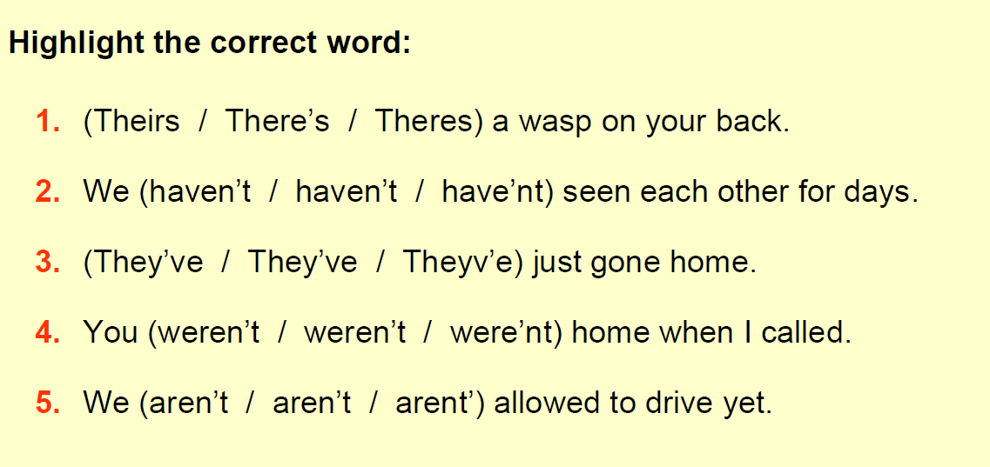
Apostrophes
Week 10

Rules of possession
Singular: When the possessor is single, we indicate possession by using an apostrophe followed by the letter s:
- The man’s coat
- My brother’s car
Plural: When the possessors are plural, the apostrophe is placed after the final s:
- The boys’ bicycles
- My cousins’ parents
When names end with the letter ‘s’, either use is acceptable:
- James’ wife or
- James’s wife
Task
Rewrite the sentences to include an apostrophe.
E.G: The coat belongs to the man = the man’s coat. (man’s = there is only one man)
- The bicycle belongs to my brother.

- The web belongs to the spider.

- The field belongs to the school.

- The computer belongs to the receptionist.

- The car belongs to my uncle.

Apostrophes
Week 11
Rewrite the sentences to include an apostrophe – remember to look at the s.
Example: The dogs’ bones are hidden in the garden. (dogs’ = more than one dog)
Task

- The players changing room was like a pig sty after the game.

- The teachers staffroom is very noisy at breaktime.

- The soldiers tank roared across the landscape.

- The doctors surgery was very busy on a Monday morning.

- One of Dickens characters in ‘Oliver Twist’ is the Artful Dodger.
Task

Write sentences containing possessive apostrophes. Make sure you are aware of whether it is singular or plural possessive.
Example: a cat + paw = The cat’s paw had a thorn in it.

- the bicycle + tyre

- Mr Jones + jacket

- three horses + field

- my sister + dress
Apostrophes
Week 12
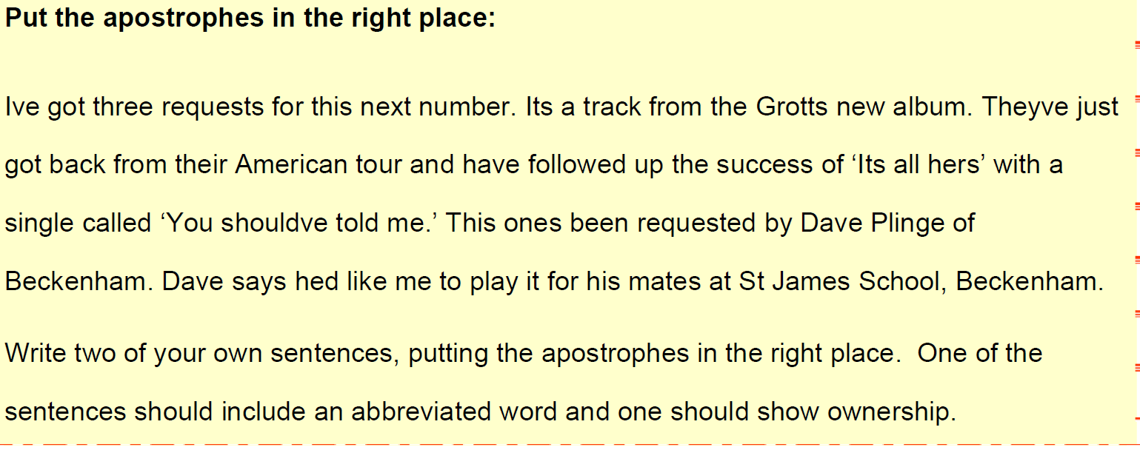
Task

Review learning

Record the rules for using an apostrophe in the box below. Remember there are 2 reasons to use an apostrophe.

Progress timeline

How confident are you with apostrophes?

